**EMERALD ROYAL INTERNATIONAL SCHOOL MPAPE, ABUJA.**

**LESSONS PLAN AND NOTE FOR WEEK 8 ENDING 14th JUNE, 2024**

**TERM: 3rd**

**WEEK: 8th**

**DATE: 190/ 06 / 2024**

**CLASS: Nursery 2**

**SUBJECT: Nature studies**

**TOPIC: Growing plants**

**SUB—TOPIC: Meaning of plant and things plants need to grow.**

**PERIOD: 4th**

**TIME: 10:40—11:20am**

**DURATION: 40 minutes**

**NUMBER IN CLASS: 13**

**AVERAGE AGE: 5 years**

**SEX: Mixed**

**LEARNING OBJECTIVES: By the end of the lesson, the pupils should be able to:**

**1. Explain the meaning of plant.**

**2. Mention the parts of plant.**

**3. State the things that plant needs to grow.**

**RATIONALE: For pupils to know about plants.**

**PREVIOUS KNOWLEDGE: Pupils have been seeing plants at home and in the school environment.**

**INSTRUCTIONAL MATERIALS: Flower plants in the school environment.**

**REFERENCE MATERIALS: Basic science and technology for Nursery schools book 3 by OPEMIPO DADA.**

**LESSON DEVELOPMENT**

|  |  |  |  |
| --- | --- | --- | --- |
| **Steps** | **Teacher's activities** | **Pupils' activities** | **Learning point** |
| **Introduction** | **Teacher introduces the lesson by reviewing the previous lesson and then displays a plant on the desk. As,** | **Pupils pay attention to the teacher.** | **To prepare pupils minds for the lesson ahead.** |
| **Presentation step 1** | **Teacher explains the meaning of plants to pupils and then asks them to repeat after her.** | **Pupils listen to the teacher and repeat after her.** | **For better understanding.** |
| **Step 2** | **Teacher mentions the parts of plants to pupils and also asks Pupils to repeat after her.** | **Pupils pay attention to the teacher and repeat after the teacher.** | **For better understanding.** |
| **Step 3** | **Teacher States the things that plants need to grow to pupils and also asks them to repeat after her.** | **Pupils listen carefully and repeat after the teacher.** | **To enhance Pupils attention span.** |
| **Board summary** | **Teacher writes the whole note of lesson on the board for pupils to copy. That is;**  **GROWING PLANTS**  **Meaning of plant**  **Plant are living things that grow from the soil, usually has a stem, leaves, roots,and flowers, and produces seeds.**  **Plants can be big or small.**  **Parts of plants**  **They are different parts of plants. This are;**  **1. The stem**  **2. The leaves**  **3. The flowers**  **4. The root**  **5. The fruit**    **Diagram of a plant.**  **THINGS THAT PLANTS NEED TO GROW**  **Just like human beings need good and water to grow, plants also need some things to grow and stay healthy.**  **1. Plants need water to grow.**  **2. Plant need sunlight to grow.**  **3. Plant need air to grow.**  **4. Plant need good soil to grow.**  **5. Plant need space to grow.**    **If plant do not have these things, they would not grow well.** | **Pupils copy the note into their books.** | **For onward study.** |
| **Evaluation** | **Teacher evaluates the lesson by asking pupils the following questions;**  **1. Define plants.**  **2. Mention the parts of plant.**  **3. The things that plants need to grow are?** | **Pupils answer the questions ask by the teacher.** | **To assess Pupils level of understanding.** |
| **Conclusion** | **Teacher concludes the lesson by marking pupils books.** | **Pupils submit their books for marking..** | **For endorsement.** |
| **Assignment** | **1. Activity 22 page 72 in Basic science text book.**  **2. Write the various parts of this plant.** | **Pupils do their assignment at home.** | **To encourage learning at home.** |

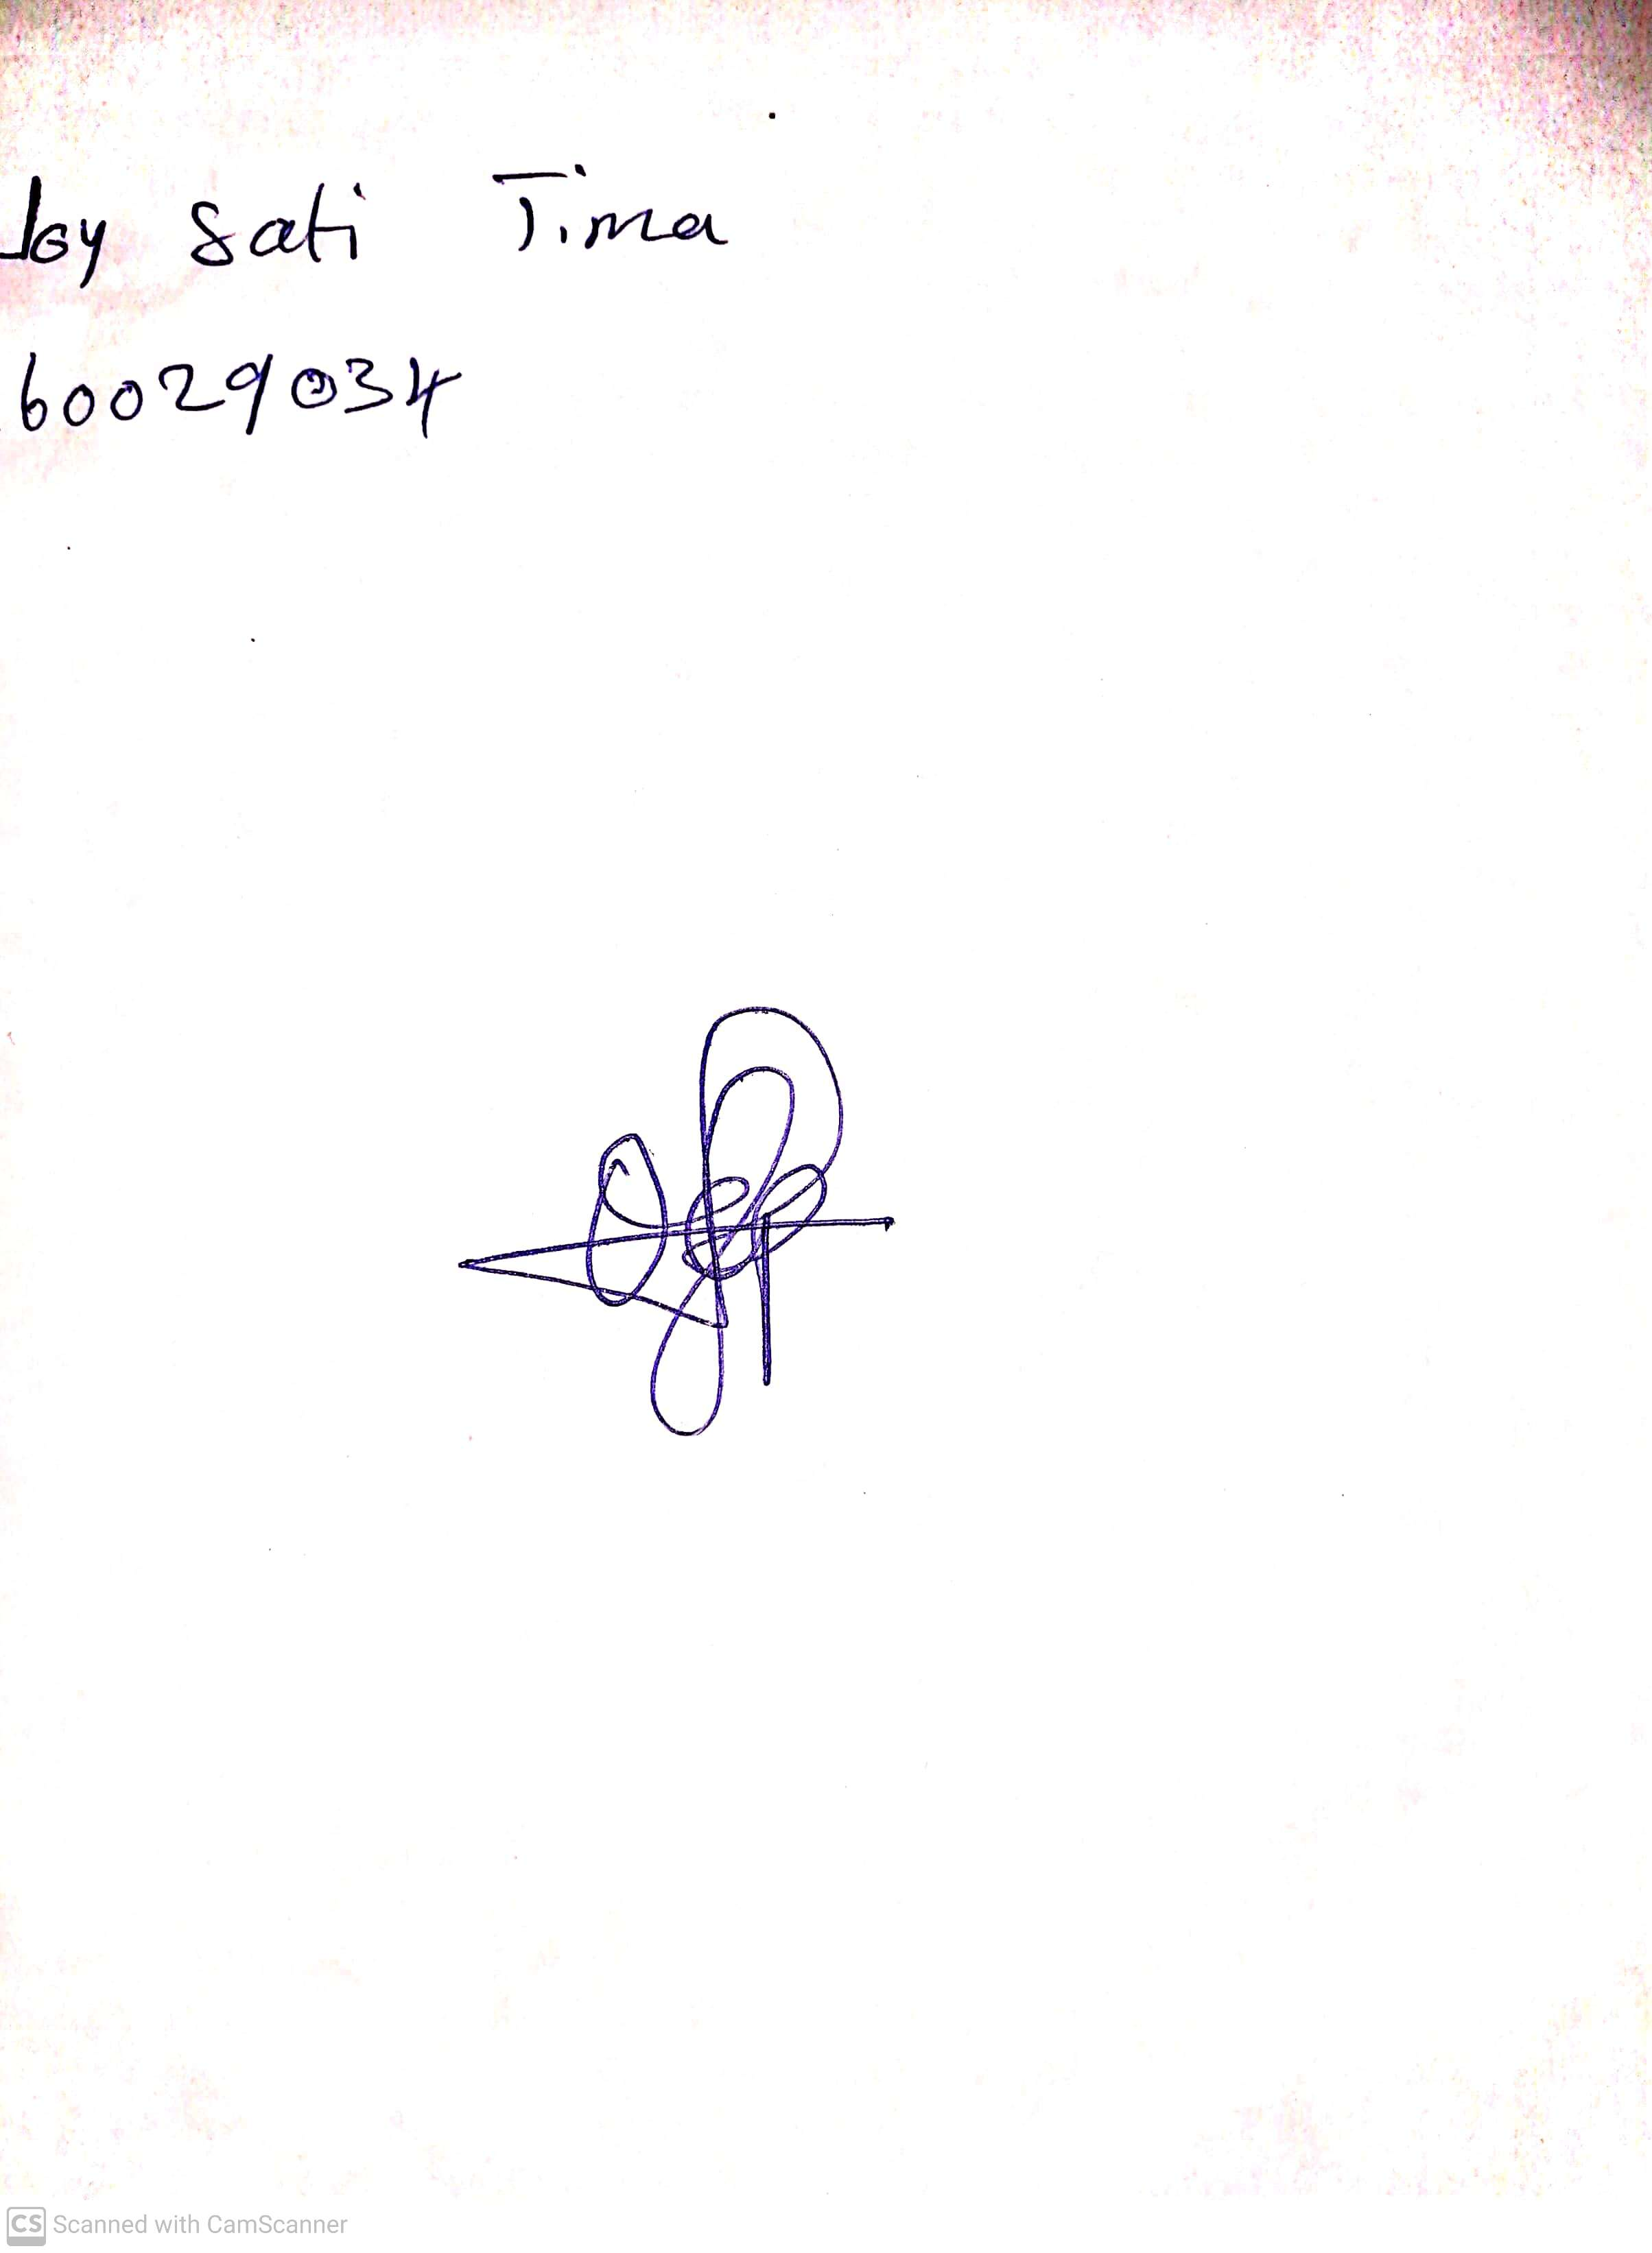

**31st May, 2024**

**Perpetual Ojoma Ocheja**

**Stream Head Nursery**