**EMERALD ROYAL INTERNATIONAL CHOOL**

**MPAPE ABUJA**

**THIRD TERM PRE-NURSERY SCHEME OF WORK ON NATURE STUDIES.**

**Week 1:-** Water(Explain water ad a liquid that is colourless, odourless and tasteless)

**Week 2:**- Sources and uses of water (Explain various places of getting water and what water is used for).

**Week 3:**- Floating objects (Explain floating as things staying on top of Water and explain why objects floats with demonstration,)

**Week 4:**- Sinking objects (Explain sinking as things going down inside water and explain why objects sinks With demonstration).

**Week 5:**- Weather (Define weather as the condition of the atmosphere and explain differences in weather.)

**Week 6:-** Types of weather (explain weather types and activities for each weather types: Rainy weather and sunny weather).

**Week 7,:**- Colours of the rainbow. (Explain rainbow as a kind coloured bowl in the sky after the rain.)

**Week 8:-** Animals and their sounds (Explain why animals make different sounds.)

**Week 9:**- Animals movement (Explain animals movement)

**Week 10:-** Simple machines (define simple machines as tools that makes work easy).

**Week 11:**- Revision.

**Week 12:**- Examination.

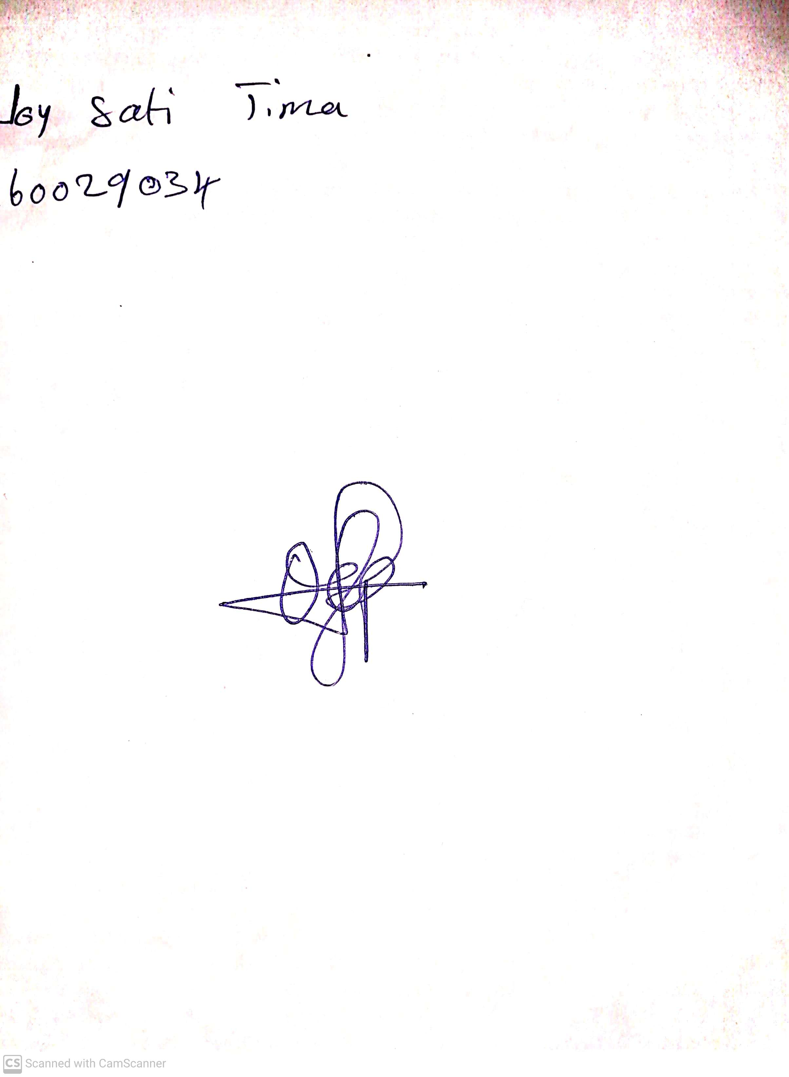

29TH APRIL, 2023

Perpetual Ojoma

Stream Head Nursery