**EMERALD ROYAL INTERNATIONAL SCHOOL**

**MPAPE, ABUJA**

**Letter Work 3rd Term Scheme of Work NURSERY 1**

|  |  |  |
| --- | --- | --- |
| **Week 1** | **Consonant sound “M”** | **Say the consonant sound of the letter “m” as Mop, Mat, etc.** |
| **Week 2** | **Coping Words with letters** | **Coping letter sound Nn, Oo, Pp, Qq.** |
| **Week 3** | **Coping Words with letters** | **Coping letter sound Rr, Ss, Tt, Uu, Vv, Ww, Xx, Yy, Zz.** |
| **Week 4** | **Two letter words** | **Learning two letter words e.g On, At, Go etc**  **Writing two letter words.** |
| **Week 5** | **Two letter words** | **Learning two letter words e.g Is, As, Be, So,It etc.**  **Coping and matching two letter words.** |
| **Week 6** | **Vowels** | **Learning Vowels**  **Coping Vowels**  **Identifying Vowels “a”, “e”, “I”, “o”, “u”.** |
| **Week 7** | **Consonants** | **Explaining the consonants**  **Naming the consonants.** |
| **Week 8** | **Three Letter words** | **Identification of three letter words** |
| **Week 9** | **Three letter words** | **Writing three letter words.** |
| **Week 10** | **Four Letter words** | **Naming four letter words**  **Identifying four letter words**  **Writing four letter words.** |
| **Week 11** | **Coping Letters and words** | **Coping Letter and words in upper case Aa-Zz.** |
| **Week 12** | **Revision** |  |
| **Week 13** | **Examination** |  |

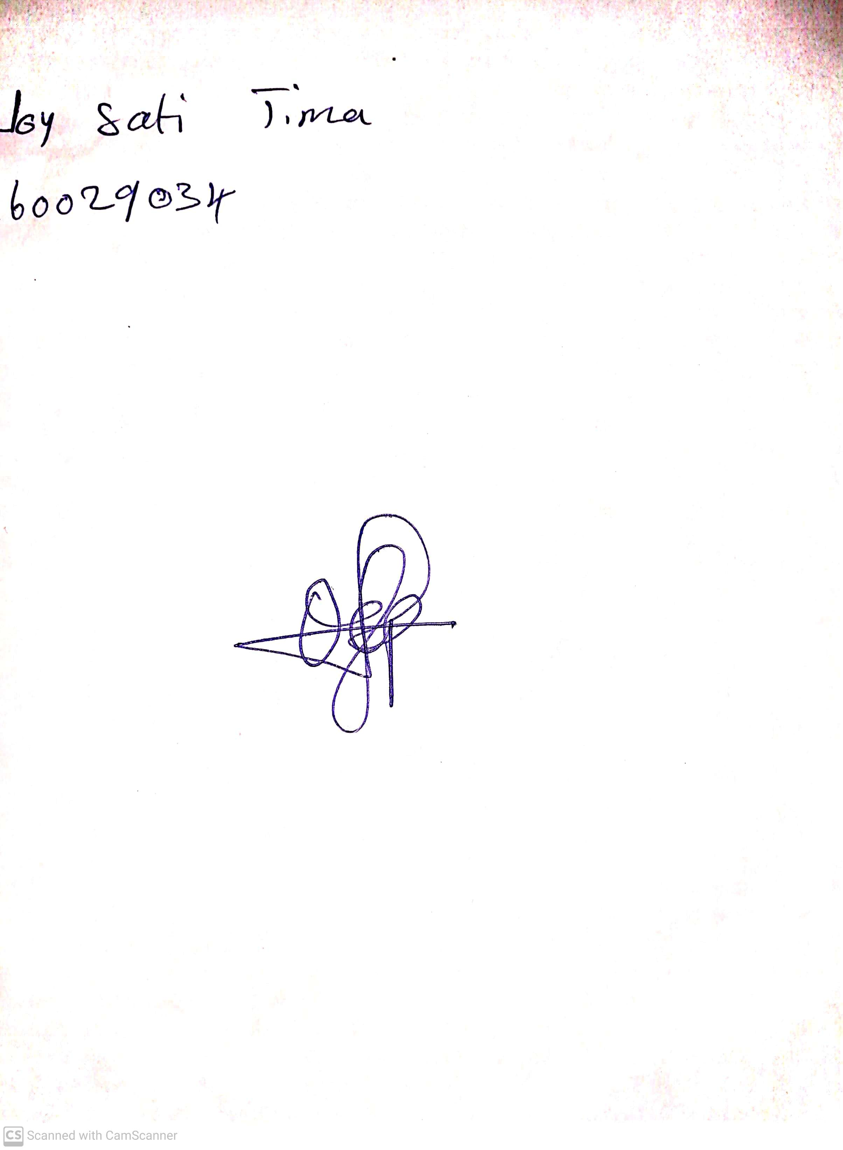

10th May, 2023

Perpetual Ojoma

Stream Head Nursery