**EMERALD ROYAL INTERNATIONAL SCHOOL**

**MPAPE, ABUJA.**

**LESSON PLAN AND NOTE FOR WEEK 9 ENDING 21/06/2024**

**TERM: THIRD**

**WEEK: 9TH**

**DATE: 17/06/2024**

**CLASS: NURSERY 2**

**SUBJECT: SOCIAL NORMS**

**TOPIC: SOME BASIC HOME APPLIANCES .**

**SUB-TOPIC: ELECTRICAL AND NON-ELECTRICAL APPLIANCES**

**PERIOD: 2ND PERIOD AFTER LONG BREAK**

**TIME: 11: 20- 12: 00PM**

**DURATION: 40 MINUTES.**

**NUMBER IN CLASS: 13**

**AVERAGE AGE: 5 YEARS.**

**SEX: MIXED.**

**SPECIFIC OBJECTIVES: BY THE END OF THE LESSON,THE PUPILS SHOULD BE**

**ABLE TO:**

1. **EXPLAIN THE MEANING OF ELECTRICAL APPLIANCES AND SOME EXAMPLES.**
2. **DESCRIBED NON-ELECTRICAL APPLIANCES AND SOME EXAMPLES**

**RATIONALE: FOR PUPILS TO KNOW THE DIFFERENCES BETWEEN**

**ELECTRICAL AND NON-ELECTRICAL APPLIANCES.**

**PREVIOU KNOWLEDGE: PUPILS HAVE BEEN SEING BOTH ELECTRICAL AND NON-ELECTRICAL APPLIANCES.**

**INSTRUCTIONAL MATERIALS: ELECTRICAL FAN, TELEVISION, PICTURES OF MORTAR**

**AND PESTLE AND KEROSINE STOVE.**

**REFERENCE MATERIALS: GOOGLE.COM**

**LESSON DEVELOPMENT**

|  |  |  |  |
| --- | --- | --- | --- |
| **STAGES/STEPS** | **TEACHER’S ACTIVITIES** | **PUPILS’ ACTIVITIES** | **LEARNING POINTS** |
| **INTRODUCTION** | **Teacher introduces the lesson by showing pupils the pictures of kerosene stove, mortar and pestle and then asks if they have seen them before?** | **Pupils pay attention to the teacher and answer the question asked by her.** | **To prepare pupils minds for the lesson ahead.** |
| **PRESENTATION**  **STEP 1** | **Teacher then explains to pupils what there are used for and then explain the meaning of electrical appliances and the examples and then asks pupils to repeat after her.** | **Pupils listen attentively to the teacher and repeat after her.** | **For proper understanding .** |
| **STEP 2** | **Teacher describes the non-electrical appliance and examples to pupils and also asks them to repeat after her.** | **Pupils pay attention to the teacher and repeat after her.** | **For better understanding.** |
| **BOARD SUMMARY** | **Teacher summarizes the lesson by writing the whole note of lesson on the board for pupils to copy into their books. That is,**  **ELECTRICAL APPLIANCES**  **Electrical appliances means a device that consumes electricity.**  **Examples:**     1. **Refrigerator** 2. **Microwave** 3. **Blender** 4. **Washing machine** 5. **Air conditioners** 6. **Freezers** 7. **Water heaters** 8. **Electrical fan** 9. **Television etc.**   **NON-ELECTRICAL APPLIANCES**  **Non-electrical appliances means a device that is not using electricity for power.**  **Examples:**     1. **Kerosene stove** 2. **Solar heater** 3. **Sewing machine** 4. **Mortar and pestle** 5. **Non electrical iron etc.** | **Pupils copy the note into their exercise books.** | **For onward study.** |
| **EVALUATION** | **Teacher evaluates the lesson by asking the following questions;**   1. **What are electrical appliances?** 2. **List the examples of electrical appliances at home.** 3. **Mention the non electrical appliances that you know..** | **Pupils answer the questions ask by the teacher.** | **To assess pupils level of understanding.** |
| **CONCLUTION** | **Teacher concludes the lesson by marking pupils books.** | **Pupils submit their books for marking.** | **For endorsement.** |
| **ASSIGNMENT** | 1. **List out 10 electrical appliances in your mummy’s kitchen.** 2. **Mention 10 non- electrical appliances in your mummy’s kitchen.** | **Pupils do their assignment at home.** | **To encourage learning at home.** |

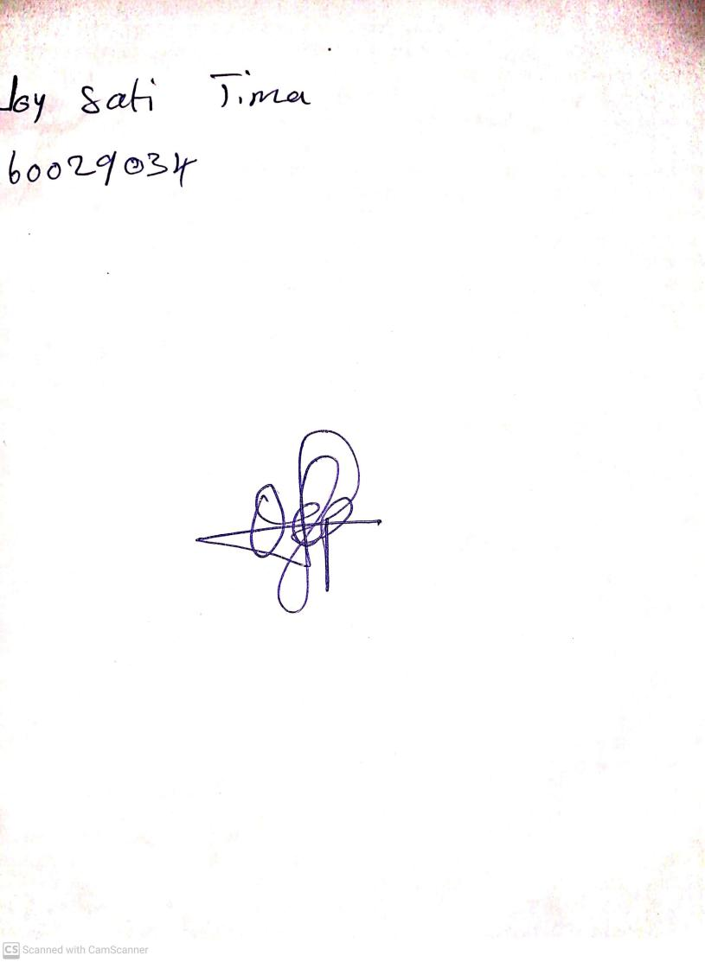

**14th June, 2024**

**Perpetual Ojoma Ocheja**

**Stream Head Nursery**