**LESSON PLAN AND NOTE 1 FOR WEEK 11 ENDING 14/07/2023**

**Term 3rd term**

**Week 11th week**

**Date 14/07/2023**

**Class Nursery One**

**Subject Letter Work**

**Topic Coping upper & lower letters and words.**

**Sub-topic Coping Aa –Ii letters and words.**

**Period 4th period**

**Time 10:40 am**

**Duration 35 minutes**

**No in class 18**

**Average Age 3 years**

**Sex Mixed**

**Specific Objectives: By the end of the lesson, the pupils should be able to:**

1. **Coping Aa, Bb, Cc, Dd letters with words.**
2. **Coping Ee, Ff, Gg, Hh, Ii letters with words.**

**Rationale: To ensure the pupils copy Aa-Ii letters with words.**

**Previous Knowledge: The pupils can match four letter words.**

**Instructional Resources: Upper & Lower Case chart, Online research.**

**Reference Material: Online research, chart.**

**LESSON PRESENTATION**

|  |  |  |  |
| --- | --- | --- | --- |
| **Steps** | **Teacher’s Activities** | **Pupils’ Activities** | **Learning Points** |
| **Introduction** | **The teacher introduces the lesson by rhyming Aa - Ii letters from upper & lower case chart.** | **The pupils listen to the teacher.** | **To arouse the interest of the pupils.** |
| **Step 1** | **The teacher copy letter Aa – Dd with words**  **Aa = Apple**  **Bb = Ball**  **Cc = Cat**  **Dd = dog** | **The pupils repeats after the teacher to copy letters with words.** | **For proper understanding of the pupils.** |
| **Step 2** | **The teacher leads the pupils to copy letters Ee – Ii with words**  **Ee = Egg**  **Ff = Fish**  **Gg = Goat**  **Hh = House**  **Ii = Ink** | **The pupils copy with the teacher the letter with words**  **Ee = Egg**  **Ff = Fish**  **Gg = Goat**  **Hh = House**  **Ii = Ink** | **For better understanding.** |
| **Summary** | **The teacher summarizes the lesson by asking the pupils to copy letters Aa – Ii.** | **The pupils respond to the teacher actively.** | **For onward study.** |
| **Evaluation** | **Question:**  **Copy letters Dd, Ee, Hh with words you know?**  **Copy letters Ee – Ii with words?** | **The pupils answer the question correctly.** | **To ascertain the pupils’ understanding.** |
| **Conclusion** | **The teacher reacts & summarizes the lesson to the pupils.** | **The pupils gives answer to the teacher’s question.** | **To consolidate the lesson.** |
| **Assignment** | **Question:**  **Copy letters Aa – Ii with words?** | **The pupils copy and do their homework at home.** | **To encourage learning while at home.** |

**LESSON PLAN AND NOTE 2 FOR WEEK 11 ENDING 14/07/2023**

**Term 3rd term**

**Week 11th week**

**Date 14/07/2023**

**Class Nursery One**

**Subject Letter Work**

**Topic Coping upper & lower letters and words.**

**Sub-topic Coping letters Jj – Rr with words.**

**Period 4th period**

**Time 10:40 am**

**Duration 35 minutes**

**No in class 18**

**Average Age 3 years**

**Sex Mixed**

**Specific Objectives: By the end of the lesson, the pupils should be able to:**

1. **Coping letters Jj – Mm with words.**
2. **Coping letters Nn - Rr letters with words.**

**Rationale: To ensure the pupils copy letters Jj – Rr with words.**

**Previous Knowledge: The pupils can copy letters Aa – Ii with words.**

**Instructional Resources: Upper & Lower Case chart, Online research.**

**Reference Material: Online research, chart.**

**LESSON PRESENTATION**

|  |  |  |  |
| --- | --- | --- | --- |
| **Steps** | **Teacher’s Activities** | **Pupils’ Activities** | **Learning Points** |
| **Introduction** | **The teacher introduces the lesson by rhyming upper & lower letters Aa -Zz** | **The pupils listen to the teacher.** | **To arouse the interest of the pupils.** |
| **Step 1** | **The teacher leads the pupils to copy letters Jj – Mm with words**  **Jj = Jug**  **Kk = Key**  **Ll = Leg**  **Mm = Mat.** | **The pupils copy letters Jj – Mm with words with the teacher.** | **For proper understanding of the pupils.** |
| **Step 2** | **The teacher guides the pupils to copy letters Nn – Rr with words**  **Nn = Net**  **Oo = Orange**  **Pp = Pot**  **Qq = Queen**  **Rr = Rabbit** | **The pupils copy letters Nn – Rr with words with the teacher.** | **For better understanding.** |
| **Summary** | **The teacher summarizes the lesson by asking the pupils to copy letters Jj – Rr** | **The pupils respond to the teacher actively.** | **For onward study.** |
| **Evaluation** | **Question:**  **Copy letters Pp, Mm, Kk with words you know?**  **Copy letters Nn – Rr with words** | **The pupils answer the question correctly.** | **To ascertain the pupils’ understanding.** |
| **Conclusion** | **The teacher reacts & summarizes the lesson to the pupils.** | **The pupils gives answer to the teacher’s question.** | **To consolidate the lesson.** |
| **Assignment** | **Question:**  **Copy letters Jj, Ll, Rr with words you know?.** | **The pupils copy and do their home-work at home.** | **To encourage learning while at home.** |

**LESSON PLAN AND NOTE 3 FOR WEEK 11 ENDING 14/07/2023**

**Term 3rd term**

**Week 11th week**

**Date 14/07/2023**

**Class Nursery One**

**Subject Letter Work**

**Topic Coping upper & lower letters with words**

**Sub-topic Coping letters Ss – Zz with words.**

**Period 4th period**

**Time 10:40 am**

**Duration 35 minutes**

**No in class 18**

**Average Age 3 years**

**Sex Mixed**

**Specific Objectives: By the end of the lesson, the pupils should be able to:**

1. **Copy letters Ss – Vv with words.**
2. **Copy letters Ww – Zz with words**

**Rationale: To ensure the pupils copy letters Ss – Zz with words.**

**Previous Knowledge: The pupils can copy letters Jj - Rr**

**Instructional Resources: Upper & lower letters chart, Online research.**

**Reference Material: Online research, chart.**

**LESSON PRESENTATION**

|  |  |  |  |
| --- | --- | --- | --- |
| **Steps** | **Teacher’s Activities** | **Pupils’ Activities** | **Learning Points** |
| **Introduction** | **The teacher introduces the lesson by rhyming letters Aa – Zz from the upper & lower case chart.** | **The pupils listen to the teacher.** | **To arouse the interest of the pupils.** |
| **Step 1** | **The teacher leads the pupils to copy letters Ss – Vv with words**  **Ss = Sun**  **Tt = Tap**  **Uu = Umbrella**  **Vv = Van** | **The pupils copy letters Ss – Vv with words with the teacher.** | **For proper understanding of the pupils.** |
| **Step 2** | **The teacher guides the pupils to copy letters Ww – Zz with words**  **Ww = Window**  **Xx = X-Ray**  **Yy = Yam**  **Zz = Zebra** | **The pupils copy letters Ww – Zz with words with the teacher.** | **For better understanding.** |
| **Summary** | **The teacher summarizes the lesson by coping letters Ss – Zz with words.** | **The pupils understand the lesson actively.** | **For onward study.** |
| **Evaluation** | **Question:**  **Copy letters Ss – Vv with words**  **Copy letters Zz with words?.** | **The pupils answer the question correctly.** | **To ascertain the pupils’ understanding.** |
| **Conclusion** | **The teacher reacts & summarizes the lesson to the pupils.** | **The pupils gives answer to the teacher’s question.** | **To consolidate the lesson.** |
| **Assignment** | **Question:**  **Copy letters Ss, Uu, Vv, Yy with words.** | **The pupils copy and do their home-work at home.** | **To encourage learning while at home.** |

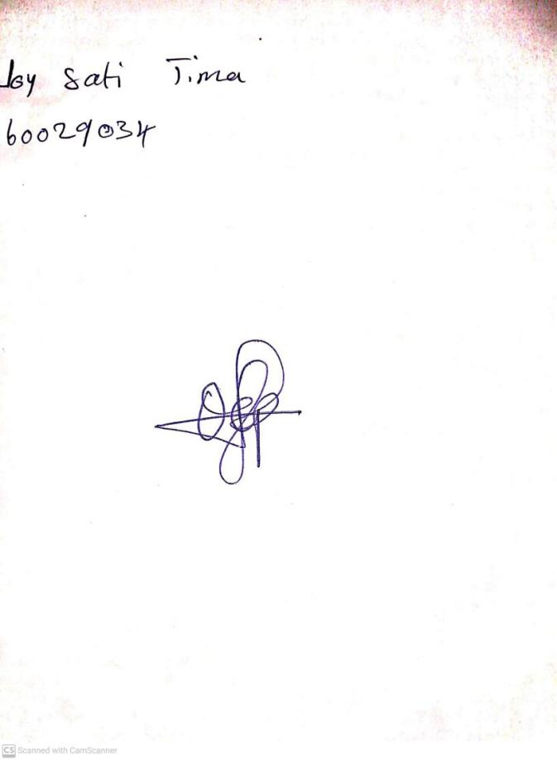

10th May, 2023

Perpetual Ojoma

Stream Head Nursery