**EMERALD ROYAL INTERNATIONAL SCHOOL MPAPE, ABUJA**

**LESSON PLAN AND NOTE FOR WEEK 2 ENDING 19/01/2024**

**TERM: 2nd**

**WEEK: 2**

**DATE: 15/01/2024**

**CLASS: Nursery 2**

**SUBJECT: Letter work**

**TOPIC: Initial consonant : Blend 1**

**SUB—TOPIC: Meaning of initial and example of initial consonant blend /bl/**

**PERIOD: 3rd**

**TIME: 09:30—10:10am**

**DURATION: 40 minutes**

**NUMBER IN CLASS: 13**

**AVERAGE AGE: 5 years**

**SEX: Mixed**

**LEARNING OBJECTIVES: By the end of the lesson, the Pupils should be able to:**

**1. Explain the meaning of initial consonant blends.**

**2. Mention words with initial consonant /bl/**

**RATIONALE: For Pupils to know the meaning of initial consonants.**

**PREVIOUS KNOWLEDGE: Pupils have learnt words with vowel a e i o u in previous Lesson.**

**INSTRUCTIONAL MATERIALS: A chart of initial consonant blends.**

**REFERENCE MATERIALS: My choice of English language stage 3 by J.F. Omotayo**

**LESSON DEVELOPMENT**

|  |  |  |  |
| --- | --- | --- | --- |
| **Steps** | **Teacher's activities** | **Pupils' activities** | **Learning point** |
| **Introduction** | **Teacher introduces the lesson by singing nursery phonics songs.** | **Pupils sing the songs along with the teacher.** | **To arouse pupils interest for the lesson ahead.** |
| **Presentation step 1** | **Teacher explains the meaning of initial consonant to pupils and then ask them to repeat after him or her.** | **Pupils listen attentively to the teacher and repeat after him or her.** | **For proper understanding.** |
| **Step 2** | **Teacher mentions the examples of initial consonant blends bl to pupils and also ask them to repeat after the teacher.** | **Pupils pay attention to the teacher and repeat after the teacher.** |  |
| **Board summary** | **Teacher summarizes the lesson by writing the whole note of lesson on the board for pupils to copy into their books. That is;**  **INITIAL CONSONANT: BLEND 1**  **Initial consonant blends can also be called Beginning blends. These refer to the consonant blends that appear at the beginning of a word.**  **Examples of initial consonant blend " bl" are**  **/ bl/ as in blue**  **/ bl / as in black**  **/ bl / as in blank**  **/ bl / as in blast**  **/ bl / as in bleed**  **/ bl / as in blend**  **/ bl / as in bless**  **/ bl /as in blind**  **/ bl /as in blink**  **/ bl / as in blood**  **/ bl / as in blade**  **/ bl/ as in block**  **/ bl / as in blister etc.** | **Pupils copy the note into their exercise books.** | **For onward study.** |
| **Evaluation** | **Teacher evaluates the lesson by asking the following questions;**  **1. What is initial consonant blend?**  **2. Mention words with initial consonant blend /bl/.** | **Pupils answer the questions ask by the teacher.** | **To assess Pupils level of understanding.** |
| **Conclusion** | **Teacher mark's Pupils books.** | **Pupils submit their books for marking.** | **For endorsement.** |
| **Assignment** | **Write 10 words with initial consonant /br/ and /cl/.** | **Pupils do their assignment at home.** | **To encourage learning at home.** |

**LESSON PLAN AND NOTE FOR WEEK 2 ENDING 19/01/2024**

**TERM: 2nd**

**WEEK: 2**

**DATE: 18/01/2024**

**CLASS: Nursery 2**

**SUBJECT: letter work**

**TOPIC: Initial consonant blend 1**

**SUB—TOPIC: Word with initial consonant blend br and cl**

**PERIOD: 2nd**

**TIME: 11:20—12:00pm**

**DURATION: 40 minutes**

**NUMBER IN CLASS: 13**

**AVERAGE AGE: 5years**

**SEX: Mixed**

**LEARNING OBJECTIVES: By the end of the lesson, the Pupils should be able to:**

**1. Mention words with initial br**

**2. State words with initial cl**

**RATIONALE: For Pupils to know words with initial consonant br and cl**

**PREVIOUS KNOWLEDGE: Pupils have learnt words with initial consonant bl in previous lesson.**

**INSTRUCTIONAL MATERIALS: A chart of initial consonants.**

**REFERENCE MATERIALS: My choice of English language stage 3 by J.F Omotayo**

**LESSON DEVELOPMENT**

|  |  |  |  |
| --- | --- | --- | --- |
| **Steps** | **Teacher's activities** | **Pupils' activities** | **Learning point** |
| **Introduction** | **Teacher introduces the lesson by reviewing the previous lesson.** | **Pupils pay attention to the teacher.** | **To arouse pupils interest for the lesson ahead.** |
| **Presentation step 1** | **Teacher mentions the examples of words with initial consonant blend br to pupils and ask them to repeat after her.** | **Pupils listen to the teacher and repeat after her.** | **For proper understanding.** |
| **Step 2** | **Teacher States the words with initial consonant blend CL to pupils and also ask them to repeat after her.** | **Pupils listen very attentively to the teacher and repeat after her.** | **For better understanding.** |
| **Board summary** | **Teacher writes the whole note of lesson on the board for pupils to copy into their books. That is;**  **WORDS WITH INITIAL CONSONANT /BR/ AND /CL/**   |  |  | | --- | --- | | **/br/** | **/cl/** | | **brush** | **clean** | | **bread** | **class** | | **breast** | **clay** | | **broom** | **clip** | | **brake** | **clock** | | **brain** | **clap** | | **brown** | **clue** | | **bring etc.** | **climb etc.** | | **Pupils copy the note into their exercise books.** | **For onward study.** |
| **Evaluation** | **Teacher evaluates the lesson by asking pupils to mention words with initial consonant br and CL on the board one after the other.** | **Pupils fo to the board and mention the words one after another.** | **To enhance Pupils participation in class.** |
| **Conclusion** | **Teacher concludes the lesson by marking pupils books.** | **Pupils submit their books for marking.** | **For endorsement.** |
| **Assignment** | **Write 5 words with initial consonant "cr" and 5 words with initial consonant "fl".** | **Pupils do their assignment at home.** | **To encourage learning at home.** |

**LESSON PLAN AND NOTE FOR WEEK 2 ENDING 19/01/2024**

**TERM: 2nd**

**WEEK: 2**

**DATE: 19/01/2024**

**CLASS: Nursery 2**

**SUBJECT: Letter work**

**TOPIC: Initial consonant blend 1**

**SUB—TOPIC: Initial consonant cr and fl**

**PERIOD: 3rd**

**TIME: 09:30—10:10am**

**DURATION: 40 minutes**

**NUMBER IN CLASS: 14**

**AVERAGE AGE: 5 years**

**SEX: Mixed**

**LEARNING OBJECTIVES: By the end of the lesson, the Pupils should be able to:**

**1. Mention words with initial consonant blend cr.**

**.. 2. List words with initial consonant blend FL.**

**RATIONALE: For Pupils to know the words with initial consonant cr and fl**

**PREVIOUS KNOWLEDGE: Pupils have learnt initial consonant blend br and cl**

**INSTRUCTIONAL MATERIALS: Chart of words and their initial.**

**REFERENCE MATERIALS: My choice of English language stage 3 by J. F. OMOTAYO**

**LESSON DEVELOPMENT**

|  |  |  |  |
| --- | --- | --- | --- |
| **Steps** | **Teacher's activities** | **Pupils' activities** | **Learning point** |
| **Introduction** | **Teacher reviews the previous lesson.** | **Pupils listen to the teacher.** | **To arouse pupils interest for the lesson.** |
| **Presentation step 1** | **Teacher mentions the words with initial consonant cr to pupils and ask them to repeat after her.** | **Pupils listen attentively to the teacher and repeat after her.** | **For proper understanding.** |
| **Step 2** | **Teacher lists the examples of words with initial consonant blend FL to pupils and also ask them to repeat after her.** | **Pupils pay attention to the teacher and also repeat after the teacher.** | **For better understanding.** |
| **Board summary** | **Teacher writes the note of lesson on the board for pupils to copy into their books. That is**  **INITIAL CONSONANT BLEND /CR/**  **1. Crab**  **2. Cram**  **3. Crash**  **4. Crayons**  **5. Crazy**  **6. Cream**  **7. Crack**  **8. Craft**  **9. Craig**  **10. Cramp**  **11. Crawl**  **12. Credit**  **13. Crime etcetc.**  **INITIAL CONSONANT BLEND /FL/**  **1. Flab**  **2. Flag**  **3. Fly**  **4. Flash**  **5. Flap**  **6. Flask**  **7. Flat**  **8. Flow**  **9. Flue**  **10. Flower**  **11. Flock**  **12. Flesh**  **13. Floor**  **14. Flood etc.** | **Pupils copy the note into their exercise books.** | **For onward study.** |
| **Evaluation** | **Teacher evaluates the lesson by asking pupils to read the word on the board one after another.** | **Pupils go to the board one after another and read.** | **To assess Pupils reading ability.** |
| **Conclusion** | **Teacher concludes the lesson by marking pupils books.** | **Pupils submit their books for marking.** | **For endorsement.** |
| **Assignment** | **Match the following initials to words.**  **br black,blue**  **fl cream,crab**  **cr floor,flag**  **cl broom,brake**  **bl clam,clash** | **Pupils do their assignment at home.** | **To encourage learning at home.** |

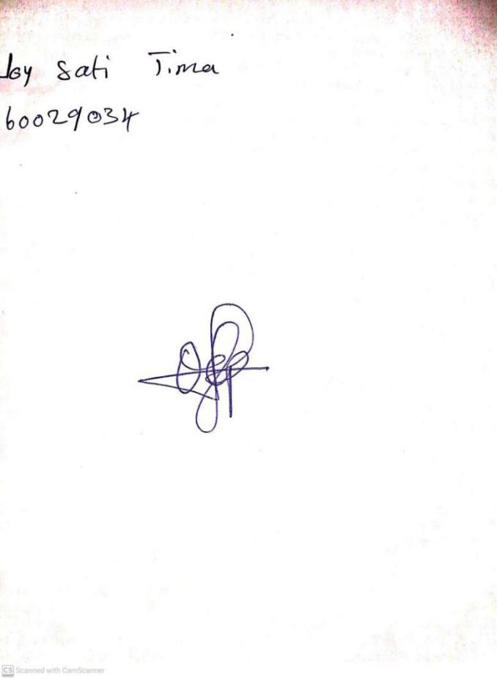

**12TH JANUARY, 2024**

**Perpetual Ojoma Ocheja**

**Stream Head Nursery**