**EMERALD ROYAL INTERNATIONAL SCHOOL MPAPE, ABUJA.**

**LESSON AND PLAN AND NOTE FOR WEEK 9 ENDING 21/06/2024**

**TERM: THIRD**

**WEEK: 9TH**

**DATE: 17/06/2024**

**CLASS: NURSERY 2**

**SUBJECT: NATURE STUDY**

**TOPIC: COLOURS .**

**SUB-TOPIC: MEANING OF COLOUR AND TYPES OF COLOURS**

**PERIOD: 1ST PERIOD AFTER LONG BREAK**

**TIME: 10: 40- 11: 20am**

**DURATION: 40 MINUTES.**

**NUMBER IN CLASS: 13**

**AVERAGE AGE: 5 YEARS.**

**SEX: MIXED.**

**SPECIFIC OBJECTIVES: BY THE END OF THE LESSON,THE PUPILS SHOULD BE**

**ABLE TO:**

1. **EXPLAIN THE MEANING OF COLOURS.**
2. **MENTION THE TYPES OF COLOURS.**
3. **IDENTIFY COLOURS.**

**RATIONALE: FOR PUPILS TO KNOW COLOURS.**

**PREVIOU KNOWLEDGE: PUPILS HAVE BEEN SEEING THINGS WITH DIFFERENT**

**COLOURS.**

**INSTRUCTIONAL MATERIALS: DIFFERED COLOURS OF CHAIRS AND TABLES IN THE**

**CLASSROOM**

**REFERENCE MATERIALS: BASIC SCIENCE AND TECHNOLOGY NURSERY SCHOOLS**

**BOOK 3 BY OPEMIPO DADA.**

**LESSON DEVELOPMENT**

|  |  |  |  |
| --- | --- | --- | --- |
| **STAGES/STEPS** | **TEACHER’S ACTIVITIES** | **PUPILS’ ACTIVITIES** | **LEARNING POINTS** |
| **INTRODUCTION** | **Teacher introduces the lesson by asking the pupils the following question; what colour of chair are you sitting on?** | **Pupils pay attention to the teacher and answer the question ask by the teacher.** | **To prepare pupils minds for the lesson ahead..** |
| **PRESENTATION**  **STEP 1** | **Teacher explains the meaning of colour to pupils and then asks them to repeat after her.** | **Pupils listen attentively to the teacher and repeat after her.** | **For proper understanding .** |
| **STEP 2** | **Teacher mentions the types of colours to pupils and also asks them to repeat after her.** | **Pupils pay attention to the teacher and repeat after her.** | **For better understanding of the lesson.** |
| **STEP 3** | **Teacher guides pupils to identify different colours in the school environment.** | **Pupils listen to the teacher and identify the colours .** | **To enhance pupils participation in class.** |
| **BOARD SUMMARY** | **Teacher summarizes the lesson by writing the whole note of lesson on the board for pupils to copy into their books. Ie COLOURS**  **Colour is the appearance of objects or light sources.**  **TYPES OF COLOURS**   1. **Primary colours** 2. **Secondary colours**   **The primary colours are;**  **Red,blue,yellow. While, The secondary colours are;**  **Orange,green,violet.** | **Pupils copy the note into their exercise books.** | **For onward study.** |
| **EVALUATION** | **Teacher evaluates the lesson by asking the following questions;**   1. **What is colour?** 2. **Mention the types of colours.** 3. **The primary colours are made up of ?** 4. **The secondary colours are made up of?** | **Pupils answer the questions ask by the teacher.** | **To assess pupils level of understanding.** |
| **CONCLUTION** | **Teacher concludes the lesson by marking pupils books.** | **Pupils submit their books for marking.** | **For endorsement.** |
| **ASSIGNMENT** | 1. **What is colours?** 2. **Mention the two types of colours** 3. **What are the primary colours?** 4. **List the secondary colours.** | **Pupils do their assignment at home.** | **To encourage learning at home.** |

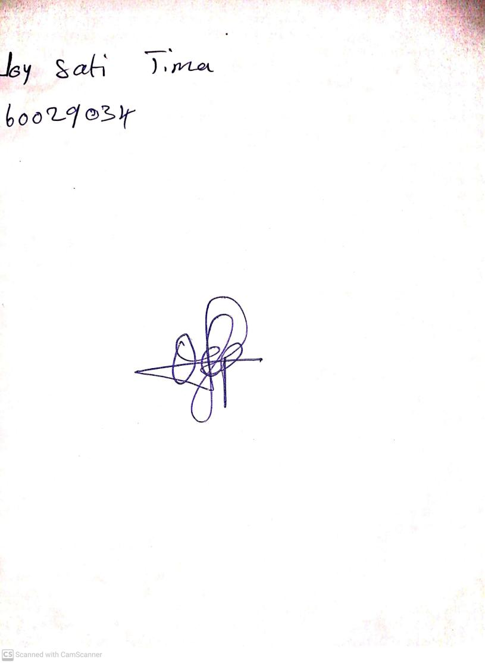

**31ST May, 2024**

**Perpetual Ojoma Ocheja**

**Stream Head Nursery**