**EMERALD ROYAL INTERNATIONAL SCHOOL**

**MPAPE, ABUJA**

**Social Norms 3rd Term Scheme Of Work NURSERY 1**

|  |  |  |
| --- | --- | --- |
| **WEEKS** | **TOPICS** | **CONTENTS** |
| **Week 1** | **Objects in the classroom** | **Define objects in the classroom**  **Name the objects you can find in the classroom.** |
| **Week 2** | **My School** | **Who is the Head Instructor of your school?**  **Who is the Vice-Principal of your school?** |
| **Week 3** | **Table Manners** | **Why it is important to observe a proper table manner.** |
| **Week 4** | **My Environment** | **What can you see in your environment** |
| **Week 5** | **Safety At Home** | **Staying away from sharp objects**  **Avoiding rough plays.** |
| **Week 6** | **Safety At School** | **Staying away from sharp objects in the school** |
| **Week 7** | **My Country** | **What is the name of your country**  **What is the colour of your country’s flag.** |
| **Week 8** | **States in my Country** | **How many states and capital do we have in your country.** |
| **Week 9** | **State in my Country** | **Name the states and capital of your country** |
| **Week 10** | **Love and Respect** | **Showing love and to everyone .** |
| **Week 11** | **Love and Respect** | **Showing respect to everybody.** |
| **Week 12** | **Revision** |  |
| **Week 13** | **Examination.** |  |

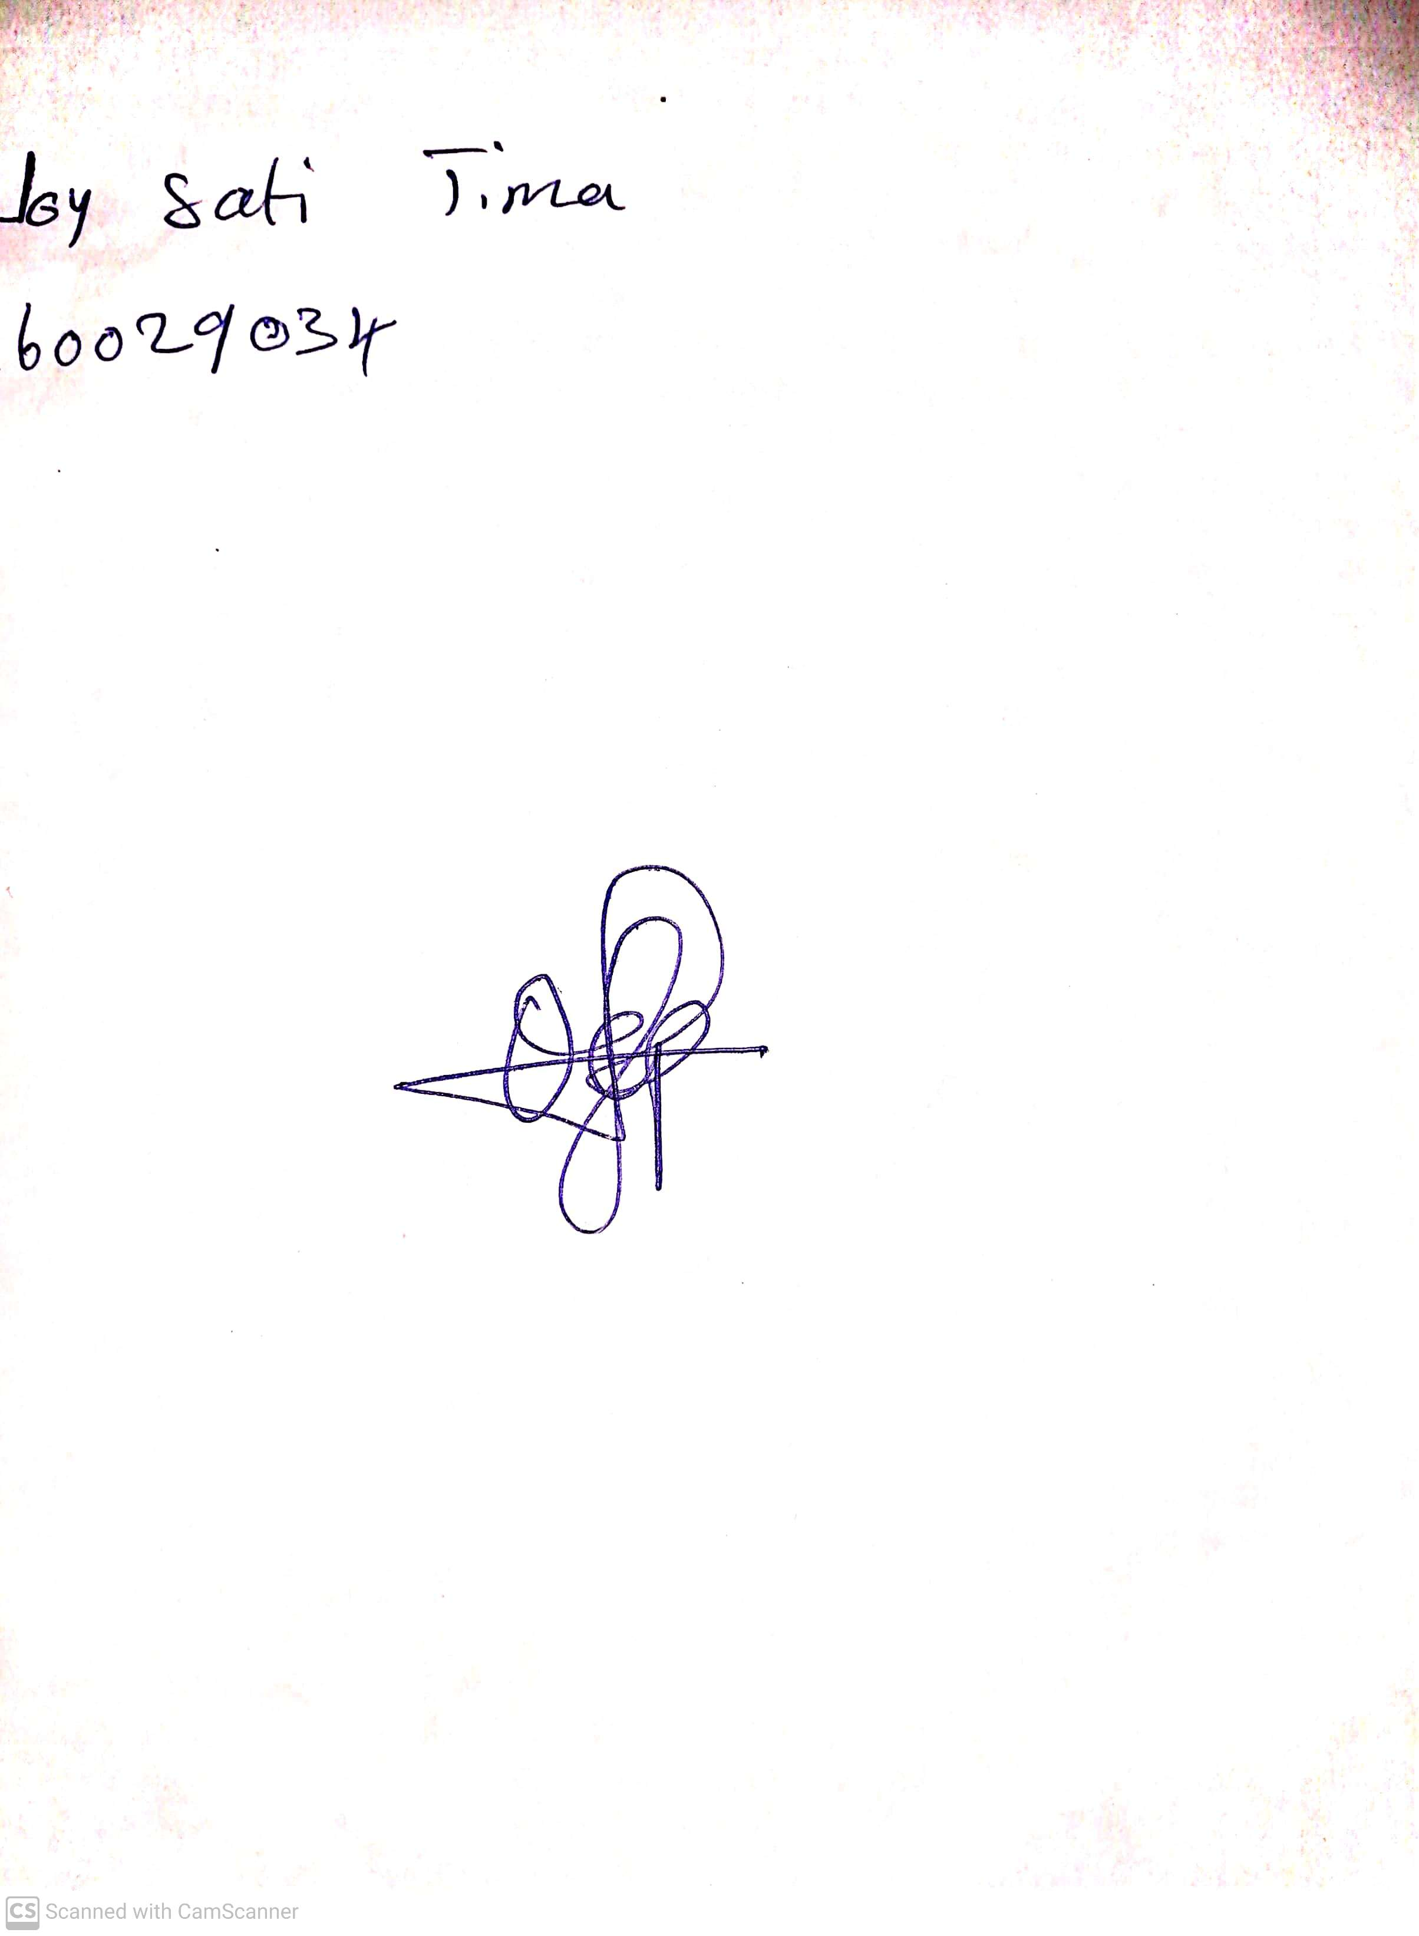

10th May, 2023

Perpetual Ojoma

Stream Head Nursery