**EMERALD ROYAL INTERNATIONAL SCHOOL MPAPE, ABUJA.**

**LESSONS PLAN AND NOTE FOR WEEK 5 ENDING 24th MAY, 2024**

**TERM: 3rd**

**WEEK: 5th**

**DATE: 20/05/2024**

**CLASS: Nursery 2**

**SUBJECT: Nature studies**

**TOPIC: Water: Methods of water purification**

**SUB—TOPIC: Meaning of water and ways of making water clean for drinking.**

**PERIOD: 4th**

**TIME: 10:40—11:20am**

**DURATION: 40 minutes**

**NUMBER IN CLASS: 13**

**AVERAGE AGE: 5 years**

**SEX: Mixed**

**LEARNING OBJECTIVES: By the end of the lesson, the pupils should be able to:**

**1. Define water.**

**2. Mention the ways of making water clean for drinking.**

**RATIONALE: For pupils to know how to make water clean for drinking.**

**PREVIOUS KNOWLEDGE: Pupils have been drinking water on daily bases.**

**INSTRUCTIONAL MATERIALS: Water, alum and filter.**

**REFERENCE MATERIALS: Basic science and technology for Nursery schools book 3 by OPEMIPO DADA.**

**LESSON DEVELOPMENT**

|  |  |  |  |
| --- | --- | --- | --- |
| **Steps** | **Teacher's activities** | **Pupils' activities** | **Learning point** |
| **Introduction** | **Teacher introduces the lesson by asking pupils if it is good to drink dirty water?** | **Pupils answer the question asked by the teacher.** | **To prepare pupils minds for the lesson ahead.** |
| **Presentation step 1** | **Teacher defines water and asks pupils to repeat after her.** | **Pupils listen to the teacher and repeat after her.** | **To improve pupils listening and speaking ability.** |
| **Step 2** | **Teacher mentions the ways of making water clean for drinking and also asks pupils to repeat after her.** | **Pupils pay attention to the teacher and repeat after the teacher.** | **To enhance pupils participation in the class.** |
| **Board summary** | **Teacher writes the whole note of lesson on the board for pupils to copy into their books.**  **WATER**  **Water is a liquid substance that is colourless, odourless and tasteless.**  **WHY WE SHOULD MAKE WATER CLEAN BEFORE DRINKING**  **Drinking dirty water can make us sick.**  **This is why we should make water clean before drinking it.**  **There are simple ways of making water in the home clean for drinking. These are:**  **1. Adding alum to water.**  **2. Boiling water.**  **3. Filtering water.** | **Pupils copy the note into their exercise books.** | **To build pupils writing ability.** |
| **Evaluation** | **Teacher evaluates the lesson by asking pupils the following questions;**  **1. Water is water?**  **2. Mention 3 ways of making water clean for drinking.** | **Pupils answer the questions ask by the teacher.** | **To assess pupils level of understanding.** |
| **Conclusion** | **Teacher concludes the lesson by marking pupils books.** | **Pupils submit their books for marking.** | **For endorsement.** |
| **Assignment** | **Activity 19 page 64. Basic science textbook.** | **Pupils do their assignment at home.** | **To encourage learning at home.** |

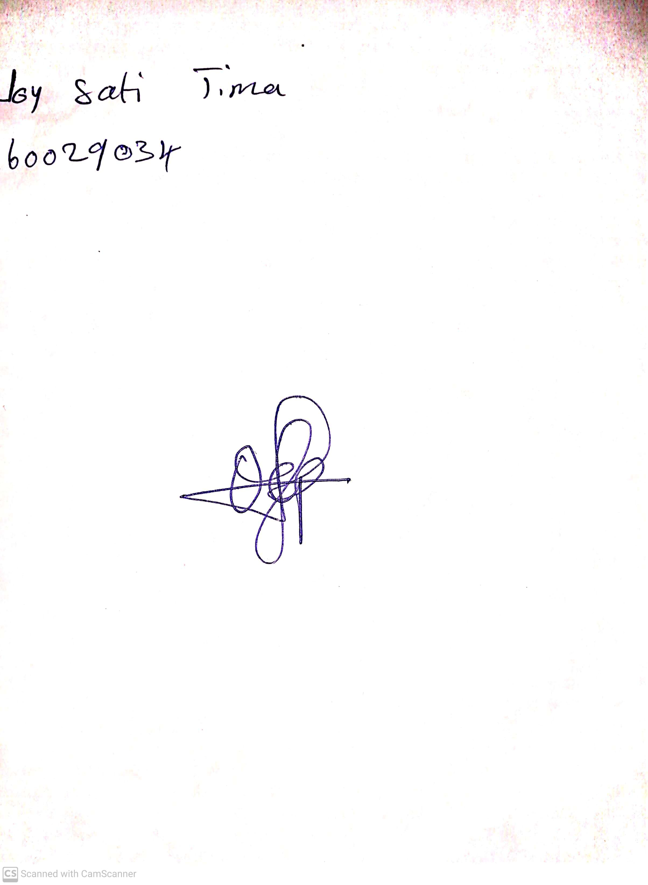

**10th  May, 2024**

**Perpetual Ojoma Ocheja**

**Stream Head Nursery**