**LESSON PLAN FOR WEEK FOUR OF SECOND TERM 2022/2023 SESSION ENDING 3RD FEBRUARY 2023**

**TERM:** SECOND TERM

**WEEK:** WEEK 4

**Subject**: social studies

**Topic:**  common drugs in our community and the right people to give them

**Sub- topic:** practical

**Date:**  10 - 01 - 2023

**Duration:** 40 minutes

**Time:**  10:30 - 11:10

**Period:**  4th

**Class:**  grade 2

**Average age:** 6+

PRACTICAL

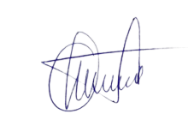

**3RD FEBRUARY 2023**

**DEPUTY HEAD INSTRUCTOR ADMIN**

**NB: NOT APPROVED, SEE ME!**