**EMERALD ROYAL INTERNATIONAL SCHOOL**

**MPAPE, ABUJA.**

**LESSON NOTE FOR WEEK 2 ENDING 22ND SEPTEMBER,2023.**

TERM: 1ST

SUBJECT: Number Work

TOPIC: Counting numbers 1 - 5.

SUB-TOPIC: Identification of numbers 1 and 2

DATE: 18th September, 2023.

DURATION: 40 minutes.

TIME: 08:50--09:30.

PERIOD: 1st

CLASS: Pre-nursery

NUMBER OF PUPILS: 15

AVERAGE AGE: 2 years

SEX: Mixed.

SPECIFIC OBJECTIVES: By the end of the lesson, the pupils should be able to:-

1. Count Numbers 1 - 5
2. Identify numbers 1 and 2

RATIONALE: For pupils to be able to count numbers.

PREVIOUS KNOWLEDGE: Pupils have been seeing objects ( cups,spoons, shoes etc) in their houses but they do not know the number of those objects.

INSTRUCTIONAL MATERIALS: Number chart, flash cards, building blocks etc

REFERENCE MATERIALS: Mastering mathematics for nursery schools book 1 by Henry Idogun.

**LESSON DEVELOPMENT**

|  |  |  |  |
| --- | --- | --- | --- |
| STAGES/STEPS | TEACHER’S ACTIVITIES | PUPILS’ ACTIVITIES | LEARNING POINTS |
| INTRODUCTION | Teacher introduces the lesson by singing a number rhyme for the pupils. | Pupils sing the rhyme along with the teacher. | To arouse pupils interest in the lesson. |
| PRESENTATION  STEP 1 | Teacher counts numbers 1 - 5 for the pupils to repeat after her. | Pupils count numbers 1 - 5 after the teacher. I.e 1 2 3 4 5. | To teach pupils counting of numbers |
| STEP 2 | Teacher writes numbers 1 and 2 boldly on flash cards then identifies the numbers for the pupils. | Pupils identify and colour the numbers  1    2 |  |
| SUMMARY | Teacher counts and point at numbers 1 - 5 I.e  1 2 3 4 5. | Pupils point at the numbers and count after the teacher. | For more understanding of the lesson. |
| EVALUATION | Teacher asks Pupils to count numbers 1 - 5 after her. | Pupils count numbers 1 - 5 after the teacher. | To assess pupils understanding of the lesson. |
| CONCLUSION | Teacher sings a number rhyme for the pupils. | Pupils sing the rhyme along with the teacher. | To improve pupils speaking ability. |
| ASSIGNMENT (HOME WORK) | Count to count numbers 1 - 5  1 2 3 4 5. | Pupils do their assignment at home. | To encourage pupils to learn at home. |

**LESSON NOTE FOR WEEK 2 ENDING 22ND SEPTEMBER, 2023.**

TERM: 1ST

SUBJECT: Number Work

TOPIC: Counting numbers 1 - 5.

SUB-TOPIC: Identification of numbers 3 and 4

DATE: 20th September, 2023.

DURATION: 40 minutes.

TIME: 08:50--09:30.

PERIOD: 2nd

CLASS: Pre-nursery

NUMBER OF PUPILS: 15

AVERAGE AGE: 2 years

SEX: Mixed.

SPECIFIC OBJECTIVES: By the end of the lesson, the pupils should be able to:-

1. Count Numbers 1 - 5

2. Identify numbers 3 and 4

RATIONALE: For pupils to be able to count numbers.

PREVIOUS KNOWLEDGE: Pupils have been seeing objects ( cups,spoons, shoes etc) in their houses but they do not know the number of those objects.

INSTRUCTIONAL MATERIALS: Number chart, flash cards, building blocks etc

REFERENCE MATERIALS: Mastering mathematics for nursery schools book 1 by Henry Idogun.

**LESSON DEVELOPMENT**

|  |  |  |  |
| --- | --- | --- | --- |
| STAGES/STEPS | TEACHER’S ACTIVITIES | PUPILS’ ACTIVITIES | LEARNING POINTS |
| INTRODUCTION | Teacher introduces the lesson by singing a number rhyme for the pupils. | Pupils sing the rhyme along with the teacher. | To arouse pupils interest in the lesson. |
| PRESENTATION  STEP 1 | Teacher counts numbers 1 - 5 for the pupils to repeat after her. | Pupils count numbers 1 - 5 after the teacher. I.e 1 2 3 4 5. | To teach pupils counting of numbers |
| STEP 2 | Teacher writes numbers 3 and 4 boldly on flash cards then identifies the numbers for the pupils. | Pupils point at the numbers and colour the numbers  3 4 | For proper understanding of the lesson. |
| SUMMARY | Teacher counts and point at numbers 1 - 5 I.e  1 2 3 4 5. | Pupils point at the numbers and count after the teacher. | For more understanding of the lesson. |
| EVALUATION | Teacher asks Pupils to point at numbers 3 and 4 on the flash cards. | Pupils point at the numbers. | To assess pupils understanding of the lesson. |
| CONCLUSION | Teacher sings a number rhyme for the pupils. | Pupils sing the rhyme along with the teacher. | To improve pupils speaking ability. |
| ASSIGNMENT (HOME WORK) | Count to count numbers 1 - 5  1 2 3 4 5. | Pupils do their assignment at home. | To encourage pupils to learn at home. |

**LESSON NOTE FOR WEEK 2 ENDING 22ND SEPTEMBER, 2023.**

TERM: 1ST

SUBJECT: Number Work

TOPIC: Counting numbers 1 - 5.

SUB-TOPIC: Identification of numbers 3 and 4

DATE: 21st September, 2023.

DURATION: 40 minutes.

TIME: 08:50--09:30.

PERIOD: 3rd

CLASS: Pre-nursery

NUMBER OF PUPILS: 15

AVERAGE AGE: 2 years

SEX: Mixed.

SPECIFIC OBJECTIVES: By the end of the lesson, the pupils should be able to:-

1. Count Numbers 1 - 5
2. Identify numbers 5

RATIONALE: For pupils to be able to count numbers.

PREVIOUS KNOWLEDGE: Pupils have been seeing objects ( cups,spoons, shoes etc) in their houses but they do not know the number of those objects.

INSTRUCTIONAL MATERIALS: Number chart, flash cards, building blocks etc

REFERENCE MATERIALS: Mastering mathematics for nursery schools book 1 by Henry Idogun.

**LESSON DEVELOPMENT**

|  |  |  |  |
| --- | --- | --- | --- |
| STAGES/STEPS | TEACHER’S ACTIVITIES | PUPILS’ ACTIVITIES | LEARNING POINTS |
| INTRODUCTION | Teacher introduces the lesson by singing a number rhyme for the pupils. | Pupils sing the rhyme along with the teacher. | To arouse pupils interest in the lesson. |
| PRESENTATION  STEP 1 | Teacher counts numbers 1 - 5 for the pupils to repeat after her. | Pupils count numbers 1 - 5 after the teacher. I.e  1 2 3 4 5. | To teach pupils counting of numbers |
| STEP 2 | Teacher writes numbers 5 boldly on flash cards then identifies the numbers for the pupils. | Pupils point at the number and colour the  number  5 | For proper understanding of the lesson. |
| SUMMARY | Teacher counts and point at numbers 1 - 5 I.e  1 2 3 4 5. | Pupils point at the numbers and count after the teacher. | For more understanding of the lesson. |
| EVALUATION | Teacher asks Pupils to point at number 5 on the flash cards. | Pupils point at the number. | To assess pupils understanding of the lesson. |
| CONCLUSION | Teacher sings a number rhyme for the pupils. | Pupils sing the rhyme along with the teacher. | To improve pupils speaking ability. |
| ASSIGNMENT (HOME WORK) | Count to count numbers 1- 5  1 2 3 4 5 | Pupils do their assignment at home. | To encourage pupils to learn at home. |

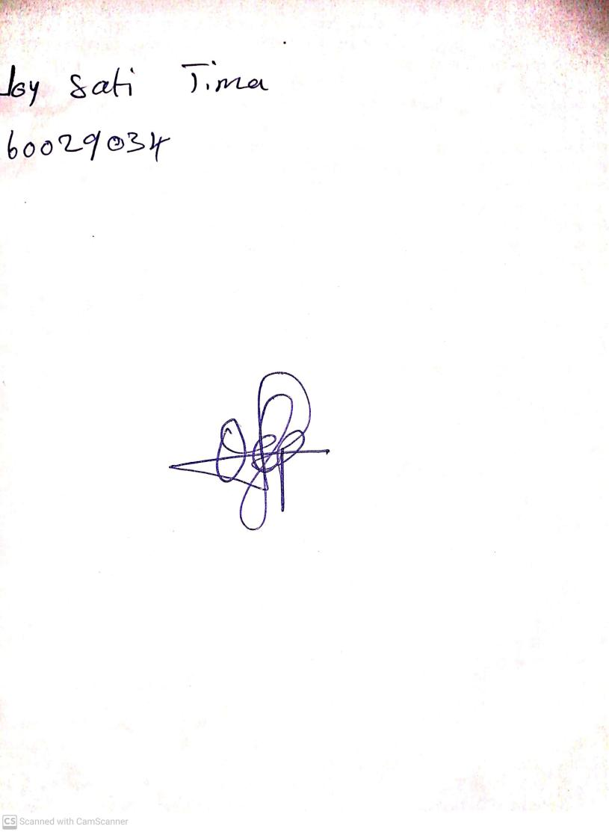

19TH September, 2023

Perpetual Ojoma Ocheja

Stream Head Nursery