**EMERALD ROYAL INTERNATIONAL SCHOOL MPAPE, ABUJA**

**NURSERY 2 (TWO) SCHEME OF WORK**

**1ST TERM**

**RHYME**

|  |  |
| --- | --- |
| **WEEKS** | **TOPIC** |
| **1** | **A B C S song** |
| **2** | **There are seven days in a week** |
| **3** | **Head, shoulders, knees and toes** |
| **4** | **Twinkle, twinkle, little stars.** |
| **5** | **This is the way I brush my teeth** |
| **6** | **I love you, you love me** |
| **7** | **Water melon (2ce)** |
| **8** | **I am a little teapot** |
| **9** | **Revision** |
| **10** | **Examination** |

**EMERALD ROYAL INTERNATIONAL SCHOOL MPAPE, ABUJA**

**NURSERY 2 (TWO) SCHEME OF WORK**

**2ND TERM**

**RHYME**

|  |  |
| --- | --- |
| **WEEKS** | **TOPIC** |
| **1** | **If you are happy and you know** |
| **2** | **Good morning to you** |
| **3** | **My telephone is ringing** |
| **4** | **Hello---, hello----, hello how are you?** |
| **5** | **The wheels on the bus** |
| **6** | **You are my sunshine** |
| **7** | **One little monkey jumping on the bed** |
| **8** | **Yon-key doodle** |
| **9** | **Histle, whistle spider climb up--------** |
| **10** | **Mary had a little lam** |
| **11** | **London bridge is falling down** |
| **12** | **Revision** |
| **13** | **Examination** |

**EMERALD ROYAL INTERNATIONAL SCHOOL MPAPE, ABUJA**

**NURSERY 2 (TWO) SCHEME OF WORK**

**3ND TERM**

**RHYME**

|  |  |
| --- | --- |
| **WEEKS** | **TOPIC** |
| **1** | **I see the moon , the moon sees me** |
| **2** | **I can see the bird standing on a tree** |
| **3** | **They was a farmer who had a dog** |
| **4** | **Traffic light, traffic light** |
| **5** | **The day is bright** |
| **6** | **Row, row, row your boat** |
| **7** | **Rain , rain go away** |
| **8** | **Once I caught my fish alive** |
| **9** | **One two boggle my shoe** |
| **10** | **1,2,3,4,5, once I caught my fish alive** |
| **11** | **Butterfly, butterfly, happy all day** |
| **12** | **Revision** |
| **13** | **Examination** |

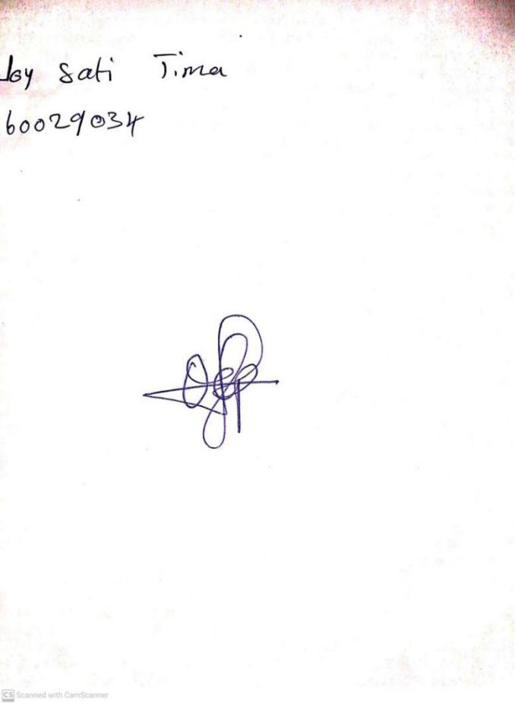

5TH January, 2024

Perpetual Ojoma Ocheja

Stream Head Nursery