**EMERALD ROYAL INTERNATIONAL SCHOOL MPAPE, ABUJA**

**NURSERY 2 (TWO) SCHEME OF WORK**

**1ST TERM**

**LITERACY**

|  |  |  |
| --- | --- | --- |
| **WEEKS** | **TOPICS** | **CONTENT/ACTIVITIES** |
| **1** | **Revision** | **Revision on letter Aa-Zz and two letter words.** |
| **2** | **Three letter words ending in “at, “ad”, “an”, “am”, “ap”.** | **Examples, sad, had, bag, man.** |
| **3** | **Three letter words ending in “ed”, “en”, “et”,”eg”.** | **Examples, bed, led, red, men, hen, den, ten, let, pet, keg, leg, beg.** |
| **4** | **Three letter words ending in “in”, “ip”, “ig”, “ib” etc.** | **Lib, rib, bib, pig, big, pin,fin,sin,win,sip, tip.** |
| **5** | **Three letter words cross-cutting ‘a’, ‘e’, and ‘i’.** | **Three letter words with ‘a’, ‘e’, ‘i’.** |
| **6** | **Simple sentences with three letter words.** | **Sentences with the above three letter words.** |
| **7** | **Three letter words with cvc structure ending in “od”, “og”, “op”, “ot”, “oy”** | **God, nod, rod, dog, log, jog,mop, top, sop, hot, pot, rot, not, boy, joy, toy.** |
| **8** | **Three letter words ending in “ug”, “um”, “un”, “ub”.** | **Hug, bug, rug, rum, gum, sum, fun, tub.** |
| **9** | **Three letter words across the five vowels.** | **Read three letter words across the five vowels a e i o u.** |
| **10** | **Reading exercises on three letter words (rhyming words).** | **Read short passage of three lines on three letter words and answer questions on the passage.** |
| **11** | **Four letter words.** | **Meaning, spelling and reading exercises.** |
| **12-13** | **Revision** |  |
| **14** | **Examination** |  |

**EMERALD ROYAL INTERNATIONAL SCHOOL MPAPE, ABUJA**

**NURSERY 2 (TWO) SCHEME OF WORK**

**2ND TERM**

**LITERACY**

|  |  |  |
| --- | --- | --- |
| **WEEKS** | **TOPICS** | **CONTENT/ACTIVITIES** |
| **1** | **Revision on three letters and four letter words.** | **Spread covers “a e i o u”** |
| **2** | **Initial consonant: Blend 1** | **Examples , ‘bl’, ‘br’, ‘cl’ and ‘cr’** |
| **3** | **Initial consonant: Blend 2** | **Examples , ‘dr’, ‘fl’, ‘fr’.** |
| **4** | **Initial consonant: Blend 3** | **Example, ‘gl’, ‘gr’, ‘pl’ and ‘pr’** |
| **5** | **Initial and final consonant 1** | **Generate words with initial and final consonants ‘pr’, ‘pl’, ‘sl’, ‘mb’, ‘nd’, ‘gh’, ‘pm’.** |
| **6** | **Things in my house and things in my class.** | **Names of things at home and in school for spelling and reading.** |
| **7** | **Initial and final consonants 2** | **‘tr’, ‘tw’, ‘sw’, ‘st’.** |
| **8** | **Consonant Digraphs 1** | **‘ck’, ‘ph’, ‘sh’, ‘ch’.** |
| **9** | **Consonant Digraphs 2** | **Generate and write words with ‘th’, ‘wh’, ‘wr’, ‘mb’.** |
| **10** | **Consonant Trigraphs and Blend.** | **Words with trigraphs and blends ‘scr’, ‘shr’, ‘sch’, ‘thr’, ‘str’, ‘tch’. - screw, shroud, three,strong, scream, shrimp,watch,catch,match, throw, street.** |
| **11** | **Revision** | **Revision** |
| **12-13** | **Examination** | **Examination** |

**EMERALD ROYAL INTERNATIONAL SCHOOL MPAPE, ABUJA**

**NURSERY 2 (TWO) SCHEME OF WORK**

**3RD TERM**

**LITERACY**

|  |  |  |
| --- | --- | --- |
| **WEEKS** | **TOPICS** | **CONTENT/ACTIVITIES** |
| **1** | **Revision** | **Revision of digraphs, trigraphs blends and three letter words.** |
| **2** | **Vowel Digraphs 1** | **"ee”, “ea”, “oo”, -see, feet, sea, look, tea, peak etc.** |
| **3** | **Vowel Digraphs 2** | **"ai”, “ay”, “or”, “aw”, -pay, rain, sport, raw, law, pork, stain,way.** |
| **4** | **Vowel Digraphs 3** | **"ea”, “ie”, “oa”, “oi” -head, chief, boat, coil etc.** |
| **5** | **Vowel Digraphs 4** | **"oy”, “aw”, “ow”, “ou”.**  **Boy, taw, cow, out, toy, maw, now, pout, mouth.** |
| **6** | **Words study: parts of my body.** | **Spelling of parts of the body.** |
| **7** | **Vowel Digraphs 5** | |  | | --- | | **"ie”, “igh”, “y”, “ew”**  **Tie, light, my, new, lie, might, by, few, pie, sight, why, flew.** | |
| **8** | **Common things in the classroom.** | **-write items in classroom**  **-match pictures of items with words.** |
| **9** | **People I know** | **Name people they know both at home and in school.**  **Write names of people mentioned on the board.** |
| **10** | **Revision** |  |
| **11** | **Examination** |  |
| **12 -13** | **END OF SESSION ACTIVITIES** |  |

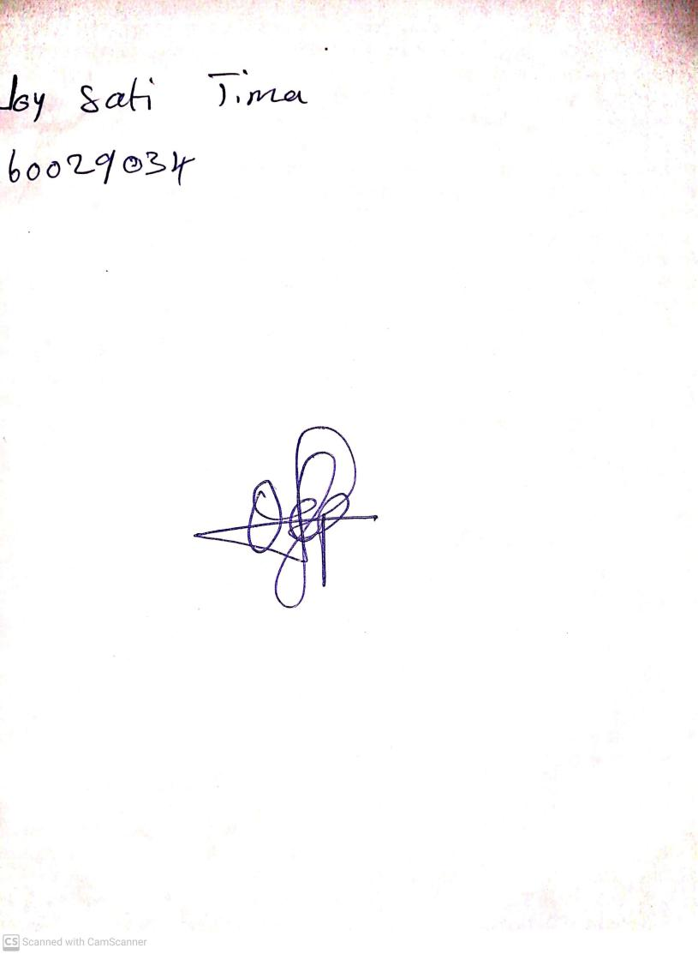

11TH OCTOBER, 2023

Perpetual Ojoma Ocheja

Stream Head Nursery