**EMERALD ROYAL INT’L SCHOOL**

**LESSON PLAN/NOTE FOR WEEK 6 ENDING: 9TH JUNE, 2023**

|  |  |
| --- | --- |
| **Term** | 3rd |
| **Week** | 6 |
| **Date** | 05/06/2023 |
| **Class** | SSS 2 |
| **Subject** | Physics |
| **Topic** | Concept of fields |
| **Sub-topic** | Magnetic fields |
| **Period** | 1 and 2 |
| **Time** | 10:30-11:50 |
| **Duration** | 80minutes |
| **Number in class** | 2 |
| **Average age** | 14years |
| **Sex** | Mixed |
| **Specific objectives** | By the end of the lesson, the students should be able to:   1. Explain the magnetic field 2. Explain the concept magnetism 3. Define the poles of the magnet |
| **Rationale** | To enable the students understand the magnetic field. |
| **Previous knowledge** | Students should have been taught on the concept of fields. |
| **Instructional aid** | One guide sheet for each student, a magnet, lesson note and a text book. |
| **Reference** | * M.W. Anyakoha. New school physics for secondary schools. Africana first publishers PLC. page 423-435 * P.N. Okeke. Macmillan Senior Secondary Physics. Pearson. Page 256-261 |

**LESSON DEVELOPMENT**

|  |  |  |  |
| --- | --- | --- | --- |
| **STEPS** | **TEACHER’S ACTIVITIES** | **STUDENTS’ ACTIVITIES** | **LEARNING POINTS** |
| **Introduction** | The teacher introduces the lesson by explaining that field is a region or space under the influence of some physical agency such as gravitation, magnetism and electricity.  There are two classes of force fields which are the scalar fields and vector fields. A scalar field is one that has only magnitude and no direction, e.g energy, temperature and density. A vector field is a field that has both magnitude and direction, e.g. gravitational, magnetic and electric fields. | The students will differentiate between scalar and vector fields. | To give the students a rudimentary magnetic field. |
| **Step I** | *The magnetic field*  The magnetic field is a region around a magnet in which the influence of the magnet can be felt or detected.  The area around a magnet in which it can attract or repel objects or in which a magnetic force can be detected is called the magnetic field of the magnet. | Begin to develop an idea of magnetic field. | To ensure proper understanding of the lesson. |
| **Step II** | *Magnetism*  A magnet can attract pieces of iron, nickel and cobalt. Such substances that can be attracted by a magnet are known as magnetic substances and this ability of a magnet to attract magnetic substances is called magnetism. | The students listen attentively the teacher’s explanation. | To ensure that all the students are carried along. |
| **STEP III** | *The poles of a magnet*  If we put a bar magnet in a plate of iron filings, on bringing out the bar magnet, it is noticed that the iron-filings cling to the magnet with most of them clinging in heavy bunches or clusters around the ends of the magnet. These ends of the bar magnet where the iron filings concentrate are called the poles of the magnet.  The poles of a magnet is the portion of the magnet where its magnetic attraction appears to be strongest. | The students listen attentively to the teacher’s explanation. | Consolidate acquired knowledge on the magnetic field. |
| **Summary** | A field is a region of space under the influence of some physical agency. Examples of fields are gravitational field, magnetic field and electric field.  A scalar field is a field that has only magnitude but no direction.  A vector field is a field that has both magnitude and direction.  The pole of a magnet is the portion of the magnet where its magnetic attraction appears to be strongest. | The students listen attentively to the teacher’s explanation. | For reference purpose. |
| **Evaluation** | The teacher evaluates the students by giving the students the following classwork.   1. Explain what is meant by a field as used in physics? 2. Distinguish between scalar fields and vector fields. Give two examples of each. | The students answer the question in their science notebook. | To ascertain the students level of understanding of the lesson. |
| **Conclusion** | The teacher makes correction of the classwork. | The students copy the correction in their exercise books. | For reference purpose |
| **Assignment (Homework)** | The teacher gives the students the following assignment.  What do you understand by the poles of a magnet? Using a magnet of known poles, how can you differentiate between the two poles of another magnet?  Which of the following will experience a force when placed in a magnetic field? Glass, plastic, iron, steel pins, paper pieces, aluminium. | The students copy the questions into their exercise books. | To encourage critical thinking of students at home. |

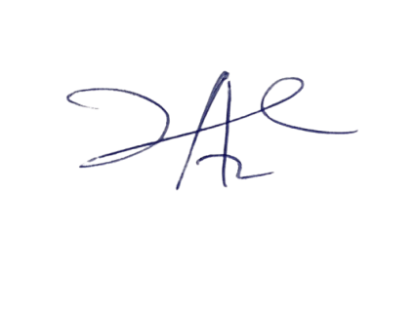

20/7/2023

Principal Head Instuctor