EMERALD ROYAL INTERNATIONAL SCHOOL, MPAPE,ABUJA.

LESSON PLAN FOR WEEK TWO ENDING 19TH JANUARY,2024

|  |  |
| --- | --- |
| TERM | 2nd |
| WEEK | 2 |
| DATE | 16th-19th January,2023 |
| SUBJECT | Social Norms |
| TOPIC | Myself |
| SUB-TOPIC | My Age |
| PERIOD | 1st |
| TIME | 8:10-8:50AM |
| DURATION | 40 Minutes |
| CLASS | Pre-Nursery |
| NO IN CLASS | 11 |
| AVERAGE AGE | 2Years |
| SEX | Mixed |
| LEARNING OBJECTIVES | By the end of the lesson, pupils should be able to:  i.Say their names.  ii.Tell their age. |
| RATIONALE | For the pupils to have self-awareness. |
| PREVIOUS KNOWLEDGE | The Pupils have practice to say their names |
| INSTRUCTIONAL RESOURCES | Pupils in the classroom |
| REFERENCE MATERIAL | **Smart Start Civic Education for Nursery Schools. Book 1.**  T.Y Alabi and A.M Solu. |

LESSON DEVELOPMENT

|  |  |  |  |
| --- | --- | --- | --- |
| STEPS | TEACHER’S ACTIVITIES | PUPILS’ ACTIVITIES | LEARNING POINTS |
| Introduction | The teacher introduces the lesson by singing nursery rhymes for the pupils. | The pupils sing the rhymes along with the teacher. | To get the pupils attention for the presentation. |
| PRESENTATION | The teacher tells the pupils her name while touching her chest, i.e “My name is Mrs Gloria Obule”. The teacher also touches a pupil and calls her name e.g “Your name is Victoria John”. | The pupils repeat after the teacher to point at themselves and say their names. | To improve pupils speaking ability and for them to know how to introduce themselves. |
| Step 2 | The teacher asks the pupils to say their age e.g “I am 2 year old” . | The pupils repeats after the teacher to say their age as “I am 2 years old”. | To enhance pupils speaking ability. |
| Summary | The teacher summarises the lesson by asking the pupils to say their names and age altogether. | The pupils practice to say their names and age. | To ensure better understanding of the lesson. |
| Evaluation | The teacher calls out the pupils one after another and asks them.  -What is your name?  -How old are you? | The pupils respond to the teacher’s questions. | To assess pupils level of understanding. |
| Conclusion | The teacher ends the lesson by playing a video clip for the pupils. | The pupils sit and watches the video. | To increase pupils attention span. |
| Assignment | The teacher communicates to the parents of the pupils to practice with the pupils on how to say their names and age. | The pupils practice to say their names and age at home. | To encourage learning at home. |

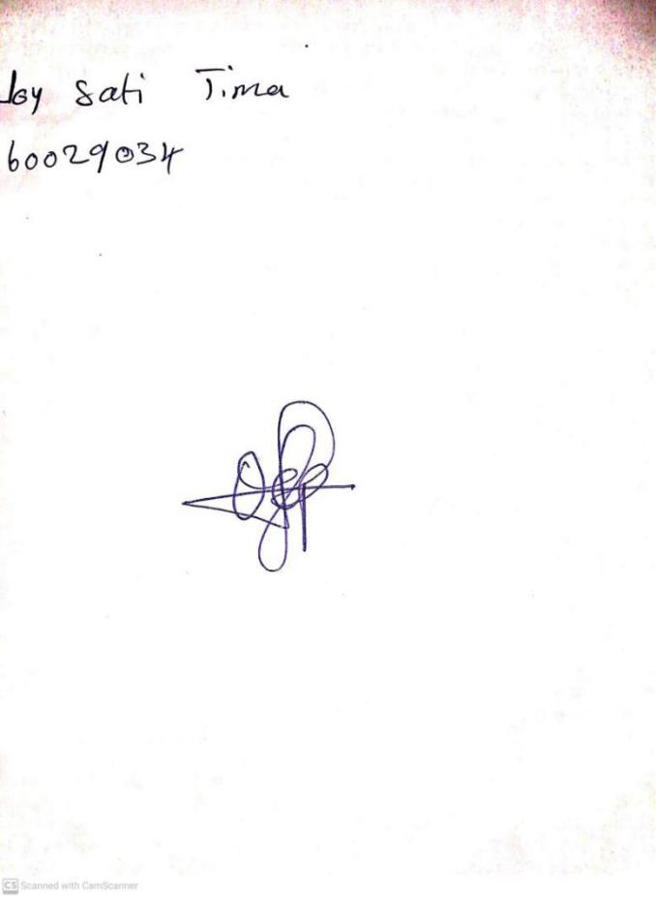

**12TH JANUARY, 2024**

**Perpetual Ojoma Ocheja**

**Stream Head Nursery**