**EMERALD ROYAL INTERNATIONAL SCHOOL**

**MPAPE, ABUJA.**

**LESSON PLAN AND NOTE FOR WEEK 5 PERIOD 1 ENDING 13/10/2023**

TERM: FIRST

WEEK: 5TH

DATE: 09/10/2023

CLASS: NURSERY 2

SUBJECT: NUMBER WORK

TOPIC: COUNTING NUMBER 25 -30 .

SUB-TOPIC: COUNTING AND IDENTIFICATION OF NUMBERS 1-30

PERIOD: 1ST.

TIME: O8:50-09:30.

DURATION: 40 MINUTES.

NUMBER IN CLASS: 14

AVERAGE AGE: 5 YEARS.

SEX: MIXED.

SPECIFIC OBJECTIVES: BY THE END OF THE LESSON,THE PUPILS SHOULD BE ABLE TO:

1. COUNT NUMBER 1-30 ORALLY.
2. IDENTIFY NUMBER 1-30 ON A CHART.

RATIONALE: FOR PUPILS TO BE ABLE TO COUNT SEQUENTIALLY AND IDENTIFY NUMBER 1-30.

PREVIOU KNOWLEDGE: PUPILS HAVE LEARNT COUNTING OF NUMBERS 1-25 IN PREVIOUS LESSON.

INSTRUCTIONAL MATERIALS: NUMBER CHART FROM 1-30.

REFERENCE MATERIALS: THE NEW MASTERING MATHEMATICS FOR NURSERY SCHOOLS BOOK 3 BY HENRY.Z.IDOGUN.

**LESSON DEVELOPMENT**

|  |  |  |  |
| --- | --- | --- | --- |
| STAGES/STEPS | TEACHER’S ACTIVITIES | PUPILS’ ACTIVITIES | LEARNING POINTS |
| INTRODUCTION | Teacher introduces the lesson by singing a number rhyme for the pupils. | Pupils sing the rhyme along with the teacher. | To arouse pupils interest in the lesson. |
| PRESENTATION  STEP 1 | Teacher claps and count number 1-30 and then asks pupils to repeat after her. | Pupils repeat after the teacher by counting number 1-30 while claping their hands. That is; 1 2 3 4 5 6 7 8 9 10 11 12 13 14 15 16 17 18 19 20 21 22 23 24 25 26 27 28 29 30 | To enhance play way method of learning . |
| STEP 2 | Teacher displaceds number chart from 1-30 and then identify and asks pupils to repeat after her | Pupils identify the numbers after the teacher repeatedly. | For better understanding of the lesson. |
| BOARD SUMMARY | Teacher summarizes the lesson by counting the numbers 1-30 on the chart over and over again. | Pupils pay attention to the teacher. | For more understanding of the lesson. |
| EVALUATION | Teacher asks Pupils to:   1. Count numbers 1–30 on the board all together. 2. Identify numbers 1 - 30 on the chart one after the other. | Pupils count and identify the numbers 1 - 30 on the board one after another. | To ascertain if pupils can count and identify numbers 1-30 on their own. |
| CONCLUSION | Teacher ends the lesson by singing a nursery rhyme. | Pupils sing the rhyme along with the teacher. | To improve pupils speaking ability. |
| ASSIGNMENT (HOME WORK) | Identify, count and write numbers 1 -30 | Pupils do their assignment at home. | To encourage learning at home. |

**LESSON PLAN AND NOTE FOR WEEK 5 PERIOD 2 ENDING 13/10/2023**

TERM: FIRST

WEEK: 5TH

DATE: 10/15/2023

CLASS: NURSERY 2

SUBJECT: NUMBER WORK

TOPIC: COUNTING NUMBER 21-30 .

SUB-TOPIC: BACKWARD COUNTING OF NUMBERS 30- 1

PERIOD: 2ND.

TIME: O8:50-09:30.

DURATION: 40 MINUTES.

NUMBER IN CLASS: 14

AVERAGE AGE: 5 YEARS.

SEX: MIXED.

SPECIFIC OBJECTIVES: BY THE END OF THE LESSON,THE PUPILS SHOULD BE ABLE TO:

1. COUNT NUMBER 30-1 BACKWARDLY
2. WRITE NUMBER 30-1

RATIONALE: FOR PUPILS TO KNOW BACKWARD COUNTING OF NUMBERS 30-1

PREVIOU KNOWLEDGE: PUPILS HAVE LEARNT COUNTING OF NUMBERS 1-30 IN PREVIOUS LESSON.

INSTRUCTIONAL MATERIALS: NUMBER FLASH CARDS.

REFERENCE MATERIALS: THE NEW MASTERING MATHEMATICS FOR NURSERY SCHOOLS BOOK 3 BY HENRY.Z.IDOGUN.

**LESSON DEVELOPMENT**

|  |  |  |  |
| --- | --- | --- | --- |
| STAGES/STEPS | TEACHER’S ACTIVITIES | PUPILS’ ACTIVITIES | LEARNING POINTS |
| INTRODUCTION | Teacher introduces the lesson by reviewing the previous lesson. | Pupil listen to the teacher. | To arouse pupils interest for the lesson ahead. |
| PRESENTATION  STEP 1 | Teacher displaceds numbers flash cards on the pupils table from 30-1 counts and then asks pupils to repeat after her. I.e,30 29 28 27 26 25 24 23 22 21 20 19 18 17 16 15 14 13 12 11 10 9 8 7 6 5 4 3 2 1. | Pupils identify and count numbers 30-1 after the teacher. | For proper understanding of the lesson . |
| STEP 2 | Teacher then writes numbers 30-1 on the board for pupils to copy into their exercise books. | Pupils count and copy the numbers into their exercise books. I.e,  30 29 28 27 26 25 24 23 22 21 20 19 18 17 16 15 14 13 12 11 10 9 8 7 6 5 4 3 2 1. | For better understanding of the lesson. |
| BOARD SUMMARY | Teacher summarizes the lesson by going through the lesson on the board over and over again. | Pupils pay attention to the teacher. | For more understanding of the lesson. |
| EVALUATION | Teacher asks Pupils to:   1. count numbers 30 - 1 on the board one after the other. 2. Identify number on flash cards individually. | Pupils count numbers 30 - 1 on the board one after another. | To assess pupils understanding of the lesson. |
| CONCLUSION | Teacher marks pupils books. | Pupils submit their books for marking. | For endorsement. |
| ASSIGNMENT | Identify, count and write numbers 30- 1. | Pupils do their assignment at home. | To encourage learning at home. |

**LESSON PLAN AND NOTE FOR WEEK 5 PERIOD 3 ENDING 13/10/2023**

TERM: FIRST

WEEK: 5TH

DATE: 13/10/2023

CLASS: NURSERY 2

SUBJECT: NUMBER WORK

TOPIC: COUNTING NUMBER 25-30 .

SUB-TOPIC: COUNTING OF NUMBERS 25- 30

PERIOD: 3RD.

TIME: O8:1O- 08:50.

DURATION: 40 MINUTES.

NUMBER IN CLASS: 14

AVERAGE AGE: 5 YEARS.

SEX: MIXED.

SPECIFIC OBJECTIVES: BY THE END OF THE LESSON,THE PUPILS SHOULD BE ABLE TO:

1.COUNT NUMBER 25 - 30

2.WRITE NUMBER 25-30

RATIONALE: FOR PUPILS TO BE ABLE TO COUNT AND WRITE NUMBER 25-30.

PREVIOU KNOWLEDGE: PUPILS HAVE LEARNT BACKWARD COUNTING OF NUMBERS 30-1 IN PREVIOUS LESSON.

INSTRUCTIONAL MATERIALS: NUMBER CHART FROM 25 - 30.

REFERENCE MATERIALS: THE NEW MASTERING MATHEMATICS FOR NURSERY SCHOOLS BOOK 3 BY HENRY.Z.IDOGUN.

**LESSON DEVELOPMENT**

|  |  |  |  |
| --- | --- | --- | --- |
| STAGES/STEPS | TEACHER’S ACTIVITIES | PUPILS’ ACTIVITIES | LEARNING POINTS |
| INTRODUCTION | Teacher introduces the lesson by reviewing the previous lesson. | Pupil listen to the teacher. | To arouse pupils interest for the lesson ahead. |
| PRESENTATION  STEP 1 | Teacher writes numbers 25-30 on the board, counts and then asks pupils to repeat after her. I.e, 25 26 27 28 29 30 | Pupils count numbers 25-30 after the teacher. | For proper understanding of the lesson . |
| STEP 2 | Teacher prepares pupils books for them to count and copy the numbers on the board into their exercise books. | Pupils count and copy the numbers into their exercise books. I.e,  25 26 27 28 29 30 | For better understanding of the lesson. |
| BOARD SUMMARY | Teacher summarizes the lesson by going through the lesson on the board over and over again. | Pupils pay attention to the teacher. | For more understanding of the lesson. |
| EVALUATION | Teacher asks Pupils to:   1. count numbers 25-30 on the board one after the other. 2. Write number 25–30 on the board one after another. | Pupils count numbers 25-30 on the board one after another. | To assess pupils understanding of the lesson. |
| CONCLUSION | Teacher marks pupils books. | Pupils submit their books for marking. | For endorsement. |
| ASSIGNMENT | Identify, and circle number 25-30 amongst others. 4 6 25 21 7 2 26 14 24 8 28 6 9 32 17 15 12 18 19 27 22 29 33 30 03 | Pupils do their assignment at home. | To encourage learning at home. |

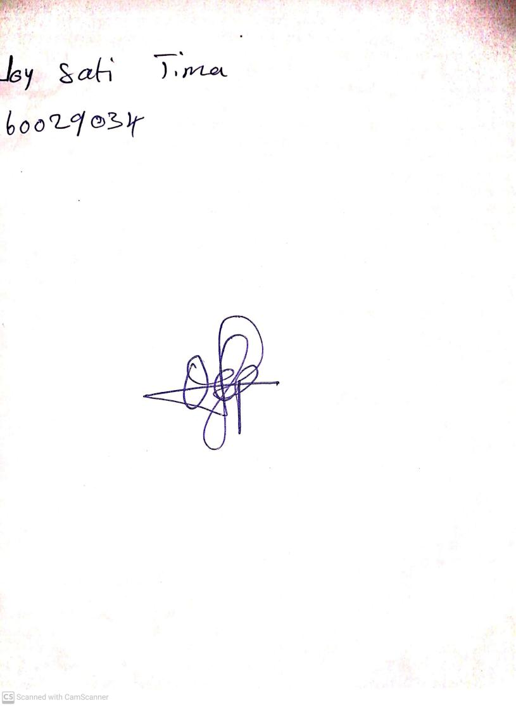

18th September, 2023

Perpetual Ojoma Ocheja

Stream Head Nursery