**EMERALD ROYAL INTERNATIONAL SCHOOL, MPAPE ABUJA**

**LESSON PLAN AND NOTE 1 FOR WEEK 5 ENDING FRIDAY, 13TH OCTOBER, 2023**

**TERM:** FIRST TERM

**WEEK:** WEEK 5

**SUBJECT:** BASIC SCIENCE

**TOPIC:** ROAD

**SUB-TOPIC:** WALKING ALONG THE ROAD

**DATE:** TUESDAY, 10TH AND WEDNESDAY, 11TH OCTOBER, 2023

**TIME:** 08:45 – 09:25AM AND 09:25 – 09:55AM

**DURATION:** 40 MINUTES

**PERIOD:** 2ND AND 3RD

**CLASS:** NURSERY 3

**NUMBER IN CLASS:** ELEVEN

**AVERAGE AGE:** FIVE

**SEX:** MIXED

**LEARNING OBJECTIVES:** By the end of the lesson, the pupils should be able to:

1. State the rules guiding the road.
2. Identify and mention roads signs.

**RATIONALE:** for pupils to learn about how to walk along the road.

**PREVIOUS KNOWLEGDE:** pupils have learnt the types of roads within and outside the school.

**INSTRUCTIONAL MATERIALS:**

1. Flash cards.
2. Road chart.

**REFERENCE MATERIALS:**

Smart Basic Science and Technology book 1 by D. I. Bika, Cambridge University Press

**LESSON DEVELOPMENT**

|  |  |  |  |
| --- | --- | --- | --- |
| **STAGES/STEPS** | **TEACHER’S ACTIVITIES** | **PUPILS’ ACTIVITIES** | **LEARNING POINTS** |
| **INTRODUCTION** | Review previous knowledge | Respond to the teacher | To arouse the pupils’ interest. |
| **PRESENTATION**  **STEP 1** | Teaches and explain the rules guiding the road while walking on the road.  **Rules guiding road users**.   1. Do not walk on the main road but the pavement. 2. Always face the traffic while walking on the road to notice oncoming vehicles. 3. Do not play on the road or run in the middle of the road. 4. Ensure to wear bright colour dress when walking on the road at night. 5. Always observe road signs 6. Do not park vehicles on the road. | States the rules guiding the road. | Rules guiding the road. |
| **STEP 2** | Teaches and explain the meaning of road signs.  **Meaning of road signs**  Road signs are those pictures that guide road users.  **Examples of road signs**   1. Round about   Screenshot_20231015-185552   1. No U turn   Screenshot_20231015-185635   1. Children crossing   Screenshot_20231015-185721   1. Two way   Screenshot_20231015-185816 | Mention the road signs | Roads signs. |
| **SUMMARY** | Summarises the lesson by emphasising on the main concept and writes note on the board | Listen and copy their notes | For onward study |
| **EVALUATION** | Asks pupils to:   1. Mention the rules of the road. 2. Define and give examples of road signs. | Respond to the teacher’s question. | To test the pupils understanding on the lesson. |
| **CONCLUSION** | Summarizes, corrects and mark pupils’ notebooks | Submit their notebooks for marking. | Clarifying the concept. |
| **HOME WORK** | 1. Write out five roads signs you know. | Cope and return with task. | Extending lesson home. |

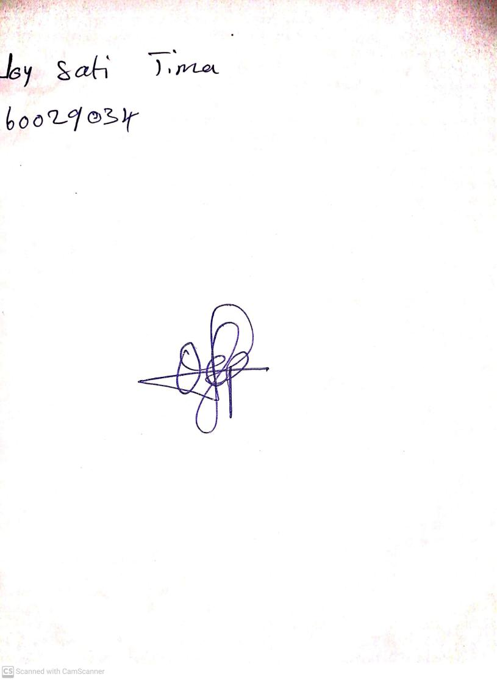

6TH October, 2023

Perpetual Ojoma Ocheja

Stream Head Nursery