**EMERALD ROYAL INTERNATIONAL SCHOOL, MPAPE ABUJA**

**LESSON PLAN AND NOTE 1 FOR WEEK 2 ENDING FRIDAY, 19TH JANUARY, 2024**

**TERM:** FIRST TERM

**WEEK:** WEEK 2

**SUBJECT:** BASIC SCIENCE

**TOPIC:** IDENTIFICATION OF COLOURS

**SUB-TOPIC:** COLOURS OF DIFFERENT OBJECTS

**DATE:** TUESDAY, 16TH ANDWEDNESDAY , 17TH JANUARY, 2024

**TIME:** 08:45– 09:25AM AND 09:25 – 10:55AM

**DURATION:** 40 MINUTES

**PERIOD:** 2ND AND 3RD

**CLASS:** NURSERY 3

**NUMBER IN CLASS:** TWELVE

**AVERAGE AGE:** FIVE

**SEX:** MIXED

**LEARNING OBJECTIVES:** By the end of the lesson, the pupils should be able to:

1. Identify objects and their colours.
2. Draw and colour objects

**RATIONALE:** for pupils to learn different objects and their colours.

**PREVIOUS KNOWLEGDE:** pupils have learnt the meaning of colour and the different types of colour.

**INSTRUCTIONAL MATERIALS:**

1. Colour chart.
2. Textbook.
3. Objects

**REFERENCE MATERIALS:**

1. Smart Basic Science and Technology book 1 by D. I. Bika, Cambridge University Press

|  |  |  |  |
| --- | --- | --- | --- |
| **STAGES/STEPS** | **TEACHER’S ACTIVITIES** | **PUPILS’ ACTIVITIES** | **LEARNING POINTS** |
| **INTRODUCTION** | Review previous knowledge | Respond to the teacher | To arouse the pupils’ interest. |
| **PRESENTATION**  **STEP 1** | Guides the pupils to identify different objects and their colours.  **Objects and their colours**   1. Brown ball 2. Orange cup 3. Red rose flower 4. Green leaf 5. Blue shirt 6. Pink bucket 7. Yellow balloon | Identify the different objects and their colours. | Identification of objects and their colours. |
| **STEP 2** | Guides the pupils to identify and draw different objects and colour them.   1. Brown ball   Screenshot_20240105-082030   1. Orange cup   Screenshot_20240105-083108   1. Red rose flower   Screenshot_20240105-083244   1. Green leaf   Screenshot_20240105-083329   1. Blue shirt   Screenshot_20240105-082103   1. Pink bucket   Screenshot_20240105-083413   1. Yellow balloon   Screenshot_20240105-083543   1. Black cap   Screenshot_20240105-083704   1. White board   Screenshot_20240105-083823   1. Purple dress   Screenshot_20240105-084339 | Draw the different objects identified and colour them. | Identification, drawing and colouring of objects with different colours. |
| **SUMMARY** | Summarises the lesson by emphasising on the main concept and writes note on the board | Listen and copy their notes | For onward study |
| **EVALUATION** | Asks pupils to:   1. Identify the different   types of object and their colours.   1. Draw and colour a ball and a cup | Respond to the teacher’s question. | To test the pupils understanding on the lesson. |
| **CONCLUSION** | Summarizes, corrects and mark pupils’ notebooks | Submit their notebooks for marking. | Clarifying the concept. |
| **HOME WORK** | 1.Write out five (5) different objects and their colours. | Cope and return with task. | Extending lesson home. |

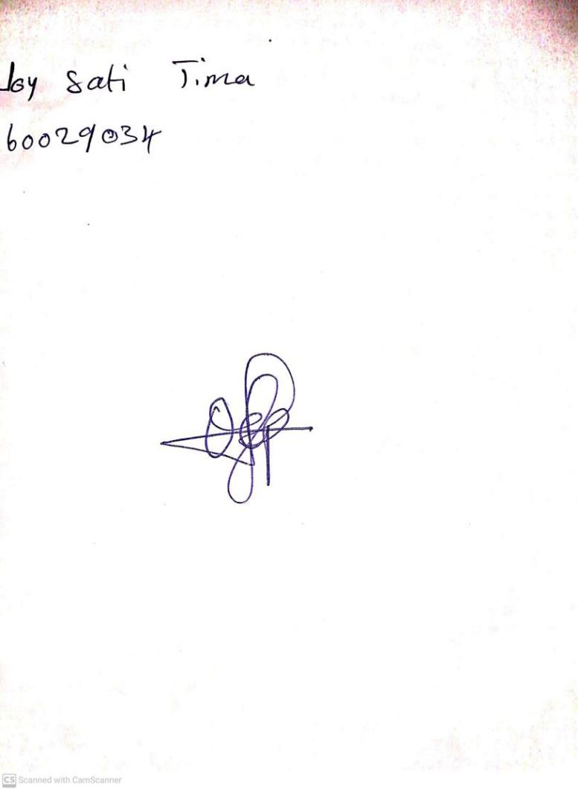

12TH January, 2024

Perpetual Ojoma Ocheja

Stream Head Nursery