**EMERALD ROYAL INTERNATIONAL SCHOOL**

**MPAPE, ABUJA.**

**LESSON PLAN AND NOTE FOR WEEK 4 ENDING 04/10/2024**

**TERM: 1st**

**WEEK: 4th**

**DATE: 30/09/2024**

**CLASS: Nursery 2**

**SUBJECT: Nature studies**

**TOPIC: Body care for cuts.**

**SUB—TOPIC: Meaning of cut and reasons for caring or cuts.**

**PERIOD: 4th**

**TIME: 10:40—11:20am**

**DURATION: 40 minutes**

**NUMBER IN CLASS: 14**

**AVERAGE AGE: 5 years**

**SEX: Mixed**

**LEARNING OBJECTIVES: By the end of the lesson, the pupils should be able to:**

1. **Explain the meaning of cut.**
2. **Mention the first aid treatment for cuts**

**3. State the reasons for caring for cuts.**

**RATIONALE: For pupils to know why we should always care for our wounds.**

**PREVIOUS KNOWLEDGE: Pupils have learnt how to care for their body in Previous lesson.**

**INSTRUCTIONAL MATERIALS: cotton wool, water and bandage.**

**REFERENCE MATERIALS: Basic science and technology for Nursery schools book 3 by OPEMIPO DADA.**

**LESSON DEVELOPMENT**

|  |  |  |  |
| --- | --- | --- | --- |
| **Steps** | **Teacher's activities** | **Pupils' activities** | **Learning point** |
| **Introduction** | **Teacher introduces the lesson by reviewing the previous lesson.** | **Pupils pay attention to the teacher.** | **To prepare pupils minds for the lesson ahead.** |
| **Presentation step 1** | **Teacher explains the meaning of cut to pupils and then asks them to repeat after her.** | **Pupils listen to the teacher and repeat after her.** | **To improve pupils listening and speaking ability.** |
| **Step 2** | **Teacher mentions the first aid treatment for cuts to pupils and also asks them to repeat after her.** | **Pupils listen very attentively to the teacher and repeat after her.** | **To improve pupils speaking ability.** |
| **Step 3** | **Teacher States the reasons why we should care for cut to pupils and also asks them to repeat after her.** | **Pupils pay attention to the teacher and repeat her.** | **To enhance pupils participation in the class.** |
| **Board summary** | **Teacher writes the whole note of lesson on the board for pupils to copy into their books. That is;**  **Body care for cuts:**  **A cut is an opening on the body made with a sharp object like a knife, scissors or razor blade.**  **Sample first aid treatment for cuts:**   1. **Stop the bleeding by pressing on the cut with a clean cloth.** 2. **Wash the cut with warm water.** 3. **Clean the cut with cotton wool soaked in iodine or antiseptic wash.** 4. **Cover the cut with a plaster or bandage.**   **Why we care for cut:**   1. **To reduce the risk of infections.** 2. **To stop the bleeding.** 3. **To promote healing etc.** | **Pupils copy the note into their exercise books.** | **For onward study.** |
| **Evaluation** | **Teacher evaluates the lesson by asking pupils the following questions;**   1. **What is a cut?** 2. **Mention the first aid treatment for cuts.** 3. **What are the reasons why we care for cut?** | **Pupils answer the questions asked by the teacher.** | **To assess pupils level of understanding.** |
| **Conclusion** | **Teacher concludes the lesson by marking pupils books.** | **Pupils submit their books for marking.** | **For endorsement.** |
| **Assignment** | 1. **Define wound.** 2. **Mention at least 5 first aid treatment for wounds.** | **Pupils do their assignment at home.** | **To encourage learning at home.** |

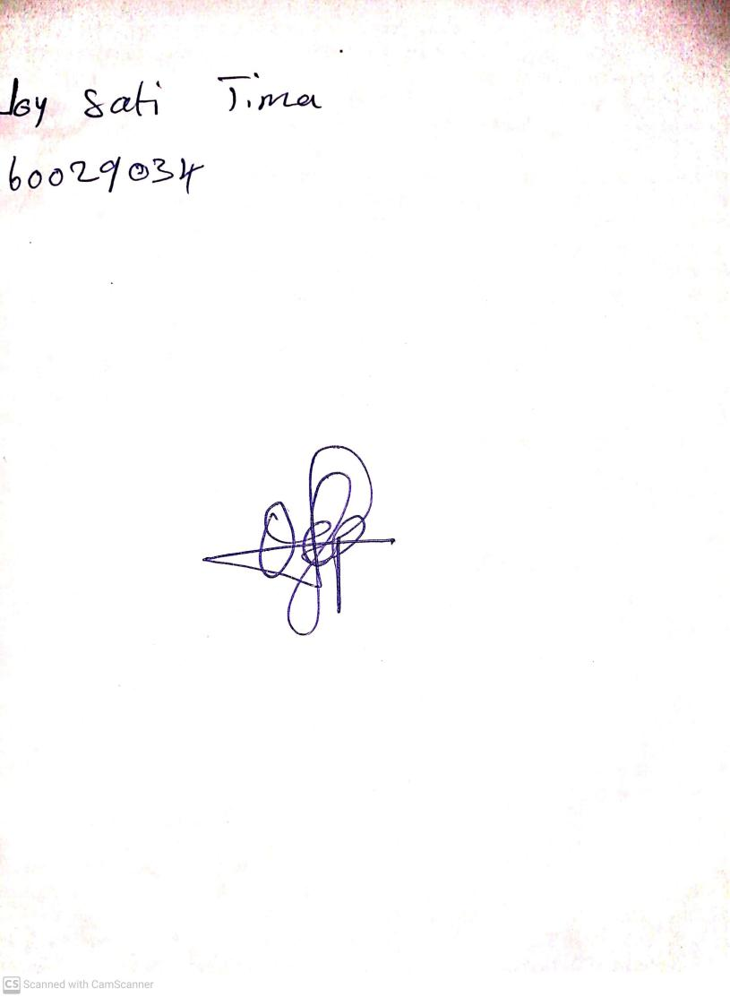

**27th September,2024**

**Perpetual Ojoma Ocheja**

**Stream Head Nursery**