**LESSON PLAN AND NOTE FOR WEEK 7 ENDING 23/02/2024**

**Term 2nd term**

**Week 7th week**

**Date 21st February,2024**

**Class Nursery one**

**Subject Nature Studies.**

**Topic Fruits & Vegetables.**

**Sub-topic Meaning & Importance of fruits & vegetables.**

**Period 2nd period**

**Time 9:05 am**

**Duration 35 minutes**

**No in class 15**

**Average Age 3 years**

**Sex Mixed.**

**Specific Objectives: By the end of the lesson, the pupils should be able to:**

1. **Explain fruits & vegetables.**
2. **Mention importance of fruits & vegetables.**

**Rationale: To make the pupils have vital knowledge of fruits & vegetables.**

**Previous Knowledge The pupils have knowledge of water.**

**Instructional Resources: Online research.**

**Reference Material: Online research, chart, Elementary science by Showers Kiddies.**

**LESSON PRESENTATION**

|  |  |  |  |
| --- | --- | --- | --- |
| **Steps** | **Teacher’s Activities** | **Pupils’ Activities** | **Learning Points** |
| **Introduction** | **The teacher introduces the topic (fruits & vegetables) by showing the pupils pictures of different kinds of fruits & vegetables.** | **The pupils listen to the teacher attentively and identify the different kinds of fruits & vegetables** | **To arouse the interest of the pupils.** |
| **Step 1** | **The teacher starts the lesson by teaching the pupils the meaning of fruits & vegetables ‘’as a nutritional, healthy substance we should eat everyday to live well’’.** | **The pupils listen attentively to the teacher and repeats over again the meaning of fruits & vegetables.** | **To ensure they know the meaning of fruits & vegetables.** |
| **Step 2** | **The teacher mention the importance of eating fruits & vegetables such as:**   1. **It makes us healthy.** 2. **It heals sickness faster than drugs.** 3. **It makes us glow and shine.** 4. **It makes us strong.** | **The pupils listen attentively to the teacher and repeats after the teacher the importance of fruits & vegetables.** | **To add to their knowledge the importance of fruits & vegetables.** |
| **Summary** | **The teacher summarizes the lesson by defining fruits & vegetables.** | **The pupils knows the definition of fruits & vegetables.** | **For better understanding of the pupils.** |
| **Evaluation** | **Question:**   1. **Mention 2 importance of fruits & vegetables.** 2. **Define fruits & vegetables.** | **The pupils answer the question correctly.** | **To ascertain the pupils’ understanding of the lesson.** |
| **Conclusion** | **The teacher applaud the pupils for their activeness.** | **The pupils applaud themselves for their activeness.** | **To make the pupils eager to learn more.** |
| **Assignment** | **Question:**   1. **Define fruits & vegetables?** 2. **Mention 3 importance of fruits & vegetables.** | **The pupils copy and do their homework at home.** | **To encourage learning while at home.** |

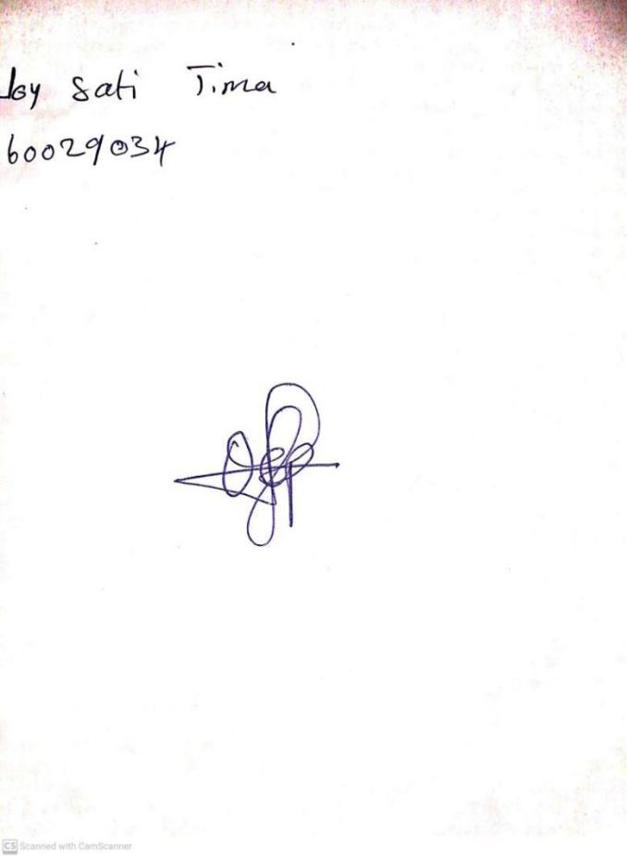

16TH February, 2024

Perpetual Ojoma Ocheja

Stream Head Nursery