**EMERALD ROYAL INTERNATIONAL SCHOOL**

**MPAPE, ABUJA.**

**LESSON PLAN AND NOTE FOR WEEK 1 ENDING 15/09/2023**

TERM: FIRST

WEEK: 1ST

DATE: 11/09/2023

CLASS: NURSERY 2

SUBJECT: SOCIAL NORMS

TOPIC: MY RIGHT .

SUB-TOPIC: MEANING AND EXAMPLES OF HUMAN RIGHT.

PERIOD: 2ND PERIOD AFTER LONG BREAK

TIME: 11: 20- 12: 00PM

DURATION: 40 MINUTES.

NUMBER IN CLASS: 14

AVERAGE AGE: 5 YEARS.

SEX: MIXED.

SPECIFIC OBJECTIVES: BY THE END OF THE LESSON,THE PUPILS SHOULD BE ABLE TO:

1. EXPLAIN THE MEANING OF RIGHT
2. STATE THE EXAMPLES OF HUMAN RIGHT

RATIONALE: FOR PUPILS TO KNOW THE MEANING AND IMPORTANT OF RIGHT

PREVIOU KNOWLEDGE: PUPILS HAVE BEEN GIVEN THE RIGHT TO EDUCATION

INSTRUCTIONAL MATERIALS: PICTURES OF FOOD, ANDCHILDREN GOING TO SCHOOL

REFERENCE MATERIALS: GOOGLE.COM

**LESSON DEVELOPMENT**

|  |  |  |  |
| --- | --- | --- | --- |
| STAGES/STEPS | TEACHER’S ACTIVITIES | PUPILS’ ACTIVITIES | LEARNING POINTS |
| INTRODUCTION | Teacher introduces the lesson by singing nursery rhymes. | Pupils sing the rhymesafter the teacher. | To arouse pupils interest for the lesson ahead. |
| PRESENTATION  STEP 1 | Teacher explains the meaning of right to pupils and then asks them to repeat after her. | Pupils listen attentively to the teacher and repeat after her. | For proper understanding . |
| STEP 2 | Teacher states the examples of human right to pupils and also asks them to repeat after her. | Pupils pay attention to the teacher and repeat after her. | For better understanding of the lesson. |
| BOARD SUMMARY | Teacher summarizes the lesson by writing the whole note of lesson on the board for pupils to copy into their books. Ie,  My right  A right is something a person has which people think should not be taken away.  It is a rule about what a person is allowed to do or have.  Human rights include:   1. The right to life and liberty 2. The right to freedom from slavery and torture 3. The right to freedom of opinion and expression. 4. The right to work and education. 5. The right to health 6. The right to name and nationality. | Pupils copy the note into their exercise books. | For onward study. |
| EVALUATION | Teacher evaluates the lesson by asking the following questions;   1. What is right? 2. State the human right. | Pupils answer the questions ask by the teacher. | To assess pupils level of understanding. |
| CONCLUSION | Teacher concludes the lesson by marking pupils books. | Pupils submit their books for marking. | For endorsement. |
| ASSIGNMENT | 1. What is child abuse? 2. Mention 3 examples of child abuse. | Pupils do their assignment at home. | To encourage learning at home. |

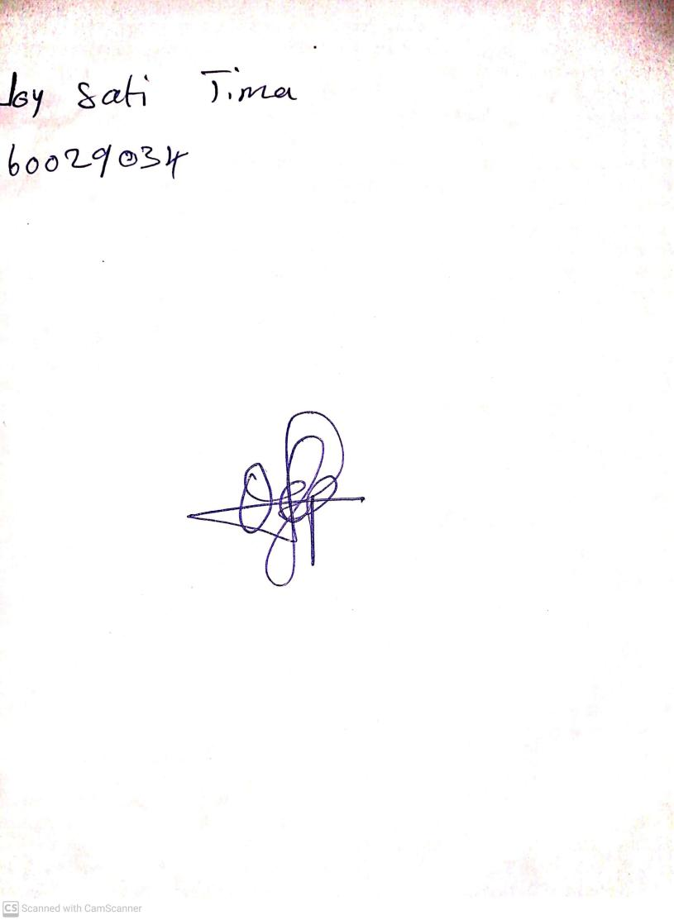

18th September, 2023

Perpetual Ojoma Ocheja

Stream Head Nursery