**LESSON PLAN AND NOTE 1 FOR WEEK 3 ENDING 29/09/2023**

**Term 1st term**

**Week 3rd week**

**Date 26th September,2023**

**Class Nursery One**

**Subject Number Work**

**Topic Counting numbers 1-35.**

**Sub-topic Count numbers 25-30**

**Period 2nd period**

**Time 8:50am**

**Duration 35 minutes**

**No in class 15**

**Average Age 3 years**

**Sex Mixed**

**Specific Objectives: By the end of the lesson ,the pupils should be able to:**

1. **Count numbers 25-30.**
2. **Identify numbers 25-30.**
3. **Write numbers 25-30.**

**Rationale: To make sure the pupils count numbers 1-35.**

**Previous Knowledge: The pupils can match and fill in missing numbers.**

**Instructional Resources: Chart, board, marker, etc.**

**Reference Material: The new mastering mathematics.**

**LESSON PRESENTATION**

|  |  |  |  |  |
| --- | --- | --- | --- | --- |
| **Steps** | **Teacher’s Activities** | **Pupils’ Activities** | | **Learning Points** |
| **Introduction** | **The teacher introduces the topic (counting numbers 1-35) to the pupils by rhyming it.** | **The pupils with the teacher rhyme the numbers 1-35.** | | **To arouse the pupils’ interest.** |
| **Step 1** | **The teacher assists the pupils to count numbers 25-30.**  **25 26 27**  **28 29 30** | **The pupils counts numbers 25-30 with their teacher.** | **For proper understanding.** | |
| **Step 2** | **The teacher leads the pupils to identify numbers 25-30**  **29 27 25**  **30 28 26** | **The pupils participate with the teacher in identifying numbers 25-30.**  **29 27 25**  **30 28 26** | **For better understanding.** | |
| **Step 3** | **The teacher guides the pupils to write numbers 25-30 inside their notebooks.** | **The pupils write numbers 25-30 as the teacher guides them.** | **For further understanding** | |
| **Summary** | **The teacher summarizes the lesson by counting numbers 25-30.** | **The pupils have master and count numbers 25-30.** | **For onward study.** | |
| **Evaluation** | **Count numbers 25-30.**  **25 26 27**  **28 29 30**  **Identify numbers 25-30.**  **Write numbers 25-30 inside their notebooks.** | **The pupils answers the question correctly.** | **To ascertain the pupils’ understanding.** | |
| **Conclusion** | **The teacher summarizes, reacts and corrects the lesson.** | **The pupils answers to the teacher’s questions** | **To consolidate the lesson** | |
| **Assignment** | **Count numbers 25-30.**  **25 26 27**  **28 29 30**  **Identify numbers 25-30.**  **Write the following numbers below**   |  |  | | --- | --- | | **25** | **26** | |  |  | | **27** | **28** | |  |  | | **29** | **30** | |  |  | | **The pupils copy and do their homework at home.** | **To encourage learning while at home.** | |

**LESSON PLAN AND NOTE 2 FOR WEEK 3 ENDING 29/09/2023**

**Term 1st term**

**Week 3rd week**

**Date 27th September,2023**

**Class Nursery One**

**Subject Number Work**

**Topic Counting numbers 1-35.**

**Sub-topic Count numbers 30-35**

**Period 4th period**

**Time 10:40 am**

**Duration 35 minutes**

**No in class 15**

**Average Age 3 years**

**Sex Mixed**

**Specific Objectives: By the end of the lesson ,the pupils should be able to:**

1. **Count numbers 30-35.**
2. **Identify numbers 30-35.**
3. **Write numbers 30-35.**

**Rationale: To make sure the pupils count numbers 1-35.**

**Previous Knowledge: The pupils knows how to count numbers 25-30.**

**Instructional Resources: Chart, board, marker, etc.**

**Reference Material: The new mastering mathematics.**

**LESSON PRESENTATION**

|  |  |  |  |
| --- | --- | --- | --- |
| **Steps** | **Teacher’s Activities** | **Pupils’ Activities** | **Learning Points** |
| **Introduction** | **The teacher introduces the topic (counting numbers 1-35) to the pupils by rhyming it.** | **The pupils with the teacher rhyme the numbers 1-35.** | **To arouse the pupils’ interest.** |
| **Step 1** | **The teacher assists the pupils to count numbers 30-35**  **30 31 32**  **33 34 35** | **The pupils counts numbers 30-35 with their teacher.** | **For proper understanding.** |
| **Step 2** | **The teacher leads the pupils to identify numbers 30-35**  **35 32 31**  **30 34 33** | **The pupils participate with the teacher in identifying numbers 30-35.**  **35 32 31**  **30 34 33** | **For better understanding.** |
| **Step 3** | **The teacher guides the pupils to write numbers 30-35 inside their notebooks.** | **The pupils write numbers 30-35 as the teacher guides them.** | **For further understanding** |
| **Summary** | **The teacher summarizes the lesson by counting numbers 30-35** | **The pupils have master and count numbers 30-35.** | **For onward study.** |
| **Evaluation** | **Count numbers 30-35**  **30 31 32**  **33 34 35**  **Identify numbers 30-35.**  **Write numbers 30-35 inside their notebooks.** | **The pupils answers the question correctly.** | **To ascertain the pupils’ understanding.** |
| **Conclusion** | **The teacher summarizes, reacts and corrects the lesson.** | **The pupils gives answers to the teacher’s questions** | **To consolidate the lesson** |
| **Assignment** | **Count numbers 30-35**  **30 31 32**  **33 34 35**  **Identify numbers 30-35.**  **Write the following numbers below**   |  |  | | --- | --- | | **30** | **31** | |  |  | | **32** | **33** | |  |  | | **34** | **35** | |  |  | | **The pupils copy and do their homework at home.** | **To encourage learning while at home.** |

**LESSON PLAN AND NOTE 3 FOR WEEK 3 ENDING 29/09/2023**

**Term 1st term**

**Week 3rd week**

**Date 28th September,2023**

**Class Nursery One**

**Subject Number Work**

**Topic Counting numbers 1-35.**

**Sub-topic Matching numbers 25-35**

**Period 2nd period**

**Time 8:50 am**

**Duration 35 minutes**

**No in class 15**

**Average Age 3 years**

**Sex Mixed**

**Specific Objectives: By the end of the lesson ,the pupils should be able to:**

1. **Match numbers 25-35.**
2. **Fill in the numbers 25-35.**

**Rationale: To make sure the pupils match numbers 1-35.**

**Previous Knowledge: The pupils knows numbers 20-30.**

**Instructional Resources: Chart, board, marker, etc.**

**Reference Material: The new mastering mathematics.**

**LESSON PRESENTATION**

|  |  |  |  |
| --- | --- | --- | --- |
| **Steps** | **Teacher’s Activities** | **Pupils’ Activities** | **Learning Points** |
| **Introduction** | **The teacher introduces the topic (counting numbers 1-35) to the pupils by rhyming it.** | **The pupils with the teacher rhyme the numbers 1-35.** | **To arouse the pupils’ interest.** |
| **Step 1** | **The teacher assists the pupils to match numbers 25-35**  **25 35**  **26 34**  **27 33**  **28 32**  **29 31**  **30 30**  **31 29**  **32 28**  **33 27**  **34 26**  **35 25** | **The pupils match numbers 25-35 with their teacher.**  **25 35**  **26 34**  **27 33**  **28 32**  **29 31**  **30 30**  **31 29**  **32 28**  **33 27**  **34 26**  **35 25** | **For proper understanding.** |
| **Step 2** | **The teacher leads the pupils to fill in the numbers 25-35**  **25 ____ 27 ______ 29**  **____ 31 ____ 33 ____**  **35** | **The pupils participate with the teacher in filling in the missing numbers 25-35.**  **25 26 27**  **28 29 30**  **31 32 33**  **34 35** | **For better understanding.** |
| **Summary** | **The teacher summarizes the lesson by counting numbers**  **25-35** | **The pupils have master and count numbers 25-35.** | **For onward study.** |
| **Evaluation** | **Fill in the numbers 25-35**  **25 ____ 27 ______ 29**  **____ 31 ____ 33 ____**  **35**  **Count numbers 25-35.**  **Match numbers 25-35**  **25 35**  **26 34**  **27 33**  **28 32**  **29 31**  **30 30**  **31 29**  **32 28**  **33 27**  **34 26**  **35 25** | **The pupils answers the question correctly.** | **To ascertain the pupils’ understanding.** |
| **Conclusion** | **The teacher summarizes, reacts and corrects the lesson.** | **The pupils gives answers to the teacher’s questions** | **To consolidate the lesson** |
| **Assignment** | **Match numbers 25-35**  **25 35**  **26 34**  **27 33**  **28 32**  **29 31**  **30 30**  **31 29**  **32 28**  **33 27**  **34 26**  **35 25**  **Fill in the missing numbers below**  **21 ____ 23 ____ 25**  **____27 ____ 29 ____**  **31 ___ 33 ____ 35** | **The pupils copy and do their homework at home.** | **To encourage learning while at home.** |

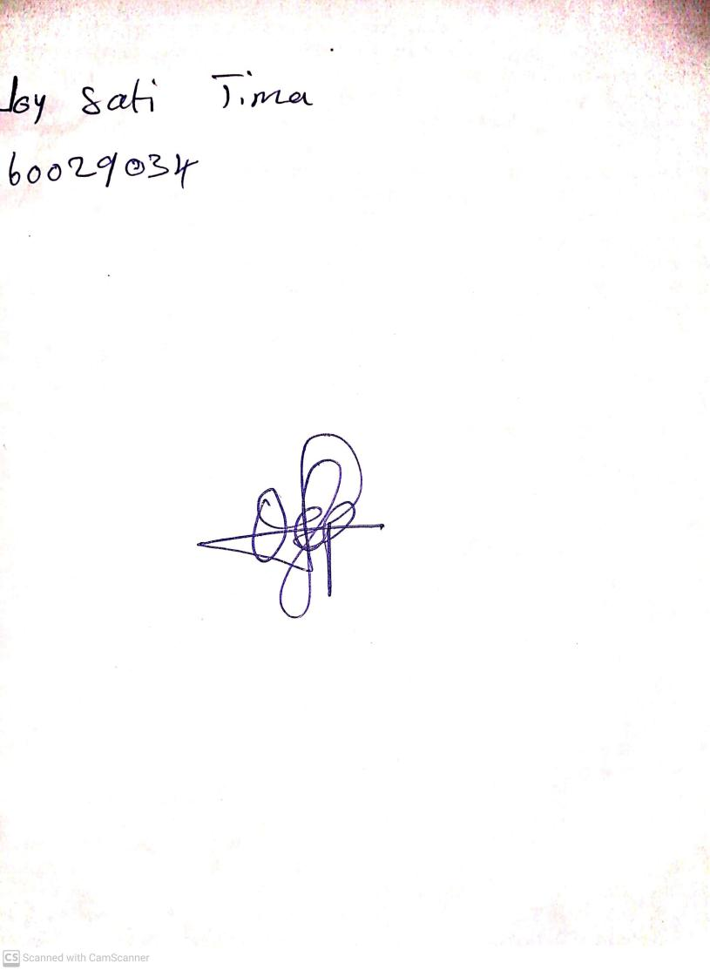

15th August, 2023

Perpetual Ojoma Ocheja

Stream Head Nursery