**EMERALD ROYAL INTERNATIONAL SCHOOL**

**MPAPE ABUJA**

**PRE-NURSERY SCHEME OF WORK ON SOCIAL** NORMS THIRD TERM

**WEEK 1**:- Being friendly.

**WEEK 2:**- Myself- Name,age and gender.

**WEEK 3**:- People that helps us in our society.

**WEEK 4:-** My classroom.

**WEEK 5:-** My classroom

**WEEK 6**:- People and their profession.

**WEEK 7**:- People and their profession.

**WEEK 8:**- Our environment.

**WEEK 9:-** Our environment.

**WEEK 10**:- Conflict resolution- hurting someone is bad.

**WEEK 11:**- Conflict resolution- saying I am sorry when you hurt someone.

**WEEK 12:**- Revision.

**WEEK 13**:- Examination.

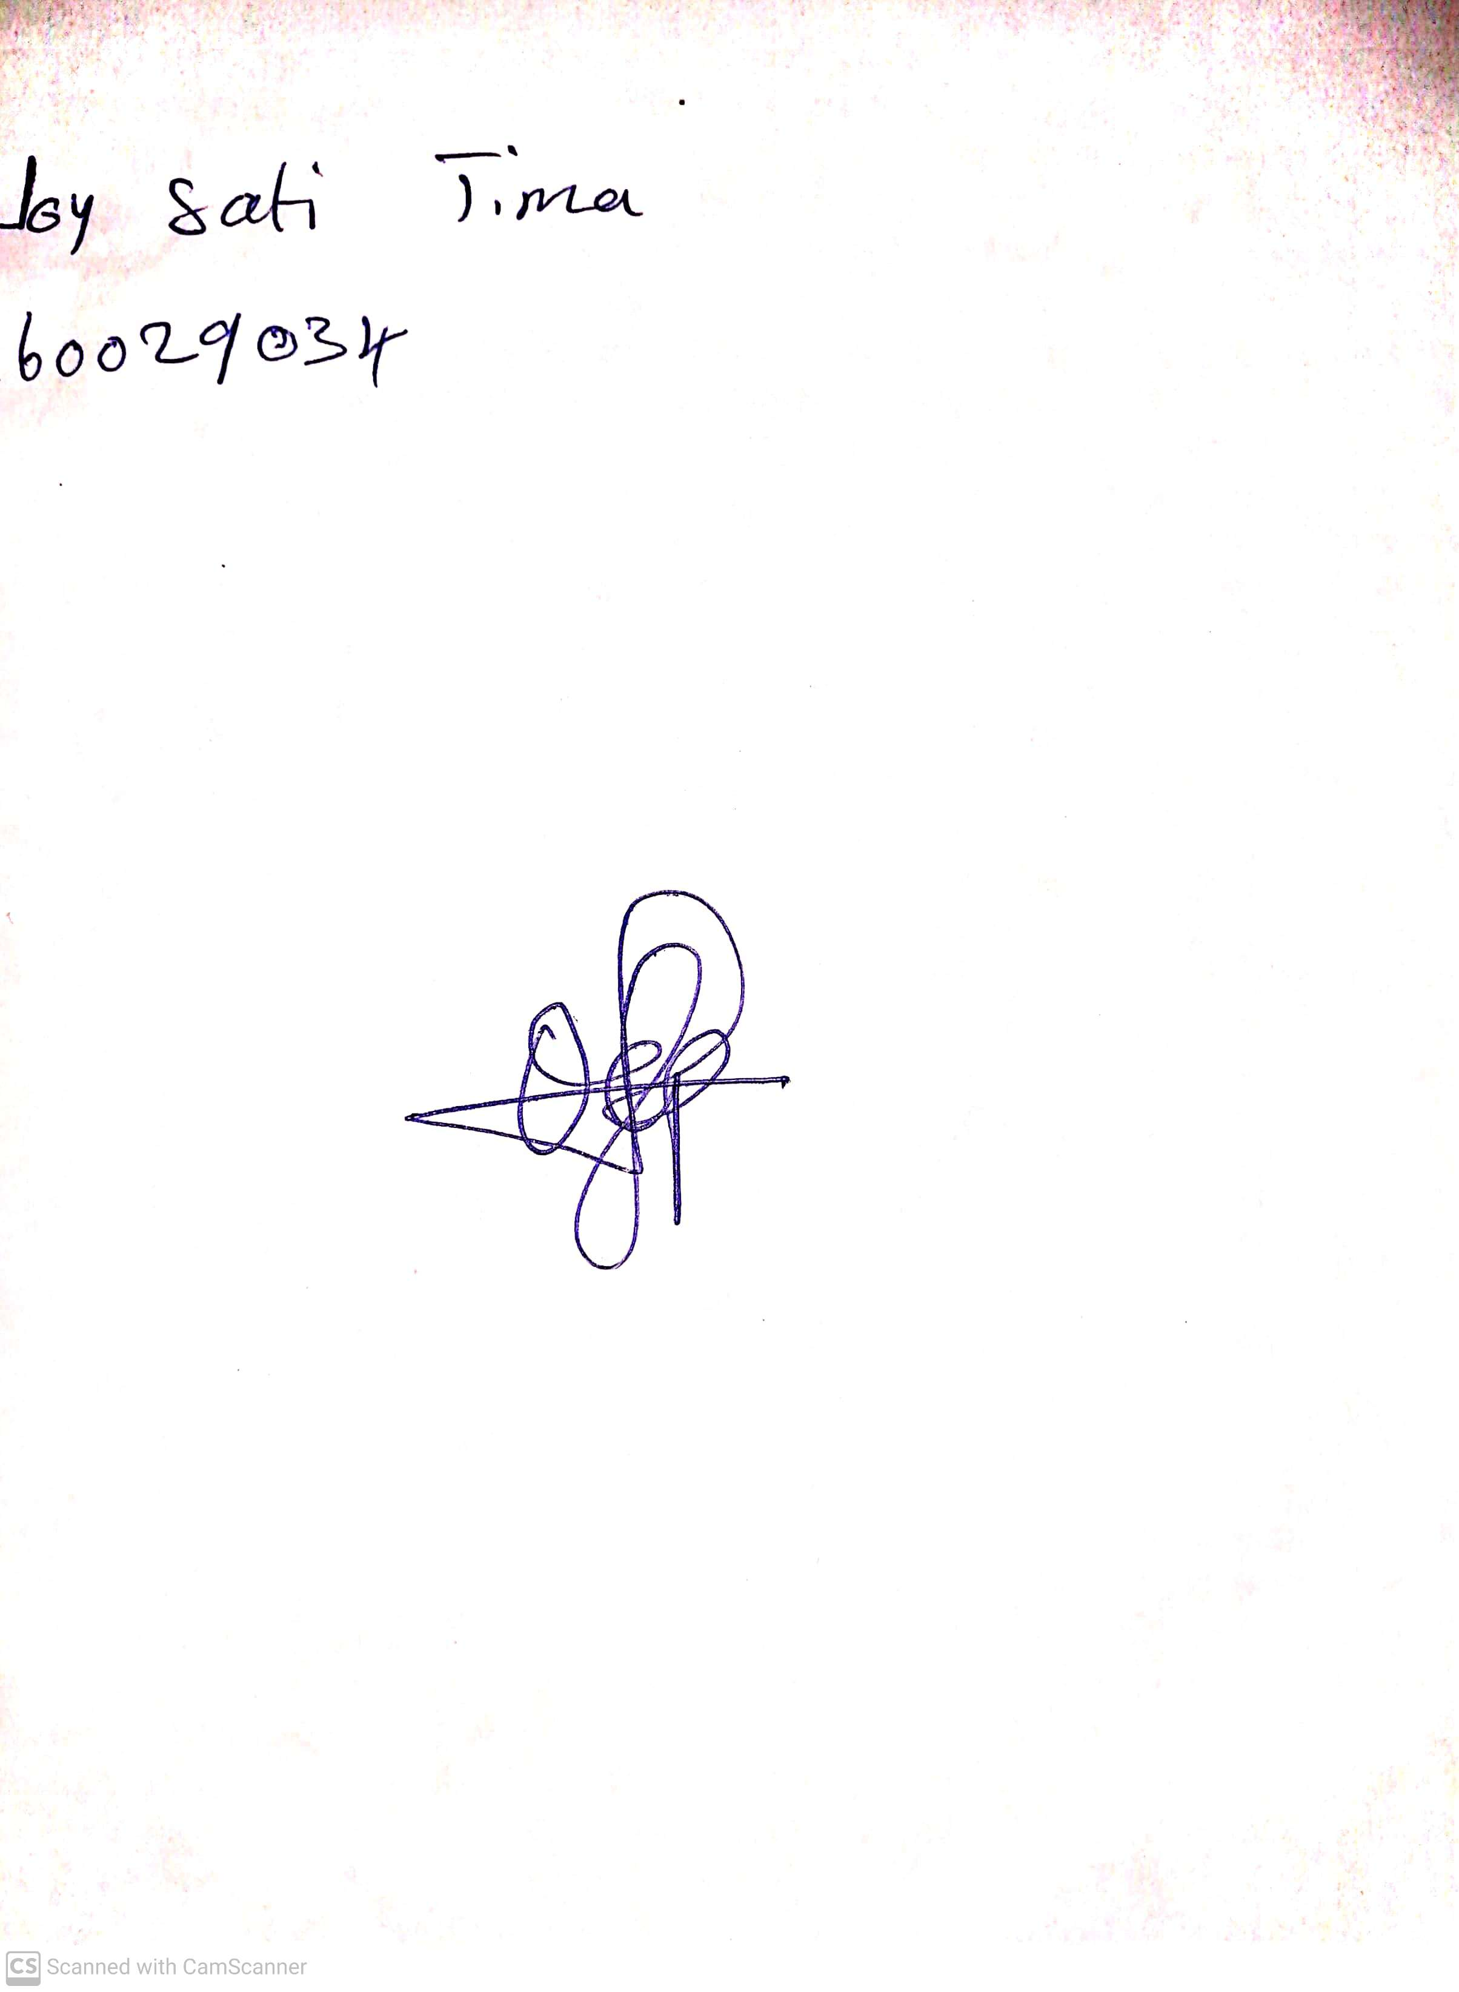

29th April, 2023

Perpetual Ojoma

Stream Head Nursery