**EMERALD ROYAL INTERNATIONAL SCHOOL**

**MPAPE, ABUJA.**

**LESSON PLAN AND NOTE FOR WEEK 10 ENDING 07/07/2023**

TERM: THIRD

WEEK: 10TH

DATE: 03/07/2023

CLASS: NURSERY 2

SUBJECT: NATURE STUDY

TOPIC: THINGS THAT HAVE NATURAL COLOURS .

SUB-TOPIC: MEANING OF NATURAL COLOURS AND EXAMPLES

PERIOD: 1ST PERIOD AFTER LONG BREAK

TIME: 10: 40- 11: 20am

DURATION: 40 MINUTES.

NUMBER IN CLASS: 14

AVERAGE AGE: 5 YEARS.

SEX: MIXED.

SPECIFIC OBJECTIVES: BY THE END OF THE LESSON,THE PUPILS SHOULD BE

ABLE TO:

1. EXPLAIN THE MEANING OF NATURAL COLOURS.
2. MENTION THE EXAMPLE OF THINGS THAT HAVE NATURAL COLOURS.

RATIONALE: FOR PUPILS TO KNOW THINGS THA HAVE NATURAL

COLOURS.

PREVIOU KNOWLEDGE: PUPILS HAVE BEEN SEEING THINGS WITH DIFFERENT

COLOURS OF OBJECTS.

INSTRUCTIONAL MATERIALS: EGG,GRASS AND CHARCOAL.

REFERENCE MATERIALS: BASIC SCIENCE AND TECHNOLOGY NURSERY SCHOOLS

BOOK 3 BY OPEMIPO DADA.

**LESSON DEVELOPMENT**

|  |  |  |  |
| --- | --- | --- | --- |
| STAGES/STEPS | TEACHER’S ACTIVITIES | PUPILS’ ACTIVITIES | LEARNING POINTS |
| INTRODUCTION | Teacher introduces the lesson by singing a nursery rhyme, red,red,red touch your head.  Blue,blue,blue tie your shoe…. | Pupils sing the rhyme along with the teacher. | To prepare pupils minds for the lesson ahead.. |
| PRESENTATION  STEP 1 | Teacher explains the meaning of natural colour to pupils and then asks them to repeat after her. | Pupils listen attentively to the teacher and repeat after her. | For proper understanding . |
| STEP 2 | Teacher mentions the example of things with natural colours to pupils and also asks them to repeat after her. | Pupils pay attention to the teacher and repeat after her. | For better understanding of the lesson. |
| BOARD SUMMARY | Teacher summarizes the lesson by writing the whole note of lesson on the board for pupils to copy into their books. Ie THINGS THAT HAVE NATURAL COLOURS.  NATURAL COLOURS: This means the colour of something or the appearance that it has.  Examples of things with natural colours are:   1. Blood 2. Sky 3. Milk 4. Charcoal 5. Fresh leaves 6. Grass 7. The tongue 8. Egg 9. Egg yolke   10 Cotton wool  11 Carrot etc. | Pupils copy the note into their exercise books. | For onward study. |
| EVALUATION | Teacher evaluates the lesson by asking the following questions;   1. What is natural colour? 2. Mention the things that has natural colours. | Pupils answer the questions ask by the teacher. | To assess pupils level of understanding. |
| CONCLUTION | Teacher concludes the lesson by marking pupils books. | Pupils submit their books for marking. | For endorsement. |
| ASSIGNMENT | 1. What is weather? 2. Mention the 3 types of weather.. | Pupils do their assignment at home. | To encourage learning at home. |

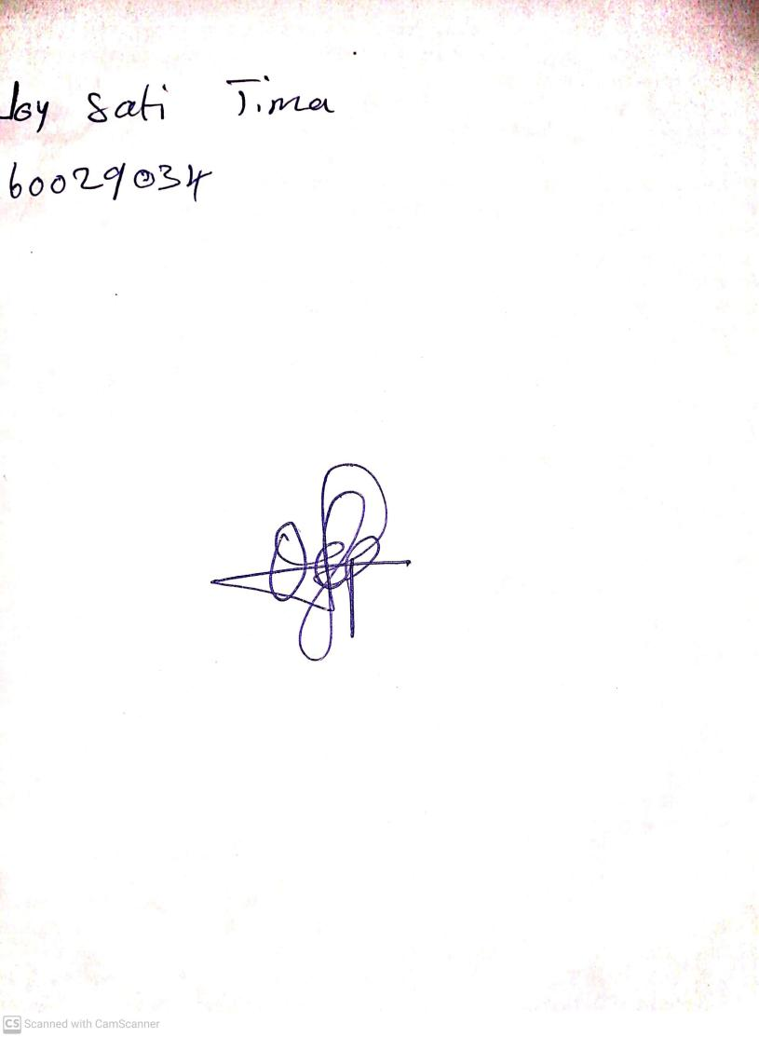

14th May, 2023

Perpetual Ojoma

Stream Head Nursery