EMERALD ROYAL INTERNATIONAL SCHOOL MPAPE, ABUJA

LESSON PLAN AND NOTE FOR WEEK 9 PERIOD 1 ENDING 10/11/2023

TERM: FIRST

WEEK: 9TH

DATE: 06/11/2023

CLASS: NURSERY 2

SUBJECT: NUMBER WORK

TOPIC: MOULDING OF NUMBERS 1-30

SUB-TOPIC: COUNTING AND MOULDING OF NUMBER 1-10

PERIOD: 2ND

TIME: 08: 50-09: 30 am

DURATION: 40 MINUTES

NUMBER IN CLASS: 16

AVERAGE AGE: 4

SEX: MIXED

SPECIFIC OBJECTIVES: BY THE END OF THE LESSON, THE PUPILS SHOULD BE ABLE

TO:

1. COUNT NUMBER 1-10.
2. MOULD NUMBER 1-10

RATIONALE: FOR PUPILS TO HAVE KNOWLEDGE ABOUT MOULDING

PREVIOUS KNOWLEDGE: PUPILS HAVE LEARNT COUNTING OF NUMBERS 1-30

INSTRUCTIONAL MATERIALS: A CHART OF NUMBERS 1-10

REFERENCE MATERIALS: MY CHOICE OF MATHEMATICS STAGE 3 BY TOP STAR.

LESSON DEVELOPMENT

|  |  |  |  |
| --- | --- | --- | --- |
| STAGES/STEPS | TEACHER’S ACTIVITIES | PUPILS’ ACTIVITIES | LEARNING POINT |
| INTODUCTION | Teacher introduces the lesson by reviewing the previous lesson. | Pupils listen attentively to the teacher. | To arouse pupils interest for the lesson ahead. |
| PRESENTATION STEP 1 | Teacher counts number 1-10 to pupils and then asks them to repeat after her. | Pupils pay attention to the teacher and repeat after her. | For proper understanding. |
| STEP 2 | Teacher guides pupils on moulding of numbers 1-10 with the use of number stencils. | Pupils pay attention and mould numbers 1-10. | For pupils to be creative. |
| BOARD SUMMARY | Teacher summarizes the lesson by writing the whole note of lesson on the board for pupils to copy into their books. That is;  Moulding of numbers 1-10  1 2 3  4 5 6  7 8 9 10 | Pupils copy the note on the board into their exercise books. | For onward study. |
| EVALUATION | Teacher evaluates the lesson by asking the following questions:   1. Count number 1-10 one after the other. 2. Mould number 1-10 one after the other. | Pupils answer the questions asked by the teacher. | To asses pupils level of understanding of the lesson. |
| CONCLUSION | Teacher concludes the lesson by marking pupils books. | Pupils submit their books for marking. | For endorsement. |
| ASSIGNMENT | Mould number 1-10 with clay soil. | Pupils do their assignment at home. | To encourage learning at home. |

LESSON PLAN AND NOTE FOR WEEK 9 PERIOD 2 ENDING 10/11/2023

TERM: FIRST

WEEK: 9TH

DATE: 07/11/2023

CLASS: NURSERY 2

SUBJECT: NUMBER WORK

TOPIC: MOULDING OF NUMBERS 1-30

SUB-TOPIC: COUNTING AND MOULDING OF NUMBER 11-20

PERIOD: 2ND

TIME: 08: 50-09: 30 am

DURATION: 40 MINUTES

NUMBER IN CLASS: 16

AVERAGE AGE: 4

SEX: MIXED

SPECIFIC OBJECTIVES: BY THE END OF THE LESSON, THE PUPILS SHOULD BE ABLE

TO:

1. COUNT NUMBER 11-20.
2. MOULD NUMBER 11-20

RATIONALE: FOR PUPILS TO HAVE KNOWLEDGE ABOUT MOULDING

PREVIOUS KNOWLEDGE: PUPILS HAVE LEARNT COUNTING OF NUMBERS 1-30

INSTRUCTIONAL MATERIALS: A CHART OF NUMBERS 11-20

REFERENCE MATERIALS: MY CHOICE OF MATHEMATICS STAGE 3 BY TOP STAR.

LESSON DEVELOPMENT

|  |  |  |  |
| --- | --- | --- | --- |
| STAGES/STEPS | TEACHER’S ACTIVITIES | PUPILS’ ACTIVITIES | LEARNING POINT |
| INTODUCTION | Teacher introduces the lesson by reviewing the previous lesson. | Pupils listen attentively to the teacher. | To arouse pupils interest for the lesson ahead. |
| PRESENTATION STEP 1 | Teacher counts number 11-20 to pupils and then asks them to repeat after her. | Pupils pay attention to the teacher and repeat after her. | For proper understanding. |
| STEP 2 | Teacher guides pupils on moulding of numbers 11-20 with the use of number stencils. | Pupils pay attention and mould numbers 11-20. | For pupils to be creative. |
| BOARD SUMMARY | Teacher summarizes the lesson by writing the whole note of lesson on the board for pupils to copy into their books. That is;  Moulding of numbers 11-20  11 12 13  14 15 16  17 18 19 20 | Pupils copy the note on the board into their exercise books. | For onward study. |
| EVALUATION | Teacher evaluates the lesson by asking the following questions:   1. Count number 11-20 one after the other. 2. Mould number 11-20 one after the other. | Pupils answer the questions asked by the teacher. | To asses pupils level of understanding of the lesson. |
| CONCLUSION | Teacher concludes the lesson by marking pupils books. | Pupils submit their books for marking. | For endorsement. |
| ASSIGNMENT | Mould number 11-20 with clay soil. | Pupils do their assignment at home. | To encourage learning at home. |

LESSON PLAN AND NOTE FOR WEEK 9 PERIOD 3 ENDING 10/11/2023

TERM: FIRST

WEEK: 9TH

DATE: 10/11/2023

CLASS: NURSERY 2

SUBJECT: NUMBER WORK

TOPIC: MOULDING OF NUMBERS 1-30

SUB-TOPIC: COUNTING AND MOULDING OF NUMBER 21-30

PERIOD: 1ST

TIME: 08: 50-09: 30 am

DURATION: 40 MINUTES

NUMBER IN CLASS: 16

AVERAGE AGE: 4

SEX: MIXED

SPECIFIC OBJECTIVES: BY THE END OF THE LESSON, THE PUPILS SHOULD BE ABLE

TO:

1. COUNT NUMBER 21 -30.
2. MOULD NUMBER 21-30

RATIONALE: FOR PUPILS TO HAVE KNOWLEDGE ABOUT MOULDING

PREVIOUS KNOWLEDGE: PUPILS HAVE LEARNT COUNTING OF NUMBERS 1-30

INSTRUCTIONAL MATERIALS: A CHART OF NUMBERS 21-30

REFERENCE MATERIALS: MY CHOICE OF MATHEMATICS STAGE 3 BY TOP STAR.

LESSON DEVELOPMENT

|  |  |  |  |
| --- | --- | --- | --- |
| STAGES/STEPS | TEACHER’S ACTIVITIES | PUPILS’ ACTIVITIES | LEARNING POINT |
| INTODUCTION | Teacher introduces the lesson by reviewing the previous lesson. | Pupils listen attentively to the teacher. | To arouse pupils interest for the lesson ahead. |
| PRESENTATION STEP 1 | Teacher counts number 21-30 to pupils and then asks them to repeat after her. | Pupils pay attention to the teacher and repeat after her. | For proper understanding. |
| STEP 2 | Teacher guides pupils on moulding of numbers 21-30 with the use of number stencils. | Pupils pay attention and mould numbers 21-30. | For pupils to be creative. |
| BOARD SUMMARY | Teacher summarizes the lesson by writing the whole note of lesson on the board for pupils to copy into their books. That is;  Moulding of numbers 21-30  21 22 23  24 25 26  27 28 29 30 | Pupils copy the note on the board into their exercise books. | For onward study. |
| EVALUATION | Teacher evaluates the lesson by asking the following questions:   1. Count number 21-30 one after the other. 2. Mould number 21-30 one after the other. | Pupils answer the questions asked by the teacher. | To asses pupils level of understanding of the lesson. |
| CONCLUSION | Teacher concludes the lesson by marking pupils books. | Pupils submit their books for marking. | For endorsement. |
| ASSIGNMENT | Mould number 21-30 with clay soil. | Pupils do their assignment at home. | To encourage learning at home. |

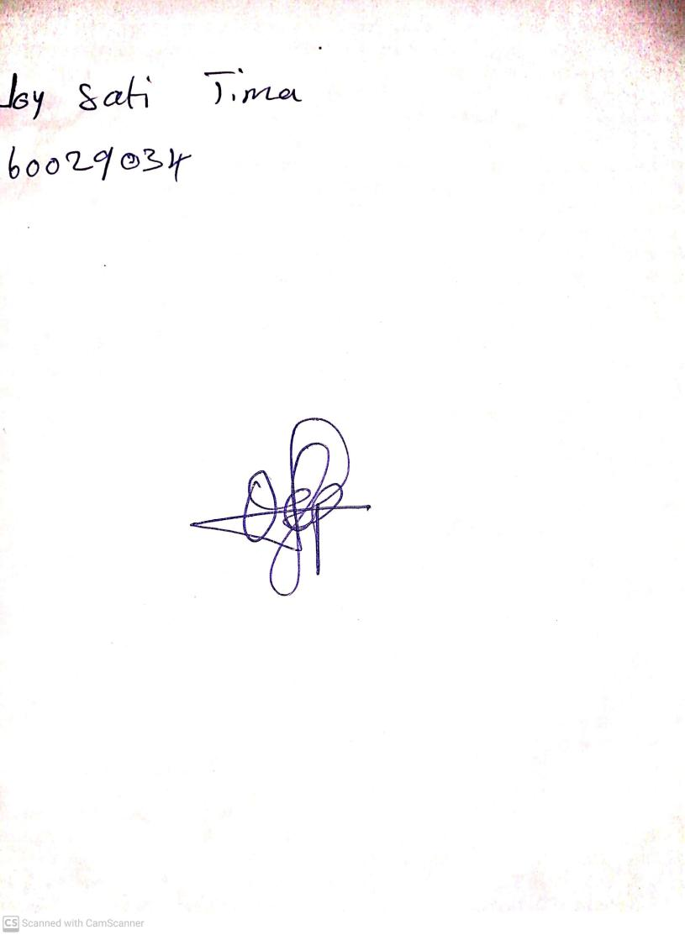

3rd November, 2023

Perpetual Ojoma Ocheja

Stream Head Nursery