**LESSON PLAN AND NOTE FOR WEEK 9 ENDING 21/6/2024**

**Term 3rd term**

**Week 9th week**

**Date 19th June, 2024**

**Class Nursery One**

**Subject Social Norms**

**Topic State in my country.**

**Sub-topic Identification of the Federal Capital Territory.**

**Period 4th period**

**Time 10:40 am**

**Duration 35 minutes**

**No in class 14**

**Average Age 3 years**

**Sex Mixed**

**Specific Objectives: By the end of the lesson, the pupils should be able to:**

1. **Identify the country’s federal capital territory.**
2. **Spell the name of their country.**

**Rationale: To teach & ensure the pupils know their country’s federal capital territory.**

**Previous Knowledge: The pupils can mention the 36 states and capital of their country.**

**Instructional Resources: Online research.**

**Reference Material: Smart Smart Civic Education by A.M Solu & T.Y Alabi, nursery 2**

**LESSON PRESENTATION**

|  |  |  |  |
| --- | --- | --- | --- |
| **Steps** | **Teacher’s Activities** | **Pupils’ Activities** | **Learning Points** |
| **Introduction** | **The teacher introduces the lesson [My Country] to the pupils.** | **The pupils pays attention to the teacher.** | **To arouse the pupils’ interest.** |
| **Step 1** | **The teacher leads the pupils to identify their country’s federal capital territory ABUJA.** | **The pupils pay attention and repeats the federal capital territory of their country with the teacher.** | **For proper understanding.** |
| **Step 2** | **The teacher guides the pupils to spell the name of their country**  **N-I-G-E-R-I-A** | **The pupils spells the name of their country along with the teacher**  **N-I-G-E-R-I-A.** | **For better understanding.** |
| **Summary** | **The teacher summarizes the lesson by explaining that the name of their federal capital territory is ABUJA.** | **The pupils listen and understands the lesson.** | **For onward study.** |
| **Evaluation** | **Question:**  **Mention the federal capital territory of your country?.**  **Spell NIGERIA?** | **The pupils answer the question correctly.** | **To ascertain the pupils’ understanding.** |
| **Conclusion** | **The teacher summarizes the lesson to the pupils.** | **The pupils gives answers to the teacher.** | **To consolidate the lesson.** |
| **Assignment** | **Question:**  **Mention the federal capital territory of your country?.**  **Spell the name of your country?.**  **________________** | **The pupils copy and do their homework .** | **To encourage learning while at home.** |

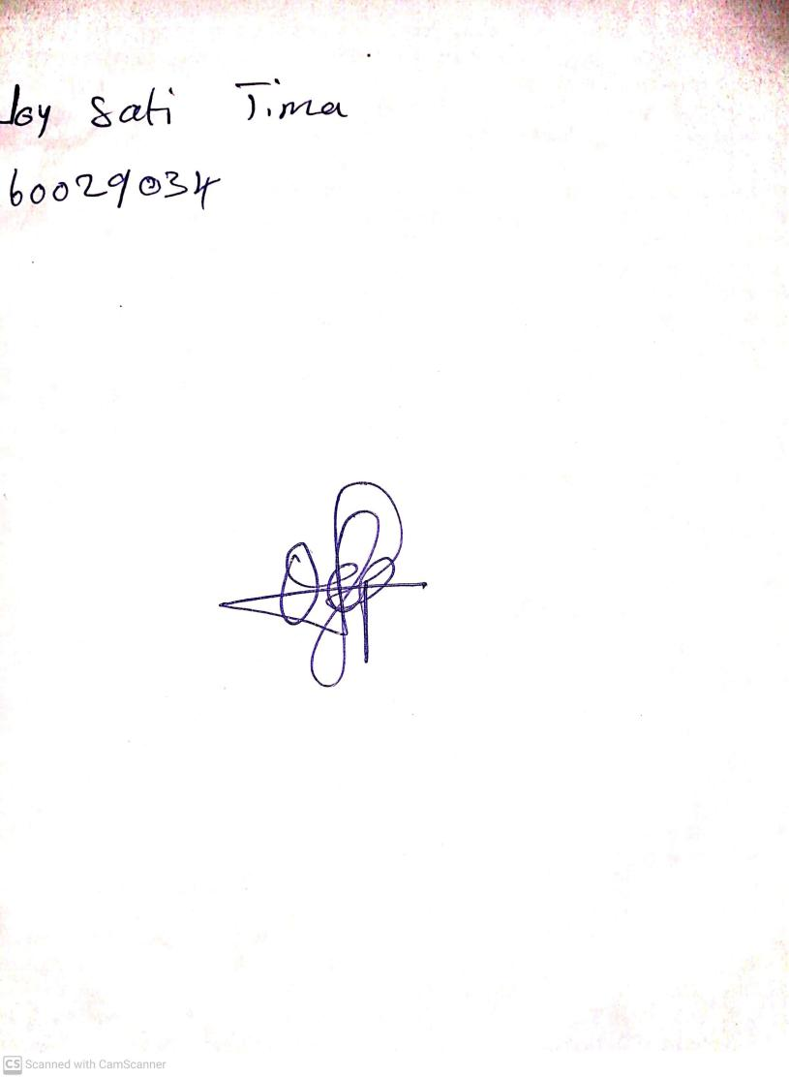

14th June, 2024

Perpetual Ojoma Ocheja

Stream Head Nursery