**LESSON PLAN AND NOTE 1 FOR WEEK 11 ENDING 22/11/2024**

**Term 1st term**

**Week 11th week**

**Date 19th November,2024**

**Class Nursery One**

**Subject Number Work**

**Topic Counting numbers 1-100.**

**Sub-topic Count numbers 90-95**

**Period 2nd period**

**Time 8:50 am**

**Duration 35 minutes**

**No in class 15**

**Average Age 3 years**

**Sex Mixed**

**Specific Objectives: By the end of the lesson ,the pupils should be able to:**

1. **Count numbers 90-95.**
2. **Identify numbers 90-95.**
3. **Write numbers 90-95**

**Rationale: To make sure the pupils count numbers 1-100.**

**Previous Knowledge: The pupils can match & fill in missing numbers 1-90.**

**Instructional Resources: Chart, board, marker, etc.**

**Reference Material: The new mastering mathematics.**

**LESSON PRESENTATION**

|  |  |  |  |  |
| --- | --- | --- | --- | --- |
| **Steps** | **Teacher’s Activities** | **Pupils’ Activities** | **Learning Points** | |
| **Introduction** | **The teacher introduces the topic (counting numbers 1-100) to the pupils by rhyming it.** | **The pupils with the teacher rhyme the numbers 1-100.** | **To arouse the pupils’ interest.** | |
| **Step 1** | **The teacher assists the pupils to count numbers 90-95**  **90 91 92**  **93 94 95** | **The pupils counts numbers 90-95 with their teacher.** | | **For proper understanding.** |
| **Step 2** | **The teacher leads the pupils to identify numbers 90-95**  **90 91 92**  **93** | **The pupils participate with the teacher in identifying numbers 90-95.**  **90 91 92**  **93** | | **For better understanding.** |
| **Step 3** | **The teacher guides the pupils to write numbers 90-95 inside their notebooks.**   |  |  | | --- | --- | | **90** | **91** | |  |  | | **92** | **93** | |  |  | | **94** | **95** | |  |  | | **The pupils write numbers 90-95 as the teacher guides them.** | | **For further understanding** |
| **Summary** | **The teacher summarizes the lesson by counting numbers 90-95.** | **The pupils have master and count numbers 90-95**  **.** | | **For onward study.** |
| **Evaluation** | **The teacher asks the pupils to:**  **Count numbers 90-95**  **90 91 92**  **93 94 95**  **Identify numbers 90-95.**  **90 91 92**  **93**  **Write numbers 90-95 below**   |  |  | | --- | --- | | **90** | **91** | |  |  | | **92** | **93** | |  |  | | **94** | **95** | |  |  | | **The pupils answers the question correctly.** | | **To ascertain the pupils’ understanding.** |
| **Conclusion** | **The teacher summarizes, reacts and corrects the lesson.** | **The pupils gives answers to the teacher’s questions** | | **To consolidate the lesson** |
| **Assignment** | **Count numbers 90-95**  **90 91 92**  **93 94 95**  **Identify numbers 90-95.**  **90 91 92**  **93**  **Write the following numbers below**   |  |  | | --- | --- | | **80** | **81** | |  |  | | **82** | **83** | |  |  | | **84** | **85** | |  |  | | **The pupils copy and do their homework at home.** | | **To encourage learning while at home.** |

**LESSON PLAN AND NOTE 2 FOR WEEK 11 ENDING 22/11/2024**

**Term 1st term**

**Week 11th week**

**Date 20th November,2024**

**Class Nursery One**

**Subject Number Work**

**Topic Counting numbers 1-100.**

**Sub-topic Count numbers 95-100**

**Period 4th period**

**Time 10:40 am**

**Duration 35 minutes**

**No in class 15**

**Average Age 3 years**

**Sex Mixed**

**Specific Objectives: By the end of the lesson ,the pupils should be able to:**

1. **Count numbers 95-100.**
2. **Identify numbers 95-100.**
3. **Write numbers 95-100.**

**Rationale: To make sure the pupils count numbers 1-100.**

**Previous Knowledge: The pupils knows how to count numbers 90-95.**

**Instructional Resources: Chart, board, marker, etc.**

**Reference Material: The new mastering mathematics.**

**LESSON PRESENTATION**

|  |  |  |  |
| --- | --- | --- | --- |
| **Steps** | **Teacher’s Activities** | **Pupils’ Activities** | **Learning Points** |
| **Introduction** | **The teacher introduces the topic (counting numbers 1-100) to the pupils by rhyming it.** | **The pupils with the teacher rhyme the numbers 1-100.** | **To arouse the pupils’ interest.** |
| **Step 1** | **The teacher assists the pupils to count numbers 95-100**  **95 96 97**  **98 99 100** | **The pupils counts numbers 95-100 with their teacher.** | **For proper understanding.** |
| **Step 2** | **The teacher leads the pupils to identify numbers 95-100**  **95 96 97**  **98** | **The pupils participate with the teacher in identifying numbers 95-100.**  **95 96 97**  **98** | **For better understanding.** |
| **Step 3** | **The teacher guides the pupils to write numbers 95-100 inside their notebooks.**   |  |  | | --- | --- | | **95** | **96** | |  |  | | **97** | **98** | |  |  | | **99** | **100** | |  |  | | **The pupils write numbers 95-100 as the teacher guides them.** | **For further understanding** |
| **Summary** | **The teacher summarizes the lesson by counting numbers 95-100** | **The pupils have master and count numbers 95-100.** | **For onward study.** |
| **Evaluation** | **The teacher asks the pupils to:**  **Count numbers 95-100**  **95 96 97**  **98 99 100**  **Identify numbers 95-100.**  **95 96 97**  **98**  **Write numbers 95-100 below?**   |  |  | | --- | --- | | **95** | **96** | |  |  | | **97** | **98** | |  |  | | **99** | **100** | |  |  | | **The pupils answers the question correctly.** | **To ascertain the pupils’ understanding.** |
| **Conclusion** | **The teacher summarizes, reacts and corrects the lesson.** | **The pupils gives answers to the teacher’s questions** | **To consolidate the lesson** |
| **Assignment** | **Count numbers 95-100**  **95 96 97**  **98 99 100**  **Identify numbers 95-100.**  **95 96 97**  **98**  **Write the following numbers below**   |  |  | | --- | --- | | **95** | **96** | |  |  | | **97** | **98** | |  |  | | **97** | **100** | |  |  | | **The pupils copy and do their homework at home.** | **To encourage learning while at home.** |

**LESSON PLAN AND NOTE 3 FOR WEEK 11 ENDING 22/11/2024**

**Term 1st term**

**Week 11th week**

**Date 21st November,2024**

**Class Nursery One**

**Subject Number Work**

**Topic Counting numbers 1-100.**

**Sub-topic Matching numbers 90-100**

**Period 2nd period**

**Time 8:50 am**

**Duration 35 minutes**

**No in class 15**

**Average Age 3 years**

**Sex Mixed**

**Specific Objectives: By the end of the lesson ,the pupils should be able to:**

1. **Match numbers 90-95.**
2. **Fill in the numbers 95-100.**

**Rationale: To make sure the pupils match numbers 1-100.**

**Previous Knowledge: The pupils knows how to count numbers 95-100.**

**Instructional Resources: Chart, board, marker, etc.**

**Reference Material: The new mastering mathematics.**

**LESSON PRESENTATION**

|  |  |  |  |
| --- | --- | --- | --- |
| **Steps** | **Teacher’s Activities** | **Pupils’ Activities** | **Learning Points** |
| **Introduction** | **The teacher introduces the topic (counting numbers 1-100) to the pupils by rhyming it.** | **The pupils with the teacher rhyme the numbers 1-100.** | **To arouse the pupils’ interest.** |
| **Step 1** | **The teacher assists the pupils to match numbers 90-95**  **90 95**  **91 94**    **92 93**  **93 92**  **94 91**  **95 90** | **The pupils match numbers 90-95 with their teacher.**  9**0 95**  9**1 94**    9**2 93**  **93 92**  **94 91**  **95 90** | **For proper understanding.** |
| **Step 2** | **The teacher leads the pupils to fill in the numbers 95-100**  **95____ 97 ______ 99**  **____** | **The pupils participate with the teacher in filling in the missing numbers 95-100.**  **95 96 97**  **98 99 100** | **For better understanding.** |
| **Summary** | **The teacher summarizes the lesson by counting numbers**  **90-100** | **The pupils have master and count numbers 90-100.** | **For onward study.** |
| **Evaluation** | **The teacher asks the pupils to:**  **Match the following numbers below**  **90 95**  **91 94**    **92 93**  **93 92**  **94 91**  **95 90**  **Fill in the missng numbers below?**  **95____ 97 ______ 99**  **____** | **The pupils answers the question correctly.** | **To ascertain the pupils’ understanding.** |
| **Conclusion** | **The teacher summarizes, reacts and corrects the lesson.** | **The pupils gives answers to the teacher’s questions** | **To consolidate the lesson** |
| **Assignment** | **Fill in the missing numbers below**  **90____92____94____96**  **____ 98____ 100**  **Match the following numbers below**  **90 95**  **91 94**    **92 93**  **93 92**  **94 91**  **95 90**  **96 100**  **97 99**  **98 98**  **99 97**  **100 96** | **The pupils copy and do their homework at home.** | **To encourage learning while at home.** |

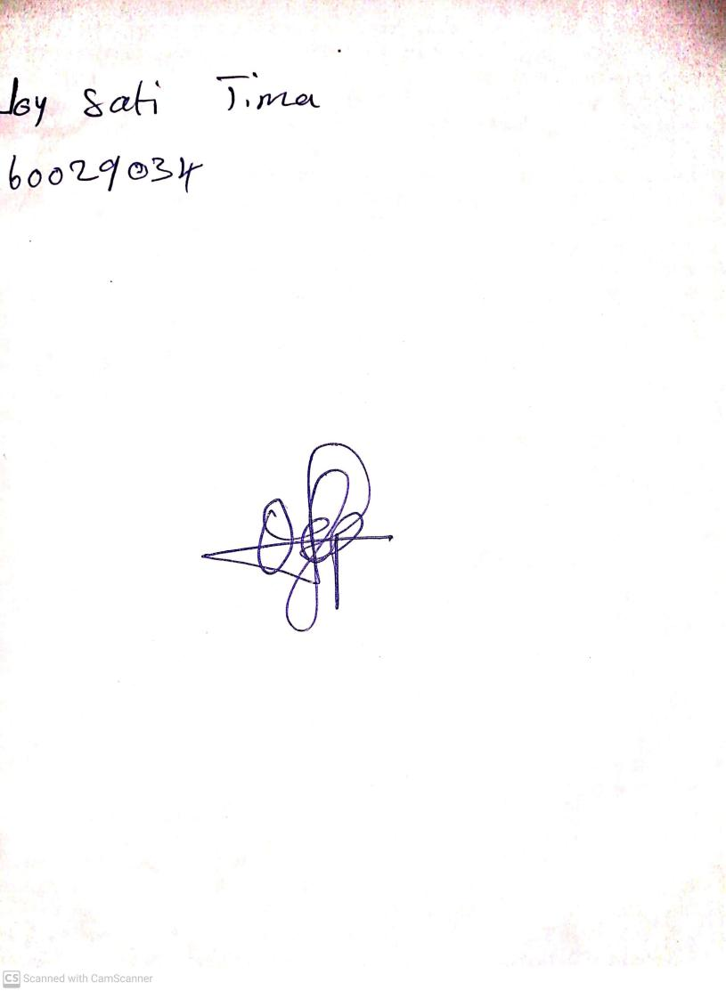

22nd November, 2024

Perpetual Ojoma Ocheja

Stream Head Nursery