**LESSON PLAN AND NOTE FOR WEEK 9 ENDING 10/11/2023**

**Term 1st term**

**Week 9th week**

**Date 6th November, 2023**

**Class Nursery One**

**Subject Social Norms**

**Topic Care of our surrounding.**

**Sub-topic Tools to care for our surrounding.**

**Period 4th period**

**Time 10:40 am**

**Duration 35 minutes**

**No in class 15**

**Average Age 3 years**

**Sex Mixed**

**Specific Objectives: By the end of the lesson, the pupils should be able to:**

1. **Mention tools for caring for our surrounding.**
2. **Mention ways of caring for our surrounding.**
3. **Identify tools for caring for our surrounding.**

**Rationale: For the pupils to mention tools for caring for our surrounding.**

**Previous Knowledge: The pupils can define and mention the types of social studies.**

**Instructional Resources: Online research, tools for caring for our surrounding.**

**Reference Material: Smart Smart Civic Education by A.M Solu & T.Y Alabi, nursery 2**

**LESSON PRESENTATION**

|  |  |  |  |
| --- | --- | --- | --- |
| **Steps** | **Teacher’s Activities** | **Pupils’ Activities** | **Learning Points** |
| **Introduction** | **The teacher introduces the lesson [Care of our surrounding) by showing the pupils the cleaning tools chart in the classroom.** | **The pupils listens to the teacher.** | **To arouse the pupils’ interest.** |
| **Step 1** | **The teacher mention tools for caring for our surrounding which includes:**  **MOP**  **BROOM**  **BUCKET**  **DETERGENT**  **RAKE**  **BRUSH**  **TOWEL**  **PAKER**  **DUSTBIN** | **The pupils pay attention and repeats continuously the tools for caring for our surrounding.** | **For proper understanding.** |
| **Step 2** | **The teacher mention ways of caring for our surrounding which includes:**  **SWEEPING OUR HOUSE WITH BROOM AND PAKER.**  **CLEANING THE HOUSE WITH WATER, DETERGENT, AND MOP.**  **CLEANING DUSTY SURFACES WITH HAND TOWEL ETC.** | **The pupils participates together with the teacher to mention ways for caring for our surrounding.** | **For better understanding.** |
| **Step 3** | **The teacher leads the pupils to identify the tools for taking care of our surrounding.**  **image of a broom A broom**  **image of a towelA towel**  **image of a bucketA bucket**  **image of a mopA mop** | **The pupils identify together with the teacher tools for taking care of our surrounding.** | **For further understanding.** |
| **Summary** | **The teacher summarizes the lesson by mentioning tools for taking care of our surrounding for the pupils.** | **The pupils listen and understands the lesson.** | **For onward study.** |
| **Evaluation** | **The teacher asks the pupils to:**   1. **Mention 2 ways we can take care of our surrounding?** 2. **Mention 2 tools for taking care of our surrounding?** 3. **Identify the tool for taking care of our surrounding below?**   **image of a broom _________**  **image of a towel__________** | **The pupils answer the question correctly.** | **To ascertain the pupils’ understanding.** |
| **Conclusion** | **The teacher reacts and summarizes the lesson to the pupils.** | **The pupils gives answers to the teacher.** | **To consolidate the lesson.** |
| **Assignment** | 1. **Mention 5 tools for taking care of our surrounding?** 2. **Identify the tool we use to take care of our surrounding below?**   **image of a broom _________**  **image of a towel__________**  **image of a bucket__________**  **image of a mop__________**   1. **Colour the tool we use to take care of our surrounding below?**   **plain dustbin**  **plain bucket** | **The pupils copy and do their homework .** | **To encourage learning while at home.** |

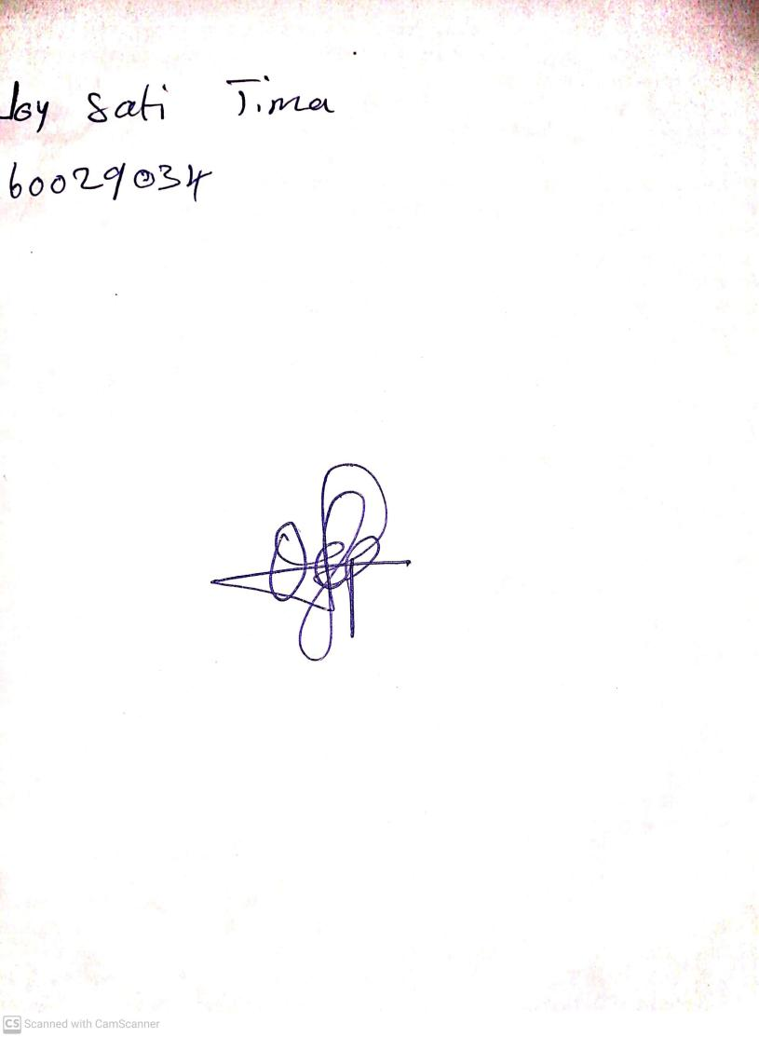

20th August, 2023

Perpetual Ojoma Ocheja

Stream Head Nursery