**EMERALD ROYAL INTERNATIONAL SCHOOL**

**MPAPE, ABUJA.**

**LESSON NOTE/PLAN FOR WEEK 2 ENDING 19th JANUARY,2024.**

**Subject : Nature studies.**

**Topic : Wild animals**

**Sub-topic: Definition of wild animals and examples of wild animals.**

**Date : 16th-18th January,2024.**

**Duration: 40mins**

**Time : 09:30-10:10 and 01:45-02:20.**

**Period : 3rd and 9th**

**Class : pre-nursery**

**Number of pupils: 17**

**Average age: 2years**

**Sex: mixed**

**Learning objectives:By the end of the lesson, the pupils should be able to**

1. **Define wild animals.**
2. **Lists some of the examples of wild animals.**

**Rationale: For pupils to identify wild animals on the chart.**

**Previous knowledge: Pupils have been taught domestic animals in the previous lesson.**

**Instructional material: chart.**

**Reference: showers kiddies books Elementary science Nursery 1 by showers kiddies books.**

**LESSON DEVELOPMENT**

|  |  |  |  |
| --- | --- | --- | --- |
| **Stages/steps** | **Teacher's activities** | **Pupils' activities** | **Learning points** |
| **Introduction** | **Teacher introduces the lesson by singing nursery rhymes for the pupils ie A lion , a lion, a lion has a head and a very small tail.** | **Pupils listen to the teacher and practice to sing the rhyme.** | **To arouse the interest of the pupils.** |
| **Presentation step 1** | **Teacher defines wild animals to the pupils as:- "Wild animals are those animals that lives in the forest." Teacher asks the pupils to repeat after the teacher.** | **Pupils listen to the teacher and repeat after the teacher to define wild animals.** | **To ensure pupils can define wild animals.** |
| **Step 2** | **Teacher leads the pupils to mention the examples of wild animals.** | **Pupils mention some examples of wild animals as:- 1) lion**   1. **snake** 2. **Tiger** 3. **Crocodile** 4. **Elephant** | **To ensure pupils can identify wild animals.** |
| **Summary** | **Teacher summarises the lesson by going over the lesson again for better understanding.** | **Pupils pay attention to the teacher.** | **For better understanding of the lesson.** |
| **Evaluation** | **Teacher asks the pupils to:- 1) define wild animals**  **2)list examples of wild animals.** | **Pupils answer the teacher's questions correctly.** | **To assess the pupils understanding.** |
| **Conclusion** | **Teacher ends the lesson singing nursery rhymes for the pupils.** | **Pupils sing along with the teacher** | **To keep pupils excited and focus.** |
| **Assignment** | **Teacher asks the pupils to colour wild animals in their books at home.** | **Pupils do the assignment at home.** | **To encourage learning at home.** |

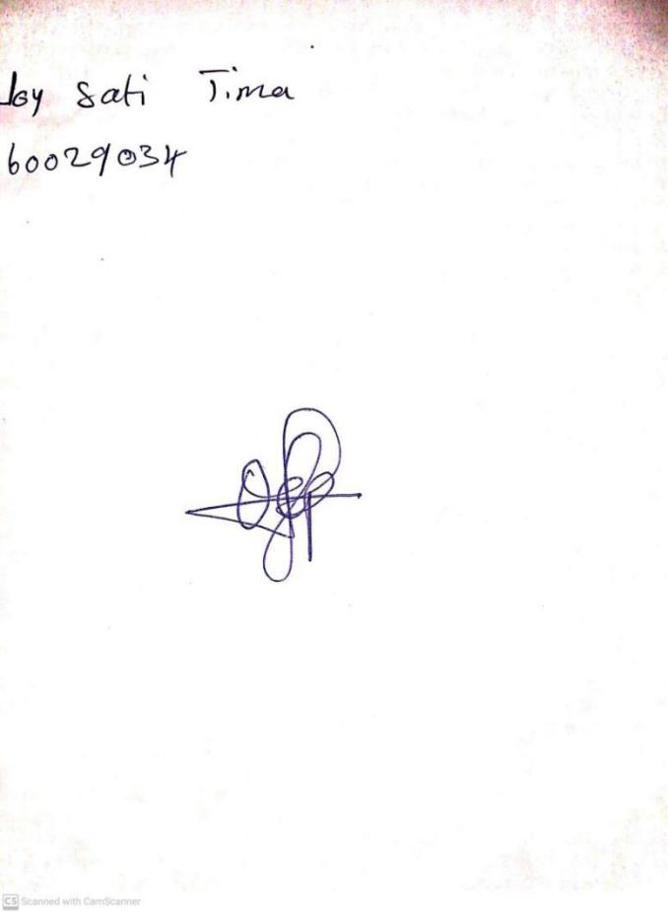

**12TH JANUARY, 2024**

**Perpetual Ojoma Ocheja**

**Stream Head Nursery**