**EMERALD ROYAL INTERNATIONAL SCHOOL MPAPE, ABUJA**

**LESSON PLAN AND NOTE FOR WEEK 8 PERIOD 1 ENDING 01/11/2024**

**TERM: FIRST**

**WEEK: 8TH**

**DATE: 28/10/2024**

**CLASS: NURSERY 2**

**SUBJECT: LITERACY**

**TOPIC: THREE LETTER WORDS WENDING IN “ug” “um” “un” “ub”**

**SUB-TOPIC: THREE LETTER WORDS ENDING IN “ug” and “um”**

**PERIOD: 3RD**

**TIME: 09: 30-10: 10 am**

**DURATION: 40 MINUTES**

**NUMBER IN CLASS: 16**

**AVERAGE AGE: 4**

**SEX: MIXED**

**SPECIFIC OBJECTIVES: BY THE END OF THE LESSON, THE PUPILS SHOULD BE ABLE TO:**

**1.STATE THREE LETTER WORDS ENDING IN “ug”AND “um”**

**2.SPELL AND PRONOUNCE THREE LETTER WORDS ENDING IN**

**“ug” AND “um”**

**RATIONALE: FOR PUPILS TO BE ABLE TO SPELL AND PRONOUNCE WORDS THAT ENDS WITH “ug” AND “um”.**

**PREVIOUS KNOWLEDGE: PUPILS HAVE LEARNT THREE LETTER WORDS ENDING “oy” AND”ol” IN PREVIOUS LESSON.**

**INSTRUCTIONAL MATERIALS: A CHART OF THREE LETTER WORDS ENDING IN “ug” AND“um”.**

**REFERENCE MATERIALS: TOP STAR MY CHOICE OF ENGLISH LANGUAGE STAGE 3 BY J.F OMOTAYO.**

**LESSON DEVELOPMENT**

|  |  |  |  |
| --- | --- | --- | --- |
| **STAGES/STEPS** | **TEACHER’S ACTIVITIES** | **PUPILS’ ACTIVITIES** | **LEARNING POINT** |
| **INTODUCTION** | **Teacher introduces the lesson by reviewing the previous lesson.** | **Pupils listen attentively to the teacher.** | **To arouse pupils interest for the lesson ahead.** |
| **PRESENTATION STEP 1** | **Teacher states the three letter words ending with “ug” and “um” to pupils and then asks them to repeat after her.** | **Pupils pay attention to the teacher and repeat after her.** | **For proper understanding.** |
| **STEP 2** | **Teacher spells and pronounce the three letter words that ends with “ug” and “um” to pupils and also asks them to repeat after her.** | **Pupils listen very attentively to the teacher and repeat after her.** | **For better understanding of the lesson.** |
| **BOARD SUMMARY** | **Teacher summarizes the lesson by writing the whole note of lesson on the board for pupils to copy into their books. That is;**  **Three letter words ending in “ug” and “um” are:**  **“ug” as in**   1. **Tug** 2. **Dug** 3. **Pug** 4. **Lug** 5. **Bug** 6. **Rug** 7. **Mug** 8. **Jug** 9. **Hug** 10. **Fug** 11. **Aug** 12. **Nug etc.**   **“um” as in :**   1. **Sum** 2. **Gum** 3. **Bum** 4. **Rum** 5. **Yum** 6. **Hum** 7. **Aum** 8. **Cum** 9. **Fum** 10. **Mum** 11. **Num** 12. **Lum** 13. **Dum etc.** | **Pupils copy the note on the board into their exercise books.** | **For onward study.** |
| **EVALUATION** | **Teacher evaluates the lesson by asking the following questions:**   1. **State the three letter words that ends with “ug” and “um”.** 2. **Spell and pronounce the three letter words that ends with “ug”.** 3. **Spell and pronounce the three letter words that ends with “um”.** | **Pupils answer the questions asked by the teacher.** | **To asses pupils level of understanding of the lesson.** |
| **CONCLUSION** | **Teacher concludes the lesson by marking pupils books.** | **Pupils submit their books for marking.** | **For endorsement.** |
| **ASSIGNMENT** | **Identify, write and pronounce the following three letter words**   1. **F - u - n =** 2. **G - u - n =** 3. **S - u - n =** 4. **B - u - n =** 5. **R - u - n =** 6. **N - u - n =** 7. **P - u - n =** 8. **D - u - n =** | **Pupils do their assignment at home.** | **To encourage learning at home.** |

**LESSON PLAN AND NOTE FOR WEEK 8 PERIOD 2 ENDING 01/11/2024**

**TERM: FIRST**

**WEEK: 8TH**

**DATE: 29/10/2024**

**CLASS: NURSERY 2**

**SUBJECT: LITERACY**

**TOPIC: THREE LETTER WORDS WENDING IN “ug” “um” “un” “ub” .**

**SUB-TOPIC: THREE LETTER WORDS ENDING IN “un” .**

**PERIOD: 2ND**

**TIME: 08: 50-09: 30 am**

**DURATION: 40 MINUTES**

**NUMBER IN CLASS: 16**

**AVERAGE AGE: 4**

**SEX: MIXED**

**SPECIFIC OBJECTIVES: BY THE END OF THE LESSON, THE PUPILS SHOULD BE ABLE TO:**

**1.STATE THREE LETTER WORDS ENDING IN “un”**

**2.SPELL AND PRONOUNCE THREE LETTER WORDS ENDING**

**WITH “un”.**

**RATIONALE: FOR PUPILS TO BE ABLE TO SPELL AND PRONOUNCE WORDS THAT ENDS WITH “un”.**

**PREVIOUS KNOWLEDGE: PUPILS HAVE LEARNT THREE LETTER WORDS ENDING IN “ug” AND “um” IN PREVIOUS LESSON.**

**INSTRUCTIONAL MATERIALS: A CHART OF THREE LETTER WORDS ENDING IN “un”**

**REFERENCE MATERIALS: TOP STAR MY CHOICE OF ENGLISH LANGUAGE STAGE 3 BY J.F OMOTAYO.**

**LESSON DEVELOPMENT**

|  |  |  |  |
| --- | --- | --- | --- |
| **STAGES/STEPS** | **TEACHER’S ACTIVITIES** | **PUPILS’ ACTIVITIES** | **LEARNING POINT** |
| **INTODUCTION** | **Teacher introduces the lesson by reviewing the previous lesson.** | **Pupils listen attentively to the teacher.** | **To arouse pupils interest for the lesson ahead.** |
| **PRESENTATION STEP 1** | **Teacher states the three letter words ending with “un” to pupils and then asks them to repeat after her.** | **Pupils pay attention to the teacher and repeat after her.** | **For proper understanding.** |
| **STEP 2** | **Teacher spells and pronounce the three letter words that ends with “un” to pupils and also asks them to repeat after her.** | **Pupils listen very attentively to the teacher and repeat after her.** | **For better understanding of the lesson.** |
| **BOARD SUMMARY** | **Teacher summarizes the lesson by writing the whole note of lesson on the board for pupils to copy into their books. That is;**  **Three letter words ending in “un” are:**  **“un” as in :**   1. **Fun** 2. **Gun** 3. **Sun** 4. **Bun** 5. **Run** 6. **Nun** 7. **Pun** 8. **Dun** 9. **Lun** 10. **Tun** 11. **Cun** 12. **Mun** 13. **Zun etc** | **Pupils copy the note on the board into their exercise books.** | **For onward study.** |
| **EVALUATION** | **Teacher evaluates the lesson by asking the following questions:**   1. **State the three letter words that ends with “un”.** 2. **Spell and pronounce the three letter words that ends with “un”** | **Pupils answer the questions asked by the teacher.** | **To asses pupils level of understanding of the lesson.** |
| **CONCLUSION** | **Teacher concludes the lesson by marking pupils books.** | **Pupils submit their books for marking.** | **For endorsement.** |
| **ASSIGNMENT** | **Identify, write and pronounce the following three letter words.**   1. **R - u - b =** 2. **N - u - b =** 3. **S - u - b =** 4. **C - u -b =** 5. **H - u - b =** 6. **T - u - b =** | **Pupils do their assignment at home.** | **To encourage learning at home.** |

**LESSON PLAN AND NOTE FOR WEEK 8 PERIOD 3 ENDING 01/11/2024**

**TERM: FIRST**

**WEEK: 8TH**

**DATE: 01/11/2024**

**CLASS: NURSERY 2**

**SUBJECT: LITERACY**

**TOPIC: THREE LETTER WORDS WENDING IN “ug” “um” “un” “ub” .**

**SUB-TOPIC: THREE LETTER WORDS ENDING IN “ub” .**

**PERIOD: 3RD**

**TIME: 09: 30-10: 10 am**

**DURATION: 40 MINUTES**

**NUMBER IN CLASS: 16**

**AVERAGE AGE: 4**

**SEX: MIXED**

**SPECIFIC OBJECTIVES: BY THE END OF THE LESSON, THE PUPILS SHOULD BE ABLE TO:**

**1.STATE THREE LETTER WORDS ENDING IN “ub”**

**2.SPELL AND PRONOUNCE THREE LETTER WORDS ENDING IN**

**“ub”.**

**RATIONALE: FOR PUPILS TO BE ABLE TO SPELL AND PRONOUNCE WORDS THAT ENDS WITH “ub”.**

**PREVIOUS KNOWLEDGE: PUPILS HAVE LEARNT THREE LETTER WORDS ENDING IN “un” IN PREVIOUS LESSON.**

**INSTRUCTIONAL MATERIALS: A CHART OF THREE LETTER WORDS ENDING IN “ub” .**

**REFERENCE MATERIALS: TOP STAR MY CHOICE OF ENGLISH LANGUAGE STAGE 3 BY J.F OMOTAYO.**

**LESSON DEVELOPMENT**

|  |  |  |  |
| --- | --- | --- | --- |
| **STAGES/STEPS** | **TEACHER’S ACTIVITIES** | **PUPILS’ ACTIVITIES** | **LEARNING POINT** |
| **INTODUCTION** | **Teacher introduces the lesson by reviewing the previous lesson.** | **Pupils listen attentively to the teacher.** | **To arouse pupils interest for the lesson ahead.** |
| **PRESENTATION STEP 1** | **Teacher states the three letter words ending with “ub” to pupils and then asks them to repeat after her.** | **Pupils pay attention to the teacher and repeat after her.** | **For proper understanding.** |
| **STEP 2** | **Teacher spells and pronounce the three letter words that ends with “ub” to pupils and also asks them to repeat after her.** | **Pupils listen very attentively to the teacher and repeat after her.** | **For better understanding of the lesson.** |
| **BOARD SUMMARY** | **Teacher summarizes the lesson by writing the whole note of lesson on the board for pupils to copy into their books. That is;**  **Three letter words ending in “ub” are:**  **“ub” as in;**   1. **Rub** 2. **Nub** 3. **Sub** 4. **Cub** 5. **Hub** 6. **Tub** 7. **Bub** 8. **Dub** 9. **Fub** 10. **Gub** 11. **Pub etc.** | **Pupils copy the note on the board into their exercise books.** | **For onward study.** |
| **EVALUATION** | **Teacher evaluates the lesson by asking the following questions:**   1. **State the three letter words that ends with “ub”.**   **2.Spell and pronounce the three letter words that ends with “ub”.** | **Pupils answer the questions asked by the teacher.** | **To asses pupils level of understanding of the lesson.** |
| **CONCLUSION** | **Teacher concludes the lesson by marking pupils books.** | **Pupils submit their books for marking.** | **For endorsement.** |
| **ASSIGNMENT** | **Sound and pronounce the following three letter words with vowel “a”.**   1. **Cat** 2. **Fat** 3. **Pat** 4. **Map** 5. **Bad** 6. **Dad** 7. **Rat** 8. **Ant** 9. **Tag** 10. **Cap** 11. **Hat** 12. **Sat** 13. **Tap** 14. **Mat** 15. **Fan** | **Pupils do their assignment at home.** | **To encourage learning at home.** |

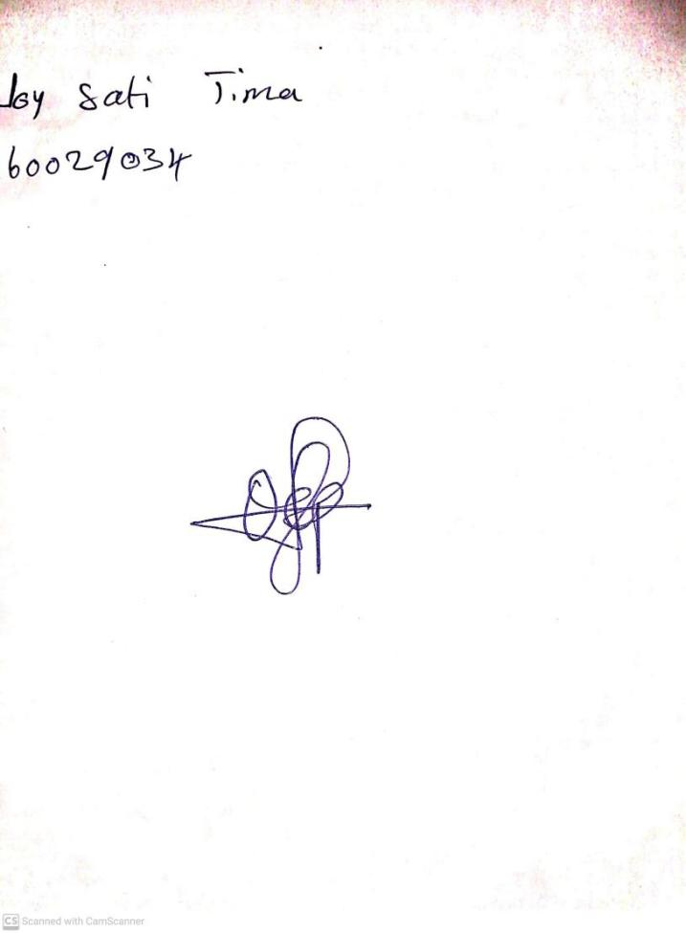

**25th October, 2024**

**Perpetual Ojoma Ocheja**

**Stream Head Nursery**