EMERALD ROYAL INTERNATIONAL SCHOOL

MPAPE, ABUJA.

LESSON PLAN AND NOTE FOR WEEK 7 ENDING 16TH JUNE, 2023

TERM: Third term.

WEEK: 7th

SUBJECT: Nature studies.

TOPIC: Rainbow

SUB-TOPIC: Colours of the rainbow.

DATE: 17/6/2023

DURATION: 40 minutes

TIME: 08:50-09:30

PERIOD: 3rd

CLASS: Pre-nursery

NUMBER OF PUPILS: 11

AVERAGE AGE: 2 years

SEX: Mixed

SPECIFIC OBJECTIVES: By the end of the lesson, the pupils should be able to:-

I Define rainbow.

2. List the colours of the rainbow.

RATIONALE: For Pupils to know the colours of the rainbow..

PREVIOUS KNOWLEDGE: Pupils have been taught the weather.

INSTRUCTIONAL MATERIALS: chart of rainbow.

REFERENCE: Showers kiddies books Elementary science book nursery 1 by showers kiddies books.

LESSON DEVELOPMENT

|  |  |  |  |
| --- | --- | --- | --- |
| Stages/steps | Teacher's activities | Pupils' activities | Learning points |
| Introduction | Teacher introduces the lesson by singing a nursery rhyme as:-  Rain rain go away  Come again another day  Little children want to play. | Pupils listen to teacher and sing along with the teacher. | To arouse the interest of the pupils. |
| Presentation  Step 1 | Teacher defines rainbow to the pupils as:  "Rainbow is a kind of coloured bowl in the sky after the rain."  "Teacher asks the pupils to repeat after the teacher. | Pupils listen to the teacher and repeat after the teacher. | For better understanding of the lesson. |
| Step 2 | Teacher guides the pupils to mention the colours of the rainbow.  Teacher also inform the pupils that there are 7 colours of the rainbow. | Pupils list the colours of the rainbow as:-   1. Red 2. Orange 3. Yellow 4. Green 5. Blue 6. Indigo 7. Violet | For active classroom participation . |
| Summary | Teacher summarizes the lesson by going over the lesson again to define rainbow and the colours of the rainbow for more understanding. | Pupils listen attentively to the teacher as she is going over the lesson. | To ensure better understanding. |
| Evaluation | Teacher asks the Pupils to :-   1. Define the rainbow. 2. Mention the colours of the rainbow | Pupils answer the teacher's questions correctly. | To ascertain the level of pupils understanding of the lesson. |
| Conclusion | Teacher concludes the lesson by drawing a rainbow shape and asks them to colour it.  The teacher also marks their books and make necessary corrections . | Pupils colour rainbow in there books and submit them for corrections. | For onwards learning. |
| Assignment | Teacher asks the pupils to colour a rainbow in there text books at home. | Pupils do the assignment at home. | To encourage Learning at home. |

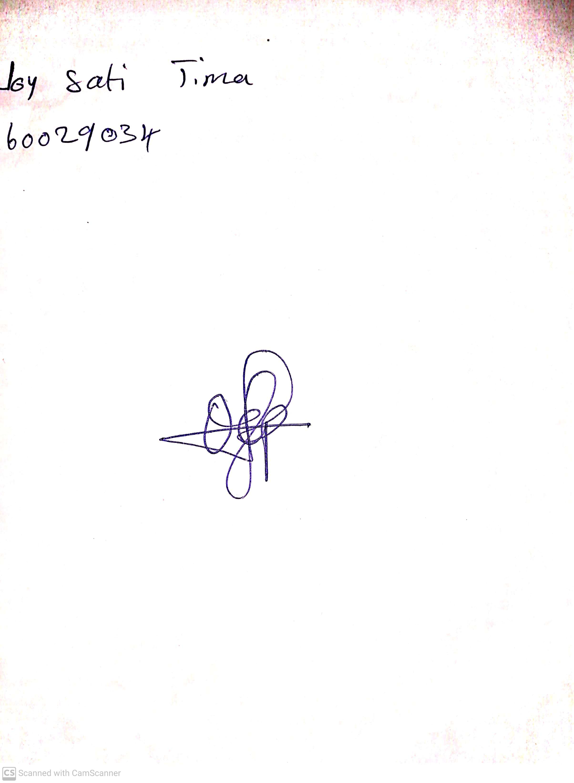

29th April, 2023

Perpetual Ojoma

Stream Head Nursery