**EMERALD ROYAL INTERNATIONAL SCHOOL**

**MPAPE, ABUJA.**

**LESSON PLAN AND NOTE 1 FOR WEEK 1 ENDING 26TH APRIL,2024.**

TERM: 3RD TERM

WEEK: 1ST WEEK

SUBJECT: Number Work

TOPIC: Counting numbers 1 - 25.

SUB-TOPIC: Identification of numbers 1 - 25

DATE: 23RD April, 2024.

DURATION: 40 minutes.

TIME: 08:50--09:30.

PERIOD: 1st

CLASS: Pre-nursery

NUMBER OF PUPILS: 19

AVERAGE AGE: 2 years

SEX: Mixed.

SPECIFIC OBJECTIVES: By the end of the lesson, the pupils should be able to:-

1. Count Numbers 1-25
2. Identify numbers 1 - 25

RATIONALE: For pupils to be able to count numbers.

PREVIOUS KNOWLEDGE: Pupils have been counting numbers.

INSTRUCTIONAL MATERIALS: Number chart, flash cards, building blocks etc

REFERENCE MATERIALS: Mastering mathematics for nursery schools book 1 by Henry Idogun.

**LESSON DEVELOPMENT**

|  |  |  |  |
| --- | --- | --- | --- |
| STAGES/STEPS | TEACHER’S ACTIVITIES | PUPILS’ ACTIVITIES | LEARNING POINTS |
| INTRODUCTION | Teacher introduces the lesson by singing a number rhyme for the pupils. | Pupils sing the rhyme along with the teacher. | To arouse pupils interest in the lesson. |
| PRESENTATION  STEP 1 | Teacher counts numbers 1 - 25 for the pupils to repeat after her. | Pupils count numbers 1 - 25 after the teacher. I.e 1 2 3 4 5 6 7 8 9 10 11 12 13 14 15 16 17 18 19 20 21 22 23 24 25. | For better understanding of the lesson . |
| STEP 2 | Teacher guides pupils to identify numbers numbers 1 - 25. | Pupils point at numbers 1 - 25. ie  1 2 3 4 5 6 7 8 9 10 11 12 13 14 15 16 17 18 19 20 21 22 23 24 25. | For proper understanding of the lesson. |
| SUMMARY | Teacher identifies each number 1 - 25 for the pupils. | Pupils point at the numbers. | For more understanding of the lesson. |
| EVALUATION | Teacher asks Pupils to count numbers 1 - 25 | Pupils count numbers 1 - 25. | To assess pupils understanding of the lesson. |
| CONCLUSION | Teacher sings a number rhyme for the pupils. | Pupils sing the rhyme along with the teacher. | To improve pupils speaking ability. |
| ASSIGNMENT (HOME WORK) | Count and circle numbers 1 - 20  1 2 3 4 5 6 7 8 9 10 11 12 13 14 15 16 19 20 21 22 23 24 25. | Pupils do their assignment at home. | To encourage pupils to learn at home. |

**LESSON PLAN AND NOTE 2 FOR WEEK 1 ENDING 26TH APRIL, 2024.**

TERM: 3RD TERM

WEEK: 1ST WEEK

SUBJECT: Number Work

TOPIC: Counting numbers 1 - 25.

SUB-TOPIC: Copying number 3

DATE: 24TH April, 2024.

DURATION: 40 minutes.

TIME: 08: 50 - 09: 30

PERIOD: 2nd

CLASS: Pre-nursery

NUMBER OF PUPILS: 19

AVERAGE AGE: 2 years

SEX: Mixed.

SPECIFIC OBJECTIVES: By the end of the lesson, the pupils should be able to:-

1. Count Numbers 1-25
2. Copy number 3

RATIONALE: For pupils to be able to count numbers.

PREVIOUS KNOWLEDGE: Pupils have been counting numbers.

INSTRUCTIONAL MATERIALS: Number chart, flash cards, building blocks etc

REFERENCE MATERIALS: Mastering mathematics for nursery schools book 1 by Henry Idogun.

**LESSON DEVELOPMENT**

|  |  |  |  |
| --- | --- | --- | --- |
| STAGES/STEPS | TEACHER’S ACTIVITIES | PUPILS’ ACTIVITIES | LEARNING POINTS |
| INTRODUCTION | Teacher introduces the lesson by singing a number rhyme for the pupils. | Pupils sing the rhyme along with the teacher. | To arouse pupils interest in the lesson. |
| PRESENTATION  STEP 1 | Teacher counts numbers 1 - 25 for the pupils to repeat after her. | Pupils count numbers 1 - 25 after the teacher. I.e 1 2 3 4 5 6 7 8 9 10 11 12 13 14 15 16 17 18 19 20 21 22 23 24 25. | For better understanding of the lesson . |
| STEP 2 | Teacher guides pupils to copy number 3 . | Pupils copy number 3 **numbers 1-   20** numbers 1-   20 numbers 1-   20  numbers 1-   20 numbers 1-   20 numbers 1-   20 | For proper understanding of the lesson. |
| SUMMARY | Teacher identifies each number 1 - 25 for the pupils. | Pupils point at the numbers. | For more understanding of the lesson. |
| EVALUATION | Teacher asks Pupils to count numbers 1 - 25 | Pupils count numbers 1 - 25. | To assess pupils understanding of the lesson. |
| CONCLUSION | Teacher sings a number rhyme for the pupils. | Pupils sing the rhyme along with the teacher. | To improve pupils speaking ability. |
| ASSIGNMENT (HOME WORK) | Copy number 3  numbers 1-   20 numbers 1-   20 numbers 1-   20 numbers 1-   20 | Pupils do their assignment at home. | To encourage pupils to learn at home. |

**LESSON PLAN AND NOTE 3 FOR WEEK 1 ENDING 26TH APRIL, 2024.**

TERM: 3RD TERM

WEEK: 1ST WEEK

SUBJECT: Number Work

TOPIC: Counting numbers 1 - 25.

SUB-TOPIC: Copying number 4

DATE: 25TH April, 2024.

DURATION: 40 minutes.

TIME: 08: 50 - 09: 30

PERIOD: 3rd

CLASS: Pre-nursery

NUMBER OF PUPILS: 19

AVERAGE AGE: 2 years

SEX: Mixed.

SPECIFIC OBJECTIVES: By the end of the lesson, the pupils should be able to:-

1. Count Numbers 1-25
2. Copy number 4

RATIONALE: For pupils to be able to count numbers.

PREVIOUS KNOWLEDGE: Pupils have been counting numbers.

INSTRUCTIONAL MATERIALS: Number chart, flash cards, building blocks etc

REFERENCE MATERIALS: Mastering mathematics for nursery schools book 1 by Henry Idogun.

**LESSON DEVELOPMENT**

|  |  |  |  |
| --- | --- | --- | --- |
| STAGES/STEPS | TEACHER’S ACTIVITIES | PUPILS’ ACTIVITIES | LEARNING POINTS |
| INTRODUCTION | Teacher introduces the lesson by singing a number rhyme for the pupils. | Pupils sing the rhyme along with the teacher. | To arouse pupils interest in the lesson. |
| PRESENTATION  STEP 1 | Teacher counts numbers 1 - 25 for the pupils to repeat after her. | Pupils count numbers 1 - 25 after the teacher. I.e 1 2 3 4 5 6 7 8 9 10 11 12 13 14 15 16 17 18 19 20 21 22 23 24 25. | For better understanding of the lesson . |
| STEP 2 | Teacher guides pupils to copy number 4. | Pupils copy number 4  numbers 1-9numbers 1-9numbers 1-9numbers 1-9numbers 1-9 | For proper understanding of the lesson. |
| SUMMARY | Teacher identifies each number 1 - 25 for the pupils. | Pupils point at the numbers. | For more understanding of the lesson. |
| EVALUATION | Teacher asks Pupils to count numbers 1 - 25 | Pupils count numbers 1 - 25. | To assess pupils understanding of the lesson. |
| CONCLUSION | Teacher sings a number rhyme for the pupils. | Pupils sing the rhyme along with the teacher. | To improve pupils speaking ability. |
| ASSIGNMENT (HOME WORK) | Copy number 4  numbers 1-9numbers 1-9numbers 1-9numbers 1-9numbers 1-9 | Pupils do their assignment at home. | To encourage pupils to learn at home. |

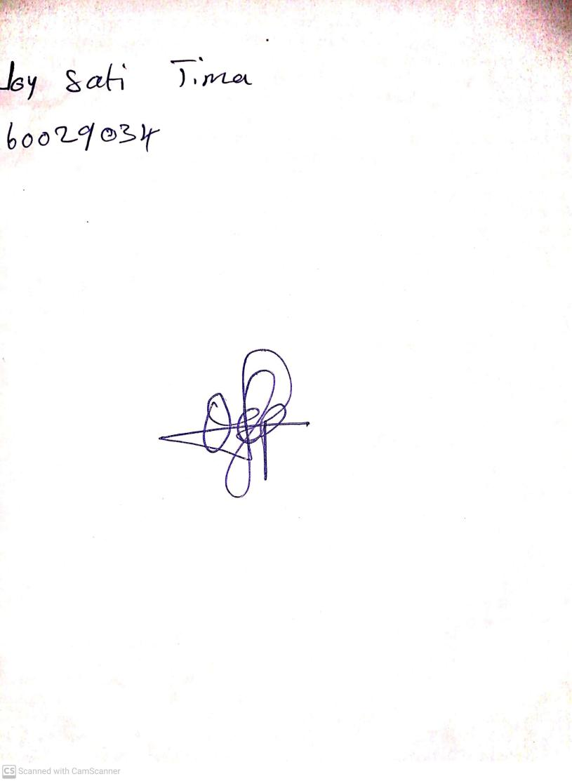

**19th April, 2024**

**Perpetual Ojoma Ocheja**

**Stream Head Nursery**