**EMERALD ROYAL INTERNATIONAL SCHOOL MPAPE, ABUJA**

**LESSON PLAN AND NOTE FOR WEEK 4 PERIOD 1 ENDING 2/02/2024**

**TERM: 2nd**

**WEEK: 4th**

**DATE: 29/01/2024**

**CLASS: Nursery 2**

**SUBJECT: Number work**

**TOPIC: Ordinal numbers (positioning)**

**SUB—TOPIC: Meaning and examples of Ordinal numbers**

**PERIOD: 3rd**

**TIME: 08:50—09:30am**

**DURATION: 40 minutes**

**NUMBER IN CLASS: 13**

**AVERAGE AGE: 5 years**

**SEX: Mixed**

**LEARNING OBJECTIVES: By the end of the lesson, the pupils should be able to:**

**1. Explain the meaning of Ordinal numbers.**

**2. State the examples of Ordinal numbers.**

**RATIONALE: For pupils to know positioning**

**PREVIOUS KNOWLEDGE: Pupils have learn counting of numbers 1—35**

**INSTRUCTIONAL MATERIALS: A chart of numbers**

**REFERENCE MATERIALS: My choice of Mathematics stage 3.**

**LESSON DEVELOPMENT**

|  |  |  |  |
| --- | --- | --- | --- |
| **Steps** | **Teacher's activities** | **Pupils' activities** | **Learning point** |
| **Introduction** | **Teacher introduces the lesson by singing nursery number rhymes.** | **Pupils sing the rhymes along with the teacher** | **To prepare pupils minds for the lesson ahead.** |
| **Presentation step 1** | **Teacher presents the lesson by explaining the meaning of Ordinal numbers to pupils and then asks them to repeat after her.** | **Pupils pay attention to the teacher and repeat after her.** | **For proper understanding.** |
| **Step 2** | **Teacher States the examples of Ordinal numbers and also asks Pupils to repeat after her.** | **Pupils listen to the teacher and also repeat after her.** | **For better understanding.** |
| **Board Summary** | **Teacher writes the whole not of lesson on the board for pupils to copy into their books. That is;**  **Ordinal number is when a number tell us about some position.**  **Examples of Ordinal numbers**  **1. Number 1 is First**  **2. Number 2 is Second**  **3. Number 3 is Third**  **4. Number 4 is Fourth**  **5. Number 5 is Fifth**  **6. Number 6 is Sixth**  **7. Number 7 is Seventh**  **8. Number 8 is Eighth**  **9. Number 9 is Ninth**  **10. Number 10 is Tenth etc.** | **Pupils copy the note into their exercise books.** | **For onward study** |
| **Evaluation** | **Teacher asks pupils to read the note on the board one after the other.** | **Pupils read the note on the board one after the other.** | **To assess pupils level of understanding.** |
| **Conclusion** | **Teacher concludes the lesson by marking pupils books.** | **Pupils submit their books for marking.** | **For endorsement** |
| **Home work** | **What is the position of the following objects?**    **Pencils.**    **Orange.**    **Crayons**    **Cups.**    **Balls.**    **Triangles** | **Pupils do their assignment at home.** | **To encourage learning at home.** |

**LESSON PLAN AND NOTE FOR WEEK 4 PERIOD 2 ENDING 02/02/2024**

**TERM: 2nd**

**WEEK: 4th**

**DATE: 01/02/2024**

**CLASS: Nursery 2**

**SUBJECT: Number work**

**TOPIC: Ordinal numbers**

**SUB—TOPIC: Difference between cardinal and Ordinal numbers**

**PERIOD: 2nd**

**TIME: 08:50—09:30am**

**DURATION: 40 minutes**

**NUMBER IN CLASS: 13**

**AVERAGE AGE: 5 years**

**SEX: Mixed**

**LEARNING OBJECTIVES: By the end of the lesson, the pupils should be able to:**

**1. Differentiate between cardinal numbers with Ordinal numbers.**

**2. Identify examples of cardinal numbers and Ordinal numbers.**

**RATIONALE: For pupils to know the difference between cardinal and Ordinal numbers.**

**PREVIOUS KNOWLEDGE: Pupils have learn the meaning and examples of Ordinal numbers.**

**INSTRUCTIONAL MATERIALS: Cardinal and Ordinal numbers chart**

**REFERENCE MATERIALS: My choice of Mathematics stage 3.**

**LESSON DEVELOPMENT**

|  |  |  |  |
| --- | --- | --- | --- |
| **Stages/steps** | **Teacher's activities** | **Pupils' activities** | **Learning point** |
| **Introduction** | **Teacher introduces the lesson by asking pupils the meaning of Ordinal numbers and examples.** | **Pupils answer the questions ask by the teacher.** | **To prepare pupils minds for the lesson ahead.** |
| **Presentation step 1** | **Teacher presents the lesson by explaining the difference between cardinal and Ordinal numbers to pupils** | **Pupils pay attention to the teacher** | **For proper understanding.** |
| **Step 2** | **Teacher mentions the examples of cardinal numbers and examples of Ordinal numbers to pupils and asks them to repeat after her.** | **Pupils listen to the teacher and repeat after her.** | **For batter understanding.** |
| **Board summary** | **Teacher writes the whole note of lesson on the board for pupils to copy into their books. That is;**  **THE DIFFERENCE BETWEEN CARDINAL NUMBERS AND ORDINAL NUMBERS**  **Cardinal numbers are written in figures or words. While**  **Ordinal numbers are written in position.**  **EXAMPLES OF CARDINAL NUMBERS**  **1 or one**  **2 or two**  **3 or three**  **4 or four**  **5 or five**  **6 or six**  **7 or seven**  **8 or eight**  **9 or nine**  **10 or ten etc.**  **EXAMPLES OF ORDINAL NUMBERS**  **1st or First**  **2nd or Second**  **3rd or Third**  **4rh or Fourth**  **5th or Fifth**  **6th or Sixth**  **7th or Seventh**  **8th or Eighth**  **9th or Ninth**  **10th or Tenth etc.** | **Pupils copy the note into their exercise books.** | **For onward study.** |
| **Evaluation** | **Teacher evaluates the lesson by asking pupils the following questions:**  **1. What are the differences between cardinal and Ordinal numbers?**  **2. Mention the examples of cardinal numbers.**  **3. List the examples of Ordinal numbers.** | **Pupils answer the questions ask by the teacher.** | **To assess pupils level of understanding.** |
| **Conclusion** | **Teacher concludes the lesson by marking pupils books.** | **Pupils submit their books for marking.** | **To make corrections where necessary.** |
| **Home work** | **Practice by writing the following Ordinal numbers.**   |  |  | | --- | --- | | **Cardinal numbers** | **Ordinal numbers** | | **4** | **4th fourth** | | **2** |  | | **8** |  | | **6** |  | | **5** |  | | **3** |  | | **1** |  | | **7** |  | | **Pupils do their assignment at home.** | **To encourage learning at home.** |

**LESSON PLAN AND NOTE FOR WEEK 4 PERIOD 3 ENDING 02/02/2024**

**TERM: 2nd**

**WEEK: 4th**

**DATE: 02/02/2024**

**CLASS: Nursery 2**

**SUBJECT: Number work**

**TOPIC: Ordinal numbers**

**SUB—TOPIC: Comparing letters positioning of words.**

**PERIOD: 1st**

**TIME: 08:10—08:50am**

**DURATION: 40 minutes**

**NUMBER IN CLASS: 13**

**AVERAGE AGE: 5 years**

**SEX: Mixed**

**LEARNING OBJECTIVES: By the end of the lesson, the pupils should be able to:**

**1. Compare the letter position of the word 'SCHOOL'**

**2. Write the letter position of the word 'ORDINAL'**

**RATIONALE: For pupils to be conversant with Ordinal numbers.**

**PREVIOUS KNOWLEDGE: Pupils have been learning the topic.**

**INSTRUCTIONAL MATERIALS: Chart of Ordinal numbers**

**REFERENCE MATERIALS: My choice of Mathematics stage 3.**

**LESSON DEVELOPMENT**

|  |  |  |  |
| --- | --- | --- | --- |
| **Steps** | **Teacher's activities** | **Pupils' activities** | **Learning point** |
| **Introduction** | **Teacher introduces the lesson by singing nursery rhymes.** | **Pupils sing the rhymes along with the teacher.** | **To prepare pupils minds for the lesson.** |
| **Presentation step 1** | **Teacher writes the word 'SCHOOL' on the board and compare the letter position.** | **Pupils pay attention to the teacher.** | **For proper understanding..** |
| **Step 2** | **Teacher writes the word 'ORDINAL' on the board and compare their letter position and then asks Pupils to repeat after her.** | **Pupils listen to the teacher and repeat after her.** | **For better understanding.** |
| **Board summary** | **Teacher writes the note of lesson on the board for pupils to copy. Ie;**  **Compare the letter position of the following words**  **(1). SCHOOL**  **S — is the 1st letter**  **C — is the 2nd letter**  **H — is the 3rd letter**  **O — is the 4th letter**  **O — is the 5th letter**  **L — is the 6th letter**  **(2).ORDINAL**  **O — is the 1st letter**  **R — is the 2nd letter**  **D — is the 3rd letter**  **I — is the 4th letter**  **N — is the 5th letter**  **A — is the 6th letter**  **L — is the 7th letter** | **Pupils copy the note into their exercise books.** | **For onward study.** |
| **Evaluation** | **Teacher evaluates the lesson by asking pupils to read the note on the board one after the other.** | **Pupils read the note on the board one after the other.** |  |
| **Conclusion** | **Teacher concludes the lesson by marking pupils books.** | **Pupils submit their books for marking.** | **For endorsement.** |
| **Assignment (home work)** | **Write the following Ordinal numbers.**   |  |  | | --- | --- | | **Cardinal numbers** | **Ordinal numbers** | | **8** |  | | **6** |  | | **3** |  | | **4** |  | | **2** |  | | **1** |  | | **7** |  | | **5** |  | | **Pupils do their assignment at home.** | **To encourage learning at home.** |

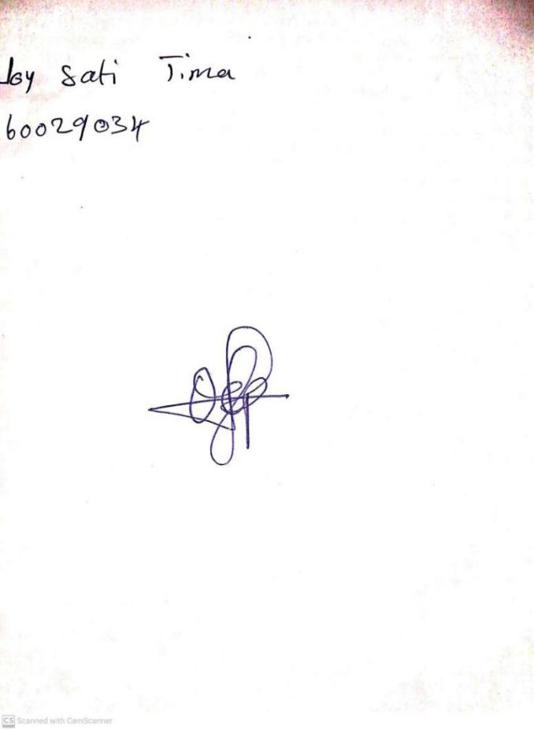

**26TH JANUARY, 2024**

**Perpetual Ojoma Ocheja**

**Stream Head Nursery**