**EMERALD ROYAL INTERNATIONAL SCHOOL**

**MPAPE, ABUJA.**

**LESSON PLAN AND NOTE FOR WEEK 6 PERIOD 1 ENDING 31/05/2024**

**TERM: THIRD**

**WEEK: 6TH**

**DATE: 27/05/2024**

**CLASS: NURSERY 2**

**SUBJECT: LETTER WORK**

**TOPIC: WORDS STUDY: PARTS OF MY BODY**

**SUB-TOPIC: SPELLING OF THE UPPER PARTS OF THE BODY(HEAD)**

**PERIOD: 1ST**

**TIME: 09: 30 - 10:10am**

**DURATION: 40 MINUTES.**

**NUMBER IN CLASS: 13**

**AVERAGE AGE: 5 YEARS.**

**SEX: MIXED.**

**SPECIFIC OBJECTIVES: BY THE END OF THE LESSON,THE PUPILS SHOULD BE**

**ABLE TO:**

**1. IDENTIFY THE VARIOUS PARTS OF THE BODY THAT**

**MAKES UP THE HEAD.**

**2. SPELL AND PRONOUNCE THE PARTS THAT MAKES**

**UP THE HEAD.**

**RATIONALE: FOR PUPILS TO LEAN SPELLINGS ON PARTS OF THE**

**BODY.**

**PREVIOU KNOWLEDGE: PUPILS HAVE BEEN IDENTIFYING THIER BODY PARTS**

**INSTRUCTIONAL MATERIALS: A CHART OF PARTS OF THE BODY**

**REFERENCE MATERIALS: THE NEW MASTERING ENGLISH FOR NURSERY**

**SCHOOLS BOOK 3 BY J. M OMOGBAI**

**LESSON DEVELOPMENT**

|  |  |  |  |
| --- | --- | --- | --- |
| **STAGES/STEPS** | **TEACHER’S ACTIVITIES** | **PUPILS’ ACTIVITIES** | **LEARNING POINTS** |
| **INTRODUCTION** | **Teacher introduces the lesson by singing nursery rhyme as;**  **My head, my shoulders, my knees, my toes ......** | **Pupil listen attentively to the teacher and sing the rhyme along with her.** | **To prepare pupils minds for the lesson ahead.** |
| **PRESENTATION**  **STEP 1** | **Teacher presents the lesson by asking pupils to point at their head, and then tell them the parts that makes up the head and asks them to repeat after her.** | **Pupils point at their head and repeat after her.** | **For proper understanding .** |
| **STEP 2** | **Teacher writes the parts of the body that makes up the head on the board, spell and pronounce and also asks pupils to repeat after her.** | **Pupils pay attention to the teacher and repeat after her.** | **For better understanding of the lesson.** |
| **BOARD SUMMARY** | **Teacher writes the whole not of lesson on the board for pupils to copy. That is;**  **PARTS OF MY BODY**  **The head is the upper part of the human body.**  **Parts of the head are:**  **1. Hair**  **2. Cheek**  **3. Nose**  **4. Mouth**  **5. Ear**  **6. Jaw**  **7. Eye** | **Pupils copy the note into their exercise books.** | **For onward study.** |
| **EVALUATION** | **Teacher evaluates the lesson by asking pupils to all stand and then spell and pronounce the parts that makes up the head on the board one after another. Such as;**  **Hair**  **Cheek**  **Nose**  **Mouth**  **Ear**  **Jaw**  **Eye.** | **Pupils listen to the teacher and answer the questions asked by the her.** | **To assess pupils reading skills.** |
| **CONCLUTION** | **Teacher concludes the lesson by marking pupils books.** | **Pupils submit their books for marking.** | **For endorsement.** |
| **ASSIGNMENT** | **Spell and pronounce the following words**  **1. Mouth**  **2. Cheek**  **3. Jaw**  **4. Nose**  **5. Eye**  **6. Ear**  **7. Hair** | **Pupils do their assignment at home.** | **To encourage learning at home.** |

**LESSON PLAN AND NOTE FOR WEEK 6 PERIOD 2 ENDING 31/05/2024**

**TERM: THIRD**

**WEEK: 6TH**

**DATE: 28/05/2024**

**CLASS: NURSERY 2**

**SUBJECT: LETTER WORK**

**TOPIC: WORDS STUDY: PARTS OF MY BODY**

**SUB-TOPIC: SPELLING OF THE MIDDLE PART OF THE BODY**

**(TRUNK)**

**PERIOD: 2ND PERIOD**

**TIME: 09: 30 - 10:10am**

**DURATION: 40 MINUTES.**

**NUMBER IN CLASS: 13**

**AVERAGE AGE: 5 YEARS.**

**SEX: MIXED.**

**SPECIFIC OBJECTIVES: BY THE END OF THE LESSON,THE PUPILS SHOULD BE**

**ABLE TO:**

**1. MENTION THE MIDDLE PARTS OF THE BODY**

**2. SPELL AND PRONOUNCE THE MIDDLE PARTS OF THE**

**BODY.**

**RATIONALE: FOR PUPILS TO KNOW THE SPELLING OF THIER BODY**

**PARTS**

**PREVIOU KNOWLEDGE: PUPILS HAVE LEARNT ABOUT THE PARTS THAT MADE UP**

**HEAD.**

**INSTRUCTIONAL MATERIALS: A CHART OF PARTS OF THE BODY**

**REFERENCE MATERIALS: THE NEW MASTERING ENGLISH FOR NURSERY SCHOOLS BOOK 3 BY J. M OMOGBAI .**

**LESSON DEVELOPMENT**

|  |  |  |  |
| --- | --- | --- | --- |
| **STAGES/STEPS** | **TEACHER’S ACTIVITIES** | **PUPILS’ ACTIVITIES** | **LEARNING POINTS** |
| **INTRODUCTION** | **Teacher introduces the lesson by asking pupils to mention the parts of the body that made up the head.** | **Pupil listen attentively to the teacher and mention.** | **To prepare pupils minds for the lesson ahead.** |
| **PRESENTATION**  **STEP 1** | **Teacher mentions the middle parts of the body to pupils and asks them to repeat after her.** | **Pupils listen attentively to the teacher and repeat after her.** | **For proper understanding .** |
| **STEP 2** | **Teacher writes the parts that made up the middle part of the body on the board, spell and pronounce and then asks Pupils to repeat after her.** | **Pupils pay attention to the teacher and repeat after her.** | **For better understanding of the lesson.** |
| **BOARD SUMMARY** | **Teacher writes the whole not of lesson on the board for pupils to copy.ie,**  **The middle parts of the body is made up of :**  **1. Neck**  **2. Shoulders**  **3. Chest**  **4. Elbow**  **5. Arm**  **6. Hand**  **7. Fingers**  **8. Stomach**  **9. Breast**  **10. Nail** | **Pupils copy the note into their exercise books.** | **For onward study.** |
| **EVALUATION** | **Teacher evaluates the lesson by asking pupils to go to the board one after the other and then**   1. **spell the words** 2. **pronounce the words one after another.** | **Pupils listen to the teacher and read the note on the board one after another.** | **To assess pupils reading skills.** |
| **CONCLUTION** | **Teacher concludes the lesson by marking pupils books.** | **Pupils submit their books for marking.** | **For endorsement.** |
| **ASSIGNMENT** | **Spell and pronounce the following parts of the body:**  **1. Fingers**  **2. Stomach**  **3. Nail**  **4. Shoulders**  **5. Breast**  **6. Hand**  **7. Arm**  **8. Elbow**  **9. Neck**  **10. Chest** | **Pupils do their assignment at home.** | **To encourage learning at home.** |

**LESSON PLAN AND NOTE FOR WEEK 6 PERIOD 3 ENDING 31/05/2024**

**TERM: THIRD**

**WEEK: 6TH**

**DATE: 31/05/2024**

**CLASS: NURSERY 2**

**SUBJECT: LETTER WORK**

**TOPIC: WORDS STUDY: PARTS OF MY BODY**

**SUB-TOPIC: SPELLING OF THE LOWER PARTS OF THE BODY**

**PERIOD: 3RD PERIOD**

**TIME: 09: 30 - 10:10am**

**DURATION: 40 MINUTES.**

**NUMBER IN CLASS: 13**

**AVERAGE AGE: 5 YEARS.**

**SEX: MIXED.**

**SPECIFIC OBJECTIVES: BY THE END OF THE LESSON,THE PUPILS SHOULD BE**

**ABLE TO:**

**1. MENTION THE LOWER PARTS OF THE BODY.**

**2. SPELL AND PRONOUNCE THE LOWER PARTS OF THE**

**BODY.**

**RATIONALE: FOR PUPILS TO KNOW HOW TO SPELL THIER BODY**

**PARTS.**

**PREVIOU KNOWLEDGE: PUPILS HAVE LEARNT ABOUT THE UPPER AND MIDDLE**

**PARTS OF THE BODY.**

**INSTRUCTIONAL MATERIALS: A CHART OF PARTS OF THE BODY**

**REFERENCE MATERIALS: THE NEW MASTERING ENGLISH FOR NURSERY**

**SCHOOLS BOOK 3 BY J. M OMOGBAI**

**LESSON DEVELOPMENT**

|  |  |  |  |
| --- | --- | --- | --- |
| **STAGES/STEPS** | **TEACHER’S ACTIVITIES** | **PUPILS’ ACTIVITIES** | **LEARNING POINTS** |
| **INTRODUCTION** | **Teacher reviews the previous lesson.** | **Pupil listen attentively to the teacher.** | **To prepare pupils minds for the lesson ahead.** |
| **PRESENTATION**  **STEP 1** | **Teacher mention the parts that made up the lower part of the body to pupils and asks them to repeat after her.** | **Pupils listen attentively to the teacher and repeat after her.** | **For proper understanding .** |
| **STEP 2** | **Teacher writes the parts that made up the lower part of the body on the board, spell and pronounce and also asks pupils to repeat after her.** | **Pupils pay attention to the teacher and repeat after her.** | **For better understanding of the lesson.** |
| **BOARD SUMMARY** | **Teacher writes the whole not of lesson on the board for pupils to copy.ie,**  **The lower parts of the body are:**  **1. Thigh (leg)**  **2. Calf (leg)**  **3. Heel**  **4. Foot**  **5. Toe**  **6. Knee**  **7. Ankle.** | **Pupils copy the note into their exercise books.** | **For onward study.** |
| **EVALUATION** | **Teacher evaluates the lesson by asking pupils to**   1. **spell the parts of the body** 2. **pronounce the parts of the body on the board one after the other.** | **Pupils listen to the teacher and read the note on the board one after another.** | **To assess pupils reading skills.** |
| **CONCLUTION** | **Teacher concludes the lesson by marking pupils books.** | **Pupils submit their books for marking.** | **For endorsement.** |
| **ASSIGNMENT** | **Spell and write 10 parts of the body that you know.** | **Pupils do their assignment at home.** | **To encourage learning at home.** |

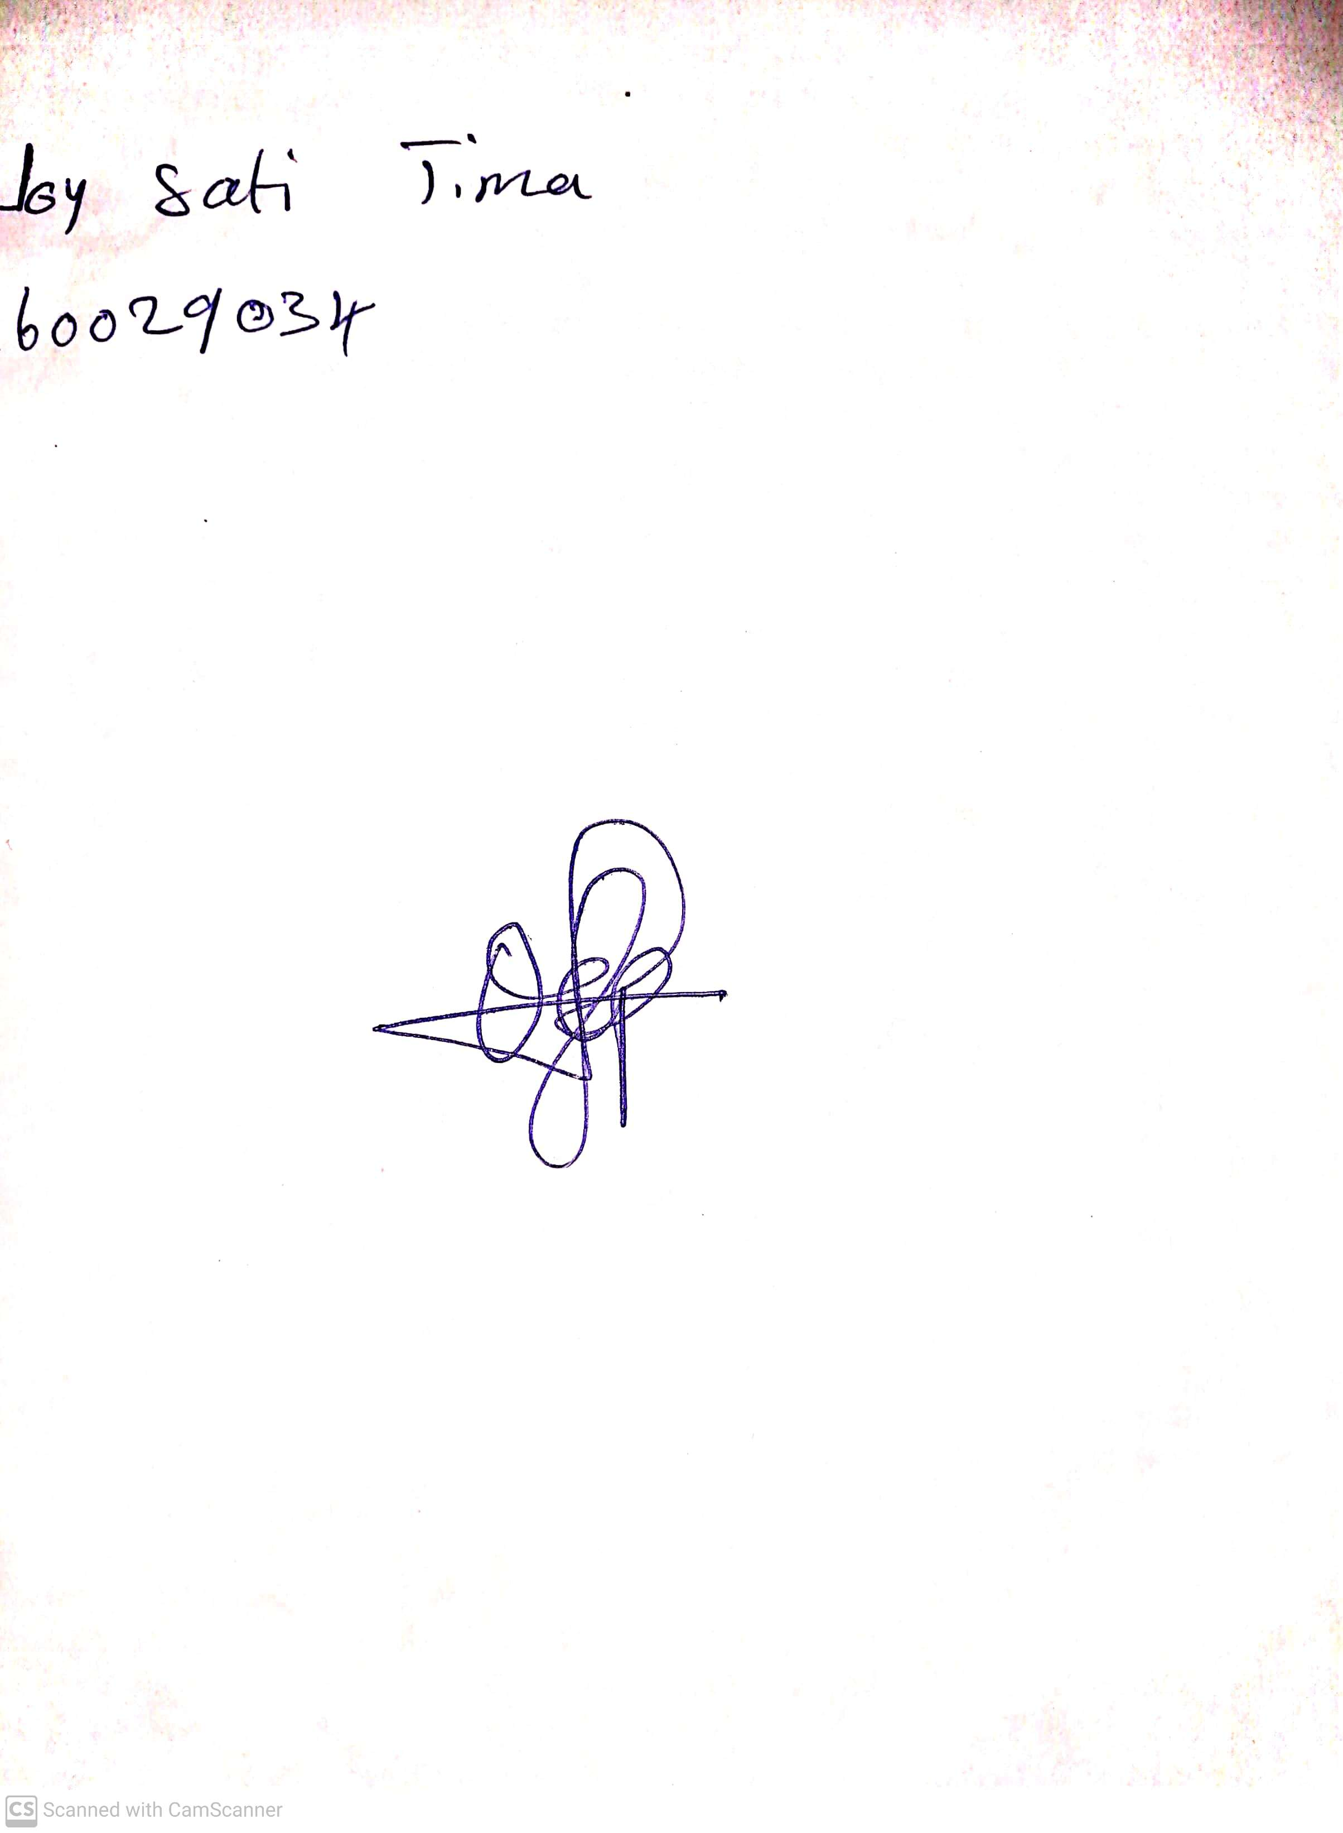

**24th May, 2024**

**Perpetual Ojoma Ocheja**

**Stream Head Nursery**