**EMERALD ROYAL INTERNATIONAL SCHOOL**

**MPAPE, ABUJA.**

**LESSON PLAN AND NOTE FOR WEEK 2 ENDING 22ND SEPTEMBER,2023**

TERM : First term.

WEEK : 2

SUBJECT: Social Norms

TOPIC: Myself

SUB-TOPIC: My Age

DATE: 19/8/2023

DURATION: 40 minutes

TIME: 10:40-11:20

PERIOD: 5th

CLASS: pre-nursery

NUMBER OF PUPILS:

AVERAGE AGE: 2

SEX: Mixed

SPECIFIC OBJECTIVES: By the end of the lesson, the pupils should be able to:-

1. Say their names.

2. Tell their age.

RATIONALE: For pupils to know about themselves.

PREVIOUS KNOWLEDGE: Pupils have practiced how to say their names in the previous lesson.

INSTRUCTIONAL MATERIALS: Pupils in the classroom.

REFERENCE: Smart start Civic education for nursery Schools book 1 by T.Y. Alabi and A. M. Solu.

LESSON DEVELOPMENT

|  |  |  |  |
| --- | --- | --- | --- |
| Stages/steps | Teacher's activities | Pupils' activities | Learning points |
| Introduction | Teacher introduces the lesson by singing nursery rhymes for the pupils | Pupils attempt to sing the rhymes along with the teacher. | To get pupils attention for the lesson. |
| Presentation  Step 1 | Teacher tells the pupils her name while touching her chest.  That is :-"My name is Mrs Gloria." Teacher also touches the child and say his/her name. "Your name is..................,........" | Pupils repeat after the teacher to say their names. Pupils do that repeatedly. | To improve pupils speaking abilities. |
| Step 2 | Teacher asks the pupils to say their age . Example:- " I am 2 years old. | Pupils repeat after the teacher to say their age repeatedly. | To improve pupils speaking abilities and to enable the pupils say their age. |
| Summary | Teacher summarizes the lesson by asking the pupils to repeat after her to say their names and age . | Pupils pay attention and say their names and age repeatedly. | To ensure better understanding of the lesson. |
| Evaluation | Teacher calls the pupils one after another and asks:-  1.What is your name?  2. How old are you? | Pupils answer the teacher's question correctly. | To assess pupils level of understanding of the lesson. |
| Conclusion | Teacher ends the lesson by singing a nursery rhyme for the pupils. | Pupils sing the rhyme along with the teacher. | To consolidate the lesson. |

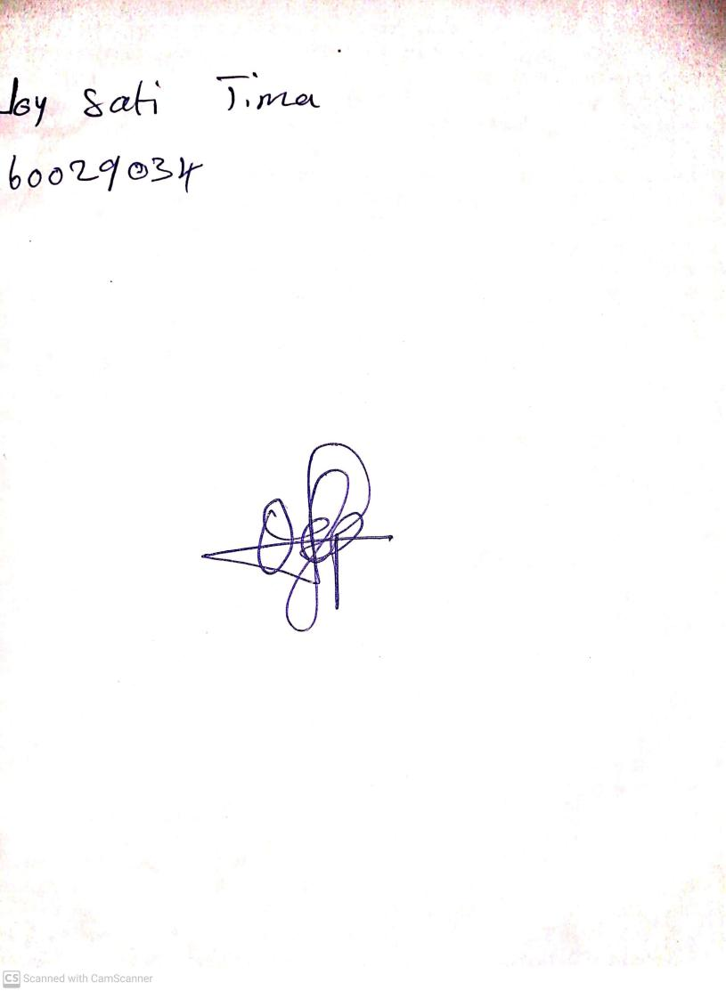

25th August, 2023

Perpetual Ojoma Ocheja

Stream Head Nursery