EMERALD ROYAL INTERNATIONAL SCHOOL

MPAPE, ABUJA.

LESSON NOTE FOR WEEK 1 ENDING 12TH JANUARY, 2024.

SUBJECT: Number Work

TOPIC: Counting Numbers 1 - 15

SUB-TOPIC: Counting Numbers 1 - 15

DATE: 08/01/2024.

DURATION: 40 minutes.

TIME: 08:50--09:30.

PERIOD: 2nd

CLASS: Pre-nursery

NUMBER OF PUPILS: 17

AVERAGE AGE: 2 YEARS

SEX: Mixed.

SPECIFIC OBJECTIVES: By the end of the lesson, the pupils should be able to:-

1. Count Numbers 1-15
2. Identify numbers 1 - 15

RATIONALE: For pupils to be able to count numbers.

PREVIOUS KNOWLEDGE: Pupils have been counting numbers.

INSTRUCTIONAL MATERIALS: N umber chart, flash cards etc

REFERENCE:Mastering mathematics for nursery schools book 1 by Henry Idogun.

LESSON DEVELOPMENT

|  |  |  |  |
| --- | --- | --- | --- |
| STAGES/STEPS | TEACHER’S ACTIVITIES | PUPILS’ ACTIVITIES | LEARNING POINTS |
| INTRODUCTION | Teacher introduces the lesson by singing a number rhyme for the pupils. | Pupils sing the rhyme along with the teacher. | To arouse pupils interest in the lesson. |
| PRESENTATION  STEP 1 | Teacher counts numbers 1 - 15 for the pupils to repeat after her. | Pupils count numbers 1 - 15 after the teacher. | For better understanding of the lesson . |
| STEP2 | Teacher guides each pupils to count numbers 1 -15. | Pupils count numbers 1 - 15 . That is. 1 2 3 4 5 6 7 8 9 10 11 12 13 14 15. | For proper understanding of the lesson. |
| SUMMARY | Teacher identifies each number 1 - 15 for the pupils. | Pupils point at the numbers. | For more understanding of the lesson. |
| EVALUATION | Teacher asks Pupils to 1. count numbers 1 - 15.  2.identify number 1-15 | Pupils count numbers 1 - 15. | To assess pupils understanding of the lesson. |
| CONCLUSION | Teacher plays a number video clip for the pupils to watch. | Pupils sit and watch the video. | To improve pupils listening ability. |
| ASSIGNMENT (HOME WORK) | Count and identify numbers 1 - 15  1 2 3 4 5 6 7 8 9 10 11 12 13 14 15. | Pupils do their assignment at home. | To encourage pupils to study at home. |

EMERALD ROYAL INTERNATIONAL SCHOOL

MPAPE, ABUJA.

LESSON NOTE FOR WEEK 1 ENDING 12TH JANUARY, 2024.

SUBJECT: Number Work

TOPIC: Counting Numbers 1 - 15

SUB-TOPIC: Counting Numbers 1 - 15

DATE: 09/01/2024.

DURATION: 40 minutes.

TIME: 08:50--09:30.

PERIOD: 2nd

CLASS: Pre-nursery

NUMBER OF PUPILS: 11

AVERAGE AGE: 2 YEARS

SEX: Mixed.

SPECIFIC OBJECTIVES: By the end of the lesson, the pupils should be able to:-

1. Count Numbers 1-15
2. Identify numbers 1 - 15

RATIONALE: For pupils to be able to count numbers.

PREVIOUS KNOWLEDGE: Pupils have been counting numbers.

INSTRUCTIONAL MATERIALS: N umber chart, flash cards etc

REFERENCE:Mastering mathematics for nursery schools book 1 by Henry Idogun.

LESSON DEVELOPMENT

|  |  |  |  |
| --- | --- | --- | --- |
| STAGES/STEPS | TEACHER’S ACTIVITIES | PUPILS’ ACTIVITIES | LEARNING POINTS |
| INTRODUCTION | Teacher introduces the lesson by singing a number rhyme for the pupils. | Pupils sing the rhyme along with the teacher. | To arouse pupils interest in the lesson. |
| PRESENTATION  STEP 1 | Teacher guides each pupils to count number 1-15 from the number chart. | Pupils count numbers 1 - 15 from the chart.. | For better understanding of the lesson . |
| STEP2 | Teacher identify numbers 1 - 15 for the pupils on the number chart. | Pupils point at the numbers on the flash card. That is .  3  2  1  4  6  5  9  8  7  12  10  11  14  15  13 | For proper understanding of the lesson. |
| SUMMARY | Teacher counts number 1-15 for the pupils. | Pupils count along with the teacher. | For more understanding of the lesson. |
| EVALUATION | Teacher asks Pupils to   1. count numbers 1 - 15. 2. Identify numbers 1-15 on the number chart. | Pupils answer the teacher”s questions . | To assess pupils understanding of the lesson. |
| CONCLUSION | Teacher plays a number video clip for the pupils to watch. | Pupils sit and watch the video. | To improve pupils listening ability. |
| ASSIGNMENT (HOME WORK) | Colour number 1 and 2.    1  2 | Pupils do their assignment at home. | To encourage pupils to study at home. |

EMERALD ROYAL INTERNATIONAL SCHOOL

MPAPE, ABUJA.

LESSON NOTE FOR WEEK 1 ENDING 12TH FEBRUARY, 2024.

SUBJECT: Number Work

TOPIC: Counting Numbers 1 - 15

SUB-TOPIC: Matching numbers 1 - 15

DATE: 11/01/2024.

DURATION: 40 minutes.

TIME: 08:50 - 09:30

PERIOD: 2nd

CLASS: Pre-nursery

NUMBER OF PUPILS: 17

AVERAGE AGE: 2 YEARS

SEX: Mixed.

SPECIFIC OBJECTIVES: By the end of the lesson, the pupils should be able to:-

1. Count Numbers 1-15
2. Match numbers 1 - 15

RATIONALE: For pupils to be able to identify numbers.

PREVIOUS KNOWLEDGE: Pupils have been counting numbers.

INSTRUCTIONAL MATERIALS: N umber chart, flash cards etc

REFERENCE:Mastering mathematics for nursery schools book 1 by Henry Idogun.

LESSON DEVELOPMENT

|  |  |  |  |
| --- | --- | --- | --- |
| STAGES/STEPS | TEACHER’S ACTIVITIES | PUPILS’ ACTIVITIES | LEARNING POINTS |
| INTRODUCTION | Teacher introduces the lesson by singing a number rhyme for the pupils. | Pupils sing the rhyme along with the teacher. | To arouse pupils interest in the lesson. |
| PRESENTATION  STEP 1 | Teacher counts numbers 1 - 15 for the pupils to repeat after her. | Pupils count numbers 1 - 15 after the teacher. I.e 1 2 3 4 5 6 7 8 9 10 11 12 13 14 15. | For better understanding of the lesson . |
| STEP2 | Teacher guides each pupils to count numbers 1 -15. | Pupils point at the numbers 1 - 15 I.e  1 ------------------------1  2 ---------------------2  3 ---------------------3  4 ---------------------4  5 ---------------------5  6 ----------------------6  7 ----------------------7  8 --------------------8  9 ----------------------9  10 -----------------------10  11 ------------------------11  12 -------------------------12  13 -------------------------13  14 --------------------------14  15 ----------------------------15 |  |
| SUMMARY | Teacher identifies each number 1 - 15 for the pupils. | Pupils point at the numbers. | For more understanding of the lesson. |
| EVALUATION | Teacher asks Pupils to   1. count numbers 1 - 15. 2. Match the numbers correctly. | Pupils answer the teacher”s questions correctly. | To assess pupils understanding of the lesson. |
| CONCLUSION | Teacher plays a number video clip for the pupils to watch. | Pupils sit and watch the video. | To improve pupils listening ability.  1 |
| ASSIGNMENT (HOME WORK) | Count and Identify numbers 1 - 15  1 2 3 4 5 6 7 8 9 10 11 12 13 14 15. | Pupils do their assignment at home. | To encourage pupils to study at home. |

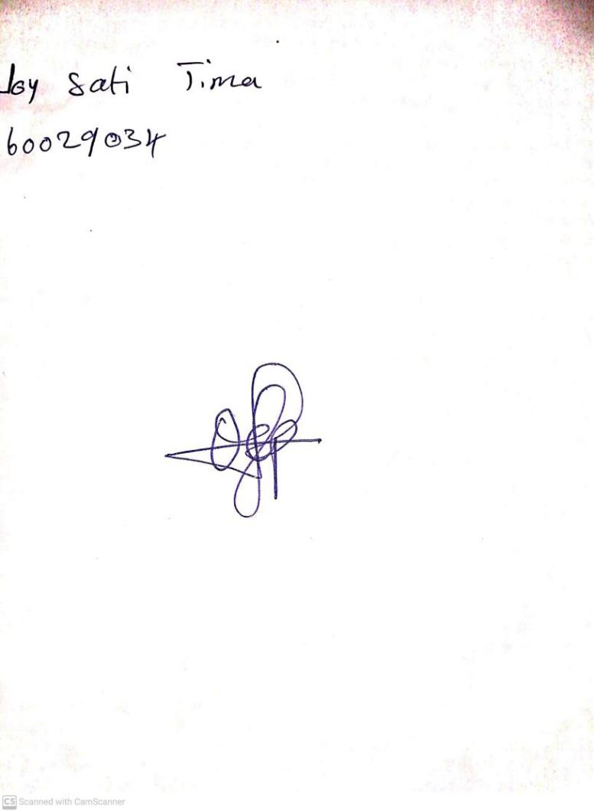

12TH January, 2024

Perpetual Ojoma Ocheja

Stream Head Nursery