**EMERALD ROYAL INTERNATIONAL SCHOOL MPAPE, ABUJA.**

**LESSON PLAN AND NOTE FOR WEEK 3 PERIOD 1 ENDING 10/05/2024**

**TERM: THIRD**

**WEEK: 3RD**

**DATE: 06/05/2024**

**CLASS: NURSERY 2**

**SUBJECT: LETTER WORK**

**TOPIC: VOWEL DIGRAPHS 2**

**SUB-TOPIC: WORDS WITH VOWEL DIGRAPHS “AI” AND “AY”**

**PERIOD: 1ST PERIOD**

**TIME: 09: 30 - 10:10am**

**DURATION: 40 MINUTES.**

**NUMBER IN CLASS: 13**

**AVERAGE AGE: 5 YEARS.**

**SEX: MIXED.**

**SPECIFIC OBJECTIVES: BY THE END OF THE LESSON,THE PUPILS SHOULD BE**

**ABLE TO:**

**1. MENTION WORDS WITH VOWEL DIGRAPHS “AI”**

**2. PRONOUNCE WORDS WITH VOWEL DIGRAPHS “AY”**

**RATIONALE: FOR PUPILS TO KNOW WORDS WITH. VOWELDIGRAPHS“AI” AND “AY”**

**PREVIOU KNOWLEDGE: PUPILS HAVE LEARNT THE MEANING OF VOWEL**

**DIGRAPHS IN PREVIOUS LESSON.**

**REFERENCE MATERIALS: GOOGLE.COM .**

**LESSON DEVELOPMENT**

|  |  |  |  |
| --- | --- | --- | --- |
| **STAGES/STEPS** | **TEACHER’S ACTIVITIES** | **PUPILS’ ACTIVITIES** | **LEARNING POINTS** |
| **INTRODUCTION** | **Teacher reviews the previous lesson on vowel digraphs to pupils.** | **Pupil listen attentively to the teacher.** | **To prepare pupils minds for the lesson ahead.** |
| **PRESENTATION**  **STEP 1** | **Teacher mentions words with vowel digraphs “ai” to pupils and asks them to repeat after her.** | **Pupils listen attentively to the teacher and repeat after her.** | **For proper understanding .** |
| **STEP 2** | **Teacher writes the words with vowel digraph “ay” on the board, spell and pronounce and also asks pupils to identify and repeat after her.** | **Pupils pay attention to the teacher and repeat after her.** | **For better understanding of the lesson.** |
| **BOARD SUMMARY** | **Teacher writes the whole not of lesson on the board for pupils to copy.ie,**  **VOWEL DIGRAPH “AI”**  **“ai” as in rain**  **“ai” as in train**  **“ai” as in maid**  **“ai” as in aim**  **“ai” as in sail**  **“ai” as in paid**  **“ai” as in wait**  **“ai” as in snail**  **“ai” as in grain**  **“ai” as in gain**  **“ai” as in afraid**  **“ai” as in nail etc**  **VOWEL DIGRAPHS “AY”**  **“ay” as in play**  **“ay” as in day**  **“ay” as in say**  **“ay” as in clay**  **“ay” as in pay**  **“ay” as in tray**  **“ay” as in away**  **“ay” as in today**  **“ay” as in relay**  **“ay” as in spray etc.** | **Pupils copy the note into their exercise books.** | **For onward study.** |
| **EVALUATION** | **Teacher evaluates the lesson by asking pupils to all,**  **1. Mention the words with vowel 'ai'**  **2. Pronounce words with vowel 'ay'** | **Pupils listen to the teacher and answer the questions asked by the her.** | **To assess pupils reading skills.** |
| **CONCLUTION** | **Teacher concludes the lesson by marking pupils books.** | **Pupils submit their books for marking.** | **For endorsement.** |
| **ASSIGNMENT** | **Make 10 words with vowel digraphs “ey”** | **Pupils do their assignment at home.** | **To encourage learning at home.** |

**LESSON PLAN AND NOTE FOR WEEK 3 PERIOD 2 ENDING 10/05/2024**

**TERM: THIRD**

**WEEK: 3RD**

**DATE: 07/05/2024**

**CLASS: NURSERY 2**

**SUBJECT: LETTER WORK**

**TOPIC: VOWEL DIGRAPHS 2**

**SUB-TOPIC: WORDS WITH VOWEL DIGRAPHS “EY”**

**PERIOD: 2ND PERIOD**

**TIME: 09: 30 - 10:10am**

**DURATION: 40 MINUTES.**

**NUMBER IN CLASS: 13**

**AVERAGE AGE: 5 YEARS.**

**SEX: MIXED.**

**SPECIFIC OBJECTIVES: BY THE END OF THE LESSON,THE PUPILS SHOULD BE**

**ABLE TO:**

**1. MENTION WORDS WITH VOWEL DIGRAPHS “EY”**

**2. PRONOUNCE WORDS WITH VOWEL DIGRAPHS “EY”**

**RATIONALE: FOR PUPILS TO KNOW WORDS WITH VOWEL DIGRAPHS“AI” AND “AY”**

**PREVIOU KNOWLEDGE: PUPILS HAVE LEARNT THE MEANING OF VOWEL**

**DIGRAPHS IN PREVIOUS LESSON.**

**REFERENCE MATERIALS: GOOGLE.COM .**

**LESSON DEVELOPMENT**

|  |  |  |  |
| --- | --- | --- | --- |
| **STAGES/STEPS** | **TEACHER’S ACTIVITIES** | **PUPILS’ ACTIVITIES** | **LEARNING POINTS** |
| **INTRODUCTION** | **Teacher reviews the previous lesson on vowel digraphs to pupils.** | **Pupil listen attentively to the teacher.** | **To prepare pupils minds for the lesson ahead.** |
| **PRESENTATION**  **STEP 1** | **Teacher mentions words with vowel digraphs “ey” to pupils and asks them to repeat after her.** | **Pupils listen attentively to the teacher and repeat after her.** | **For proper understanding .** |
| **STEP 2** | **Teacher writes the words with vowel digraph “ey” on the board, spell and pronounce and also asks pupils to identify and repeat after her.** | **Pupils pay attention to the teacher and repeat after her.** | **For better understanding of the lesson.** |
| **BOARD SUMMARY** | **Teacher writes the whole not of lesson on the board for pupils to copy.ie,**  **VOWEL DIGRAPH “EY”**  **“ey” as in key**  **“ey” as in honey**  **“ey” as in donkey**  **“ey” as in monkey**  **“ey” as in kidney**  **“ey” as in hockey**  **“ey” as in they**  **“ey” as in hey**  **“ey” as in whey**  **“ey” as in obey**  **“ey” as in survey etc** | **Pupils copy the note into their exercise books.** | **For onward study.** |
| **EVALUATION** | **Teacher evaluates the lesson by asking pupils to all stand and then spell and pronounce the words with vowel "ey" on the board all together.** | **Pupils listen to the teacher and read the note on the board one after another.** | **To assess pupils reading skills.** |
| **CONCLUTION** | **Teacher concludes the lesson by marking pupils books.** | **Pupils submit their books for marking.** | **For endorsement.** |
| **ASSIGNMENT** | **Make 10 words with vowel digraphs “aw”** | **Pupils do their assignment at home.** | **To encourage learning at home.** |

**LESSON PLAN AND NOTE FOR WEEK 3 PERIOD 3 ENDING 10/05/2024**

**TERM: THIRD**

**WEEK: 3RD**

**DATE: 10/05/2024**

**CLASS: NURSERY 2**

**SUBJECT: LETTER WORK**

**TOPIC: VOWEL DIGRAPHS 2**

**SUB-TOPIC: WORDS WITH VOWEL DIGRAPHS “AW”**

**PERIOD: 3RD PERIOD**

**TIME: 09: 30 - 10:10am**

**DURATION: 40 MINUTES.**

**NUMBER IN CLASS: 13**

**AVERAGE AGE: 5 YEARS.**

**SEX: MIXED.**

**SPECIFIC OBJECTIVES: BY THE END OF THE LESSON,THE PUPILS SHOULD BE**

**ABLE TO:**

**1. MENTION WORDS WITH VOWEL DIGRAPHS “AW”**

**2. PRONOUNCE WORDS WITH VOWEL DIGRAPHS “AW”**

**RATIONALE: FOR PUPILS TO KNOW WORDS WITH VOWEL DIGRAPHS“AW”**

**PREVIOU KNOWLEDGE: PUPILS HAVE LEARNT THE MEANING OF VOWEL**

**DIGRAPHS IN PREVIOUS LESSON.**

**REFERENCE MATERIALS: GOOGLE.COM .**

**LESSON DEVELOPMENT**

|  |  |  |  |
| --- | --- | --- | --- |
| **STAGES/STEPS** | **TEACHER’S ACTIVITIES** | **PUPILS’ ACTIVITIES** | **LEARNING POINTS** |
| **INTRODUCTION** | **Teacher reviews the previous lesson on vowel digraphs to pupils.** | **Pupil listen attentively to the teacher.** | **To prepare pupils minds for the lesson ahead.** |
| **PRESENTATION**  **STEP 1** | **Teacher mentions words with vowel digraphs “aw” to pupils and asks them to repeat after her.** | **Pupils listen attentively to the teacher and repeat after her.** | **For proper understanding .** |
| **STEP 2** | **Teacher writes the words with vowel digraph “aw” on the board, spell and pronounce and also asks pupils to identify and repeat after her.** | **Pupils pay attention to the teacher and repeat after her.** | **For better understanding of the lesson.** |
| **BOARD SUMMARY** | **Teacher writes the whole not of lesson on the board for pupils to copy.ie,**  **VOWEL DIGRAPH “AW”**  **“aw” as in claw**  **“aw” as in crawl**  **“aw” as in dawn**  **“aw” as in draw**  **“aw” as in drawers**  **“aw” as in fawn**  **“aw” as in hawk**  **“aw” as in lawn**  **“aw” as in paw**  **“aw” as in prawn**  **“aw” as in raw**  **“aw”as in saw**  **“aw” as in straw**  **“aw” as in shawl** | **Pupils copy the note into their exercise books.** | **For onward study.** |
| **EVALUATION** | **Teacher evaluates the lesson by asking pupils to spell and pronounce the words with vowel "aw" on the board one after another.** | **Pupils listen to the teacher and read the note on the board one after another.** | **To assess pupils reading skills.** |
| **CONCLUTION** | **Teacher concludes the lesson by marking pupils books.** | **Pupils submit their books for marking.** | **For endorsement.** |
| **ASSIGNMENT** | 1. **Make 10 words with vowel digraphs “ea”** 2. **Write 10 words with vowel digraphs “ie”** | **Pupils do their assignment at home.** | **To encourage learning at home.** |

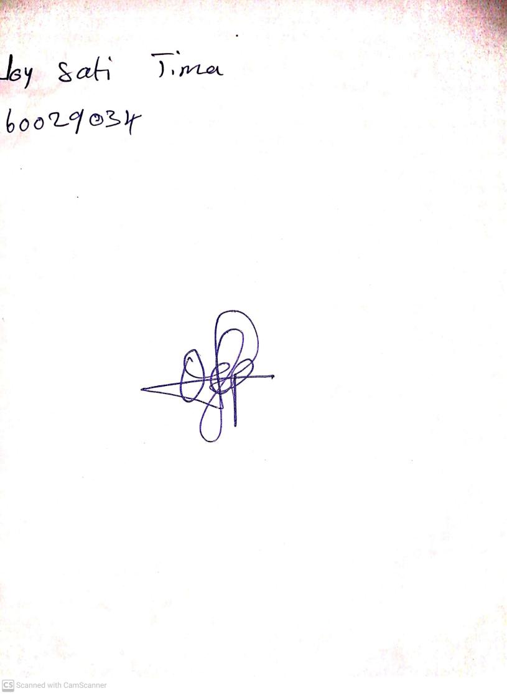

**3rd May, 2024**

**Perpetual Ojoma Ocheja**

**Stream Head Nursery**