**EMERALD ROYAL INTERNATIONAL SCHOOL, MPAPE ABUJA**

**LESSON PLAN AND NOTE FOR WEEK 3 ENDING FRIDAY, 26TH JANUARY, 2024**

**TERM:** FIRST TERM

**WEEK:** WEEK 3

**SUBJECT:** ENGLISH LANGUAGE (SPEECH)

**TOPIC:** LISTENING AND SPEEKING

**SUB-TOPIC:** SIMPLE COMMAND

**DATE:** WEDNESDAY, 24TH JANUARY, 2024

**TIME:** 02:00 – 02:30PM

**DURATION:** 30 MINUTES

**PERIOD:** 9TH

**CLASS:** NURSERY 3

**NUMBER IN CLASS:** TWELVE

**AVERAGE AGE:** FIVE

**SEX:** MIXED

**LEARNING OBJECTIVES:** By the end of the lesson, the pupils should be able to

1. Define simple command.
2. Practices simple command.

**RATIONALE:** for pupils to learn about simple command.

**PREVIOUS KNOWLEGDE:** pupils have learnt simple greetings

**INSTRUCTIONAL MATERIALS:**

1. Textbook
2. Pictorial charts of animals

**REFERENCE MATERIALS:**

1. Nigeria Primary English book 1 by B. Someye, D Dallas etal 2000

**LESSON DEVELOPMENT**

|  |  |  |  |
| --- | --- | --- | --- |
| **STAGES/STEPS** | **TEACHER’S ACTIVITIES** | **PUPILS’ ACTIVITIES** | **LEARNING POINTS** |
| **INTRODUCTION** | Review previous knowledge. | Respond to the teacher and identify the animals on the chart. | Arousing pupils’ interest |
| **PRESENTATION**  **STEP 1** | Teaches and explain the meaning of simple command.  **Meaning of simple command**  Simple command is an act of giving an order or telling someone to do something in a forceful and often official way. | Learn attentively. | Meaning of simple command. |
| **STEP 2** | Guides the pupils to practices simple command.   1. Stand up, Miracle and answer the question! 2. Run very fast! 3. Sit down all of you! 4. Bring me that book! 5. Close your eyes! | Practices simple command in the classroom | For better understanding. |
| **SUMMARY** | Summarises the lesson by emphasising on the main concept and writes note on the board. | Listen and copy their notes | For onward study |
| **EVALUATION** | Asked pupils to:   1. Define simple command 2. Practice with your mate simple command in the class. | Respond to the teacher’s questions. | Based on the stated objectives. |
| **CONCLUSION** | Summarizes, correct and mark pupils’ notebooks. | Write the note on the board and submit their notebooks for marking | Clarifying the concept. |
| **HOME-WORK** | Nigeria Primary English book 1 page 107, exercise 1 and 2. | Return their notebooks for marking. | Extending lesson home. |

**LESSON PLAN AND NOTE FOR WEEK 3 ENDING FRIDAY, 26TH JANUARY, 2024**

**TERM:** FIRST TERM

**WEEK:** WEEK 3

**SUBJECT:** ENGLISH LANGUAGE (GRAMMAR)

**TOPIC:** COMPOUND WORDS

**SUB-TOPIC:** MEANING OF COMPOUND WORDS

**DATE:** MONDAY, 22ND JANUARY, 2024

**TIME:** 01:20 – 02:00PM

**DURATION:** 30 MINUTES

**PERIOD:** 8TH

**CLASS:** NURSERY 3

**NUMBER IN CLASS:** ELEVEN

**AVERAGE AGE:** FIVE

**SEX:** MIXED

**LEARNING OBJECTIVES:** By the end of the lesson, the pupils should be able to:

1. Know the meaning of compound words.
2. List examples of compound words.

**RATIONALE:** for pupils to know the meaning and examples of compound words.

**PREVIOUS KNOWLEGDE:** pupils have learnt about simple past tense.

**INSTRUCTIONAL MATERIALS:**

1. Flash cards
2. Textbooks
3. Charts

**REFERENCE MATERIALS:**

1. Nigeria Primary English book 1 by B. Someye, D Dallas etal 2000

**LESSON DEVELOPMENT**

|  |  |  |  |
| --- | --- | --- | --- |
| **STAGES/STEPS** | **TEACHER’S ACTIVITIES** | **PUPILS’ ACTIVITIES** | **LEARNING POINTS** |
| **INTRODUCTION** | Preview previous knowledge. | Respond to the teacher. | Arousing pupils’ interest. |
| **PRESENTATION**  **STEP 1** | Teaches and explains the meaning of compound words.  **Meaning of compound words**  Compound words are words that two words are joined together to form one word. | Learns attentively. | Compound words. |
| **STEP 2** | Teaches pupils examples of compound words.  **Examples of compound words**   1. Head+master= headmaster 2. Bed+room =bedroom 3. Wheel+barrow=wheelbarrow 4. Police+man=policeman 5. House+keeper=housekeeper 6. Book+shelf=bookshelf | Listens attentively | Examples of compound words. |
| **SUMMARY** | Summarises the lesson by emphasising on the main concept and writes note on the board. | Listen and copy their notes | For onward study |
| **EVALUATION** | Asks pupils to:   1. Give the meaning of compound words. 2. Write down three (3) examples of compound words. | Respond to teachers’ questions. | Based on the stated objectives. |
| **CONCLUSION** | Summarizes, corrects and marks the pupil’s notebooks. | Cope their notes and submit their notebooks for marking. | Clarifying the concept. |
| **HOME-WORK** | Nigeria Primary English book 1, page 112, exercise 1 and 2. | Return book with task for marking. | Extending lesson home. |

**LESSON PLAN AND NOTE FOR WEEK 3 ENDING FRIDAY, 26TH JANUARY, 2024**

**TERM:** FIRST TERM

**WEEK:** WEEK 3

**SUBJECT:** ENGLISH LANGUAGE (COMPREHENSION)

**TOPIC:** READING

**SUB-TOPIC:** THE PIG AND THE TORTOISE

**DATE:** THURSDAY, 25TH AND FRIDAY, 26TH JANUARY, 2024

**TIME:** 09:25 – 10:55AM AND 11: 25 – 12PM

**DURATION:** 45 MINUTES

**PERIOD:** 3RD AND 6TH

**CLASS:** NURSERY 3

**NUMBER IN CLASS:** TWELVE

**AVERAGE AGE:** FIVE

**SEX:** MIXED

**LEARNING OBJECTIVES:** By the end of the lesson, the pupils should be able to

1. Concentrate fully in reading
2. Pronounce difficult words
3. Answer the questions bellow the passage

**RATIONALE:** for pupils to be fluent and improve in their reading skills and pronunciation.

**PREVIOUS KNOWLEGDE:** pupils read the passage ‘Binta and the mango tree’.

**INSTRUCTIONAL MATERIALS:**

1. Nigeria Primary English Book 1 by F Ademola – Adeoye, J omiteru etal 2000

**REFERENCE MATERIALS:**

1. Nigeria Primary English book 1 by B. Someye, D Dallas etal 2000

**LESSON DEVELOPMENT**

|  |  |  |  |
| --- | --- | --- | --- |
| **STAGES/STEPS** | **TEACHER’S ACTIVITIES** | **PUPILS ACTIVITIES** | **LEARNING POINT** |
| **INTRODUCTION** | Preview of previous knowledge | Respond to the teacher. |  |
| **PRSENTATION STEP I** | Leads pupils to read the passage on page 108 of their textbooks titled ‘Pig and Tortoise’.  There was famine in the forest. Animals could not find food to eat. They were hungry. Tortoise went to pig to borrow some money to buy food. Tortoise could not pay back on time as he had promised…….. | Listen and read carefully after the teacher. | Reading skill. |
| **STEP 2** | Teaches pupils to pronounce difficult words in the passage.   1. Grinding 2. Promised 3. Famine 4. Hungry 5. Borrow 6. Patient 7. Threw 8. Money 9. Animals 10. Angry | Identify all difficult words in the passage. | Difficult words in the passage. |
| **STEP 3** | Leads pupils to answer the question the questions below the passage. | Answer the questions orally. | Answering the questions from the passage. |
| **SUMMARY** | Summarises the lesson by emphasising on the main concept and writes note on the board. | Listen and copy their notes. | For onward study. |
| **EVALUATION** | Ask pupils to:  1. read the passage.  2. mention the difficult words.  3. answer the question from the passage. | Respond to the teacher’s questions. | Based on stated objectives. |
| **CONCLUSION** | Summaries, corrects and marks pupils’ notebooks. | Copy the note on the board and submit their notebooks for marking. | Clarifying the concept. |
| **HOME WORK** | Nigeria Primary English book 1, page 20, exercise 1. | Return book with task for marking. | Extending lesson home. |

**LESSON PLAN AND NOTE FOR WEEK 3 ENDING FRIDAY, 26TH JANUARY, 2024**

**TERM:** FIRST TERM

**WEEK:** WEEK 3

**SUBJECT:** ENGLISH LANGUAGE (COMPOSITION)

**TOPIC:** COMPOSITION

**SUB-TOPIC:** MAKING SENTENCES FROM THE TABLE

**DATE:** THURSDAY, 25TH JANUARY, 2024

**TIME:** 11:10 – 11:50PM

**DURATION:** 45 MINUTES

**PERIOD:** 5TH

**CLASS:** NURSERY 3

**NUMBER IN CLASS:** TWELVE

**AVERAGE AGE:** FIVE

**SEX:** MIXED

**LEARNING OBJECTIVES:** By the end of the lesson, the pupils should be able to:

1. Form sentences from the table.
2. Write down the sentences.

**RATIONALE:** for pupils to learn how to form and write out sentences from the table provided.

**PREVIOUS KNOWLEGDE:** pupils have learnt how to write the letter ‘w’.

**INSTRUCTIONAL MATERIALS:**

1. A book
2. Pencil
3. Text book – Nigeria Primary English book 1 – Fourth Edition

**REFERENCE MATERIALS:**

1. Nigeria Primary English book 1 by B. Someye, D Dallas etal 2000

**LESSON DEVELOPMENT**

|  |  |  |  |
| --- | --- | --- | --- |
| **STAGES /STEPS** | **TEACHER’S ACTIVITIES** | **PUPILS’ ACTIVITIES** | **LEARNING POINT** |
| **INTRODUCTION** | Preview previous knowledge | Respond to the teacher. | Arousing interest. |
| **PRESENTATION**  **STEP 1** | Leads pupils to form sentences from the table below.   |  | | --- | | People dog brown run fast | | Making sentences from the table. | For better understanding. |
| **STEP 2** | Leads pupils to write out the sentences formed.   1. This is a dog. 2. It is brown in colour. 3. The dog can run very far. 4. It can also run very fast. 5. People like dogs. | Write out the sentences formed | For proper understanding |
| **SUMMARY** | Summarises the lesson by emphasising on the main concept and writes note on the board. | Listen and copy their notes | For onward study |
| **EVALUATION** | Ask pupils to:  1. write out sentences from the table. | Respond to the teacher’s questions. | Based on the stated objectives. |
| **CONCLUSION** | Summarizes, corrects and mark the pupils’ notebook. | Copy the note on the board and submit for marking. | Clarifying the concept. |
| **HOME-WORK** | 1. Nigeria Primary English book 1, page 113. | Return home with task. | Extending lesson home. |

**LESSON PLAN AND NOTE FOR WEEK 3 ENDING FRIDAY, 26TH JANUARY, 2024**

**TERM:** FIRST TERM

**WEEK:** WEEK 3

**SUBJECT:** ENGLISH LANGUAGE (PHONICS)

**TOPIC:** SOUND BANK

**SUB-TOPIC:** SOUND BANK /θ/

**DATE:** TUESDAY23RD JANUARY, 2024

**TIME:** 10:30 – 11:10PM

**DURATION:** 40 MINUTES

**PERIOD:** 4TH

**CLASS:** NURSERY 3

**NUMBER IN CLASS:** TWELVE

**AVERAGE AGE:** FIVE

**SEX:** MIXED

**LEARNING OBJECTIVES:** By the end of the lesson, the pupils should be able to:

1. Identify sound /θ/
2. Pronounce the sounds /θ/
3. State and write words with the sounds /θ/

**RATIONALE:** for pupils to learns to learn how to say the sound /θ/ and pronounce words with the sound.

**PREVIOUS KNOWLEGDE:** pupils learnt about the sounds /Ʒ/

**INSTRUCTIONAL MATERIALS:**

1. Flash cards
2. pictorial chars

**REFERENCE MATERIALS:**

1. Nigeria Primary English book 1 by B. Someye, D Dallas etal 2000

**LESSON DEVELOPMENT**

|  |  |  |  |
| --- | --- | --- | --- |
| **STAGES/STEPS** | **TEACHER’S ACTIVITIES** | **PUPILS ACTIVITIES** | **LEARNING POINTS** |
| **INTRODUCTION** | Review previous knowledge. | Respond to the teacher. | Arousing interest. |
| **PRESENTATION**  **STEP 1** | Leads pupils to identify the sounds /θ/   |  | | --- | | /θ/ | | Identifies sounds /θ/ | Identifying the sounds /θ/. |
| **STEP 2** | Teaches pupils to pronounce sounds /θ/ | Pronounce sounds /ɒ/ and /Ɔ:/ | Pronouncing sounds /θ/. |
| **STEP 3** | Teaches and highlight words with the sounds /θ/  Words with the sound /θ/   1. Think 2. Throw 3. Both 4. Third 5. Bath 6. Thing 7. Wealthy 8. Author 9. North 10. Thick | Identifies, learn and write words with the sounds /θ/. | Words with sounds /θ/. |
| **SUMMARY** | Summarises the lesson by emphasising on the main concept and writes note on the board. | Listen and copy their notes | For onward study |
| **EVALUATION** | Ask pupils to:   1. Identify /θ/ 2. Pronounce sounds /θ/ 3. Pronounce and underline sounds /θ/ 4. Thread 5. Tooth 6. Truth 7. Tenth 8. thumb | Respond to the teacher’s questions. | Based on the stated objectives. |
| **CONCLUSION** | Summarizes, corrects and mark the pupils’ notebook. | Copy the note on the board and submit for marking. | Clarifying the concept. |
| **HOMEWORK** | Nigeria Primary English work book 1, page 25. | Return home with task. | Extending lesson home. |

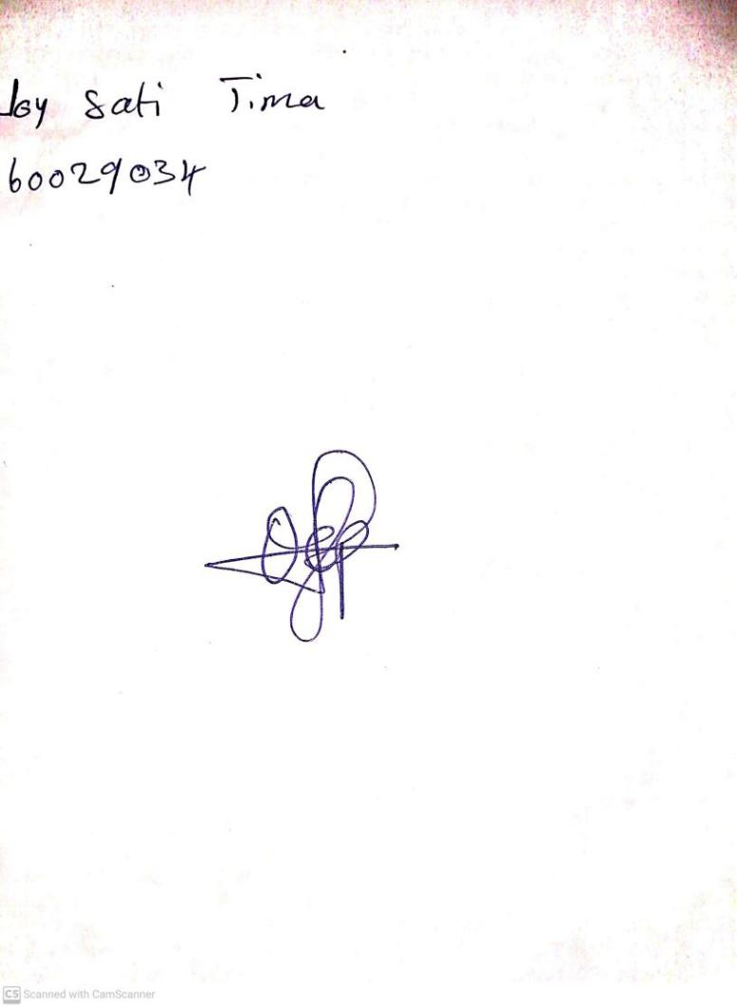

19TH January, 2024

Perpetual Ojoma Ocheja

Stream Head Nursery