LESSON PLAN AND NOTE FOR WEEK 3 1ST PERIOD ENDING 19/05/2023

TERM: 3rd

WEEK: 3rd

DATE: 15/05/2023

CLASS: Nursery 2

SUBJECT: Number work

TOPIC: Greater than (>) and less than (<)

SUB–TOPIC: Meaning of greater than (>) sign and examples.

PERIOD: 1st

TIME: 08:50–09:30 am

DURATION: 40 minutes

NUMBER IN CLASS: 14

AVERAGE AGE: 5 years

SEX: Mixed

LEARNING OBJECTIVES: By the end of the lesson, the Pupils should be able to:

1. Explain the meaning of greater than sign.

2. Identify the examples of greater than

RATIONALE: For Pupils to be able to know what its means by greater than.

PREVIOUS KNOWLEDGE: Pupils have learnt counting of numbers 1–45

INSTRUCTIONAL MATERIALS: Picture of a folded right elbow.

REFERENCE MATERIALS: New method mathematics for primary schools book 3 by C.F Oredugba, R.Ohuche etel

LESSON DEVELOPMENT

|  |  |  |  |
| --- | --- | --- | --- |
| STAGES/ STEPS | TEACHER'S ACTIVITIES | PUPILS' ACTIVITIES | LEARNING POINT |
| Introduction | Teacher introduces the lesson by asking pupils to all stand up and fold their right elbow and then say, greater than. | Pupils all stand up and do according to the instructions and say , greater than. | To arouse pupils interest for the lesson. |
| Presentation step 1 | Teacher explains the meaning of greater than sign to pupils and then asks them to repeat after her. | Pupils listen to the teacher and repeat after her.. | For proper understanding. |
| Step 2 | Teacher then writes the examples of numbers on the board for pupils to identify the numbers that are greater than the other. | Pupils pay attention to the board and identify the numbers. | For better understanding. |
| Board summary | Teacher summarizes the lesson by writing the whole note of lesson on the board for pupils to copy. That is;  WHAT IS GREATER THAN SIGN?    “>”is greater than sign, it means that the value on the right side is greater than the value on the left side.  For example,  1. 9 > 1 which means 9 is greater than 1.  2. 8 > 6  3. 7 > 3  4. 10 > 5  5. 2 > 1  6. 1 > 0 | Pupils copy the note into their exercise books. | For onward study. |
| Evaluation | Teacher asks the following questions;  1. What is greater than sign?  2. What is the symbol for the following  A. 5 — 2  B. 8 — 4  C. 3 — 1  D. 9 — 8  E. 6 — 4 | Pupils answer the questions asked by the teacher. | To assess Pupils level of understanding. |
| Conclusion | Teacher concludes the lesson by marking pupils books. | Pupils submit their books for marking. | Fo endorsement. |
| Assignment | Answer the questions below. | Pupils do their assignment at home. | To encourage learning at home. |

LESSON PLAN AND NOTE FOR WEEK 3 2ND PERIOD ENDING 19/05/2023

TERM: 3rd

WEEK: 3

DATE: 16/05/2023

CLASS: Nursery 2

SUBJECT: Number work

TOPIC: Greater than (>) and less than (<)

SUB—TOPIC: Meaning of less than sign (>) and examples.

PERIOD: 2nd

TIME: 08:50—09:30

DURATION: 40 minutes

NUMBER IN CLASS: 17

AVERAGE AGE: 5 years

SEX: Mixed

LEARNING OBJECTIVES: By the end of the lesson, the Pupils should be able to:

1. Explain the meaning of less than sign

2 . Identify the examples of less than

RATIONALE: For Pupils to be able to know what its means by less than.

PREVIOUS KNOWLEDGE: Pupils have learnt about greater than in previous lesson.

INSTRUCTIONAL MATERIALS: Picture of a folded left elbow.

REFERENCE MATERIALS: New method mathematics for primary schools book 3 by C.F Oredugba, R.Ohuche etel

LESSON DEVELOPMENT

|  |  |  |  |
| --- | --- | --- | --- |
| STAGES/ STEPS | TEACHER'S ACTIVITIES | PUPILS' ACTIVITIES | LEARNING POINT |
| Introduction | Teacher introduces the lesson by asking pupils to all stand up and fold their left elbow and then say, less than. | Pupils all stand up and do according to the instructions and say , less than. | To arouse pupils interest for the lesson. |
| Presentation step 1 | Teacher explains the meaning of less than sign to pupils and then asks them to repeat after her. | Pupils listen to the teacher and repeat after her.. | For proper understanding. |
| Step 2 | Teacher then writes the examples of numbers on the board for pupils to identify the numbers that are less than the other. | Pupils pay attention to the board and identify the numbers. | For better understanding. |
| Board summary | Teacher summarizes the lesson by writing the whole note of lesson on the board for pupils to copy. That is;.  WHAT IS LESS THAN SIGN?    “<”is less than sign, it means that the value on the left side is less than the value on the right side.  For example,  1. 15 < 16 which means 15 is less than 16.  2. 1 < 3  3. 4 < 7  4. 8 < 10  5. 3 < 4  6. 1< 2 | Pupils copy the note into their exercise books. | For onward study. |
| Evaluation | Teacher asks the following questions;  1. What is less than sign?  2. Fill in the correct sign for the following  A. 1 — 2  B. 4 — 6  C. 3 — 4  D. 6 — 9  E. 5 — 6 etc | Pupils answer the questions asked by the teacher. | To assess Pupils level of understanding. |
| Conclusion | Teacher concludes the lesson by marking pupils books. | Pupils submit their books for marking. | Fo endorsement. |
| Assignment | Count and answer the following: | Pupils do the5r assignment at home. | To encourage learning at home. |

LESSON PLAN AND NOTE FOR WEEK 3 3RD PERIOD ENDING 19/05/2023

TERM: 3rd

WEEK: 3

DATE: 19/05/2023

CLASS: Nursery 2

SUBJECT: Number work

TOPIC: Greater than (>) and less than (<)

SUB—TOPIC: Identify and solve numbers with greater than and less than.

PERIOD: 3rd

TIME: 08:10—08:50 am

DURATION: 40 minutes

NUMBER IN CLASS: 14

AVERAGE AGE: 5 years

SEX: Mixed

LEARNING OBJECTIVES: By the end of the lesson, the Pupils should be able to:

1. Identify numbers that are greater than the order.

2. Mention numbers that are less than the order

3. Solve questions on greater than and less than.

RATIONALE: For Pupils to know more about the topic.

PREVIOUS KNOWLEDGE: Pupils have learnt about greater than and less than in previous lesson.

INSTRUCTIONAL MATERIALS: Picture of a folded left elbow and a folded right elbow.

REFERENCE MATERIALS: New method mathematics for primary schools book 3 by C.F Oredugba, R.Ohuche etel

LESSON DEVELOPMENT

|  |  |  |  |
| --- | --- | --- | --- |
| STAGES/ STEPS | TEACHER'S ACTIVITIES | PUPILS' ACTIVITIES | LEARNING POINT |
| Introduction | Teacher introduces the lesson by asking pupils to all stand up and fold their left elbow and right elbow and then say, less than, greater than. | Pupils all stand up and do according to the instructions and say , less than, greater than. | To arouse pupils interest for the lesson. |
| Presentation step 1 | Teacher writes some numbers on the board for pupils to identify the numbers that are greater than the others. As;  1 and 3  6 and 5  8 and 6  1 and 2. | Pupils listen to the teacher and identify.as;  1 and 3 = 3 > 1  6 and 5 = 6 > 5  8 and 6 = 8 > 6  1 and 2 = 2 > 1 | For proper understanding. |
| Step 2 | Teacher guides pupils to mention numbers that are less than the others. As,  1 and 3  6 and 5  8 and 6  1 and 2. | Pupils mention the numbers that are less than the others. That is;  1 and 3 = 1 < 3  6 and 5 = 5 < 6  8 and 6 = 6 < 8  1 and 2 = 1 < 2 | To enhance Pupils participation in class. |
| Step 3 | Teacher then write some questions on the board and solve. That is;  What is the symbol for the following numbers?  1. 10 and 5  2. 5 and 10  3. 6 and 4  4. 4 and 6  Solution  1. 10 and 5 = 10 > 5  2. 5 and 10 = 5 < 10  3. 6 and 4 = 6 > 4  4. 4 and 6 = 4 < 6 | Pupils pay attention to the board . | For better understanding. |
| Board summary | Teacher summarizes the lesson by going through the lesson on the board over and over again and then prepares pupils books for them to copy the note on the board. | Pupils listen to the teacher and copy the note into their exercise books. | For onward study. |
| Evaluation | Teacher asks the following questions;  Fill in the correct symbol.  1) 3 ____ 5  2) 1 ____ 3  3) 7 ____ 4  4) 10 ____ 5  5) 5 ____ 4  6) 4 ____5  7) 8 ____ 10  8) 5 ____ 8  9) 9 ____ 8  10) 1 ____ 0 | Pupils answer the questions ask by the teacher. | To assess Pupils level of understanding. |
| Conclusion | Teacher concludes the lesson by marking pupils books. | Pupils submit their books for marking. | Fo endorsement. |
| Assignment | Section A:  Copy and complete. Use the correct symbol: <, > or =  1) 7_____ 6  2) 8_____ 7  3) 0_____ 4  4) 1 + 3  5) 2 ____ 5  Section B:    Section C: | Pupils do their assignment at home. | To encourage learning at home. |

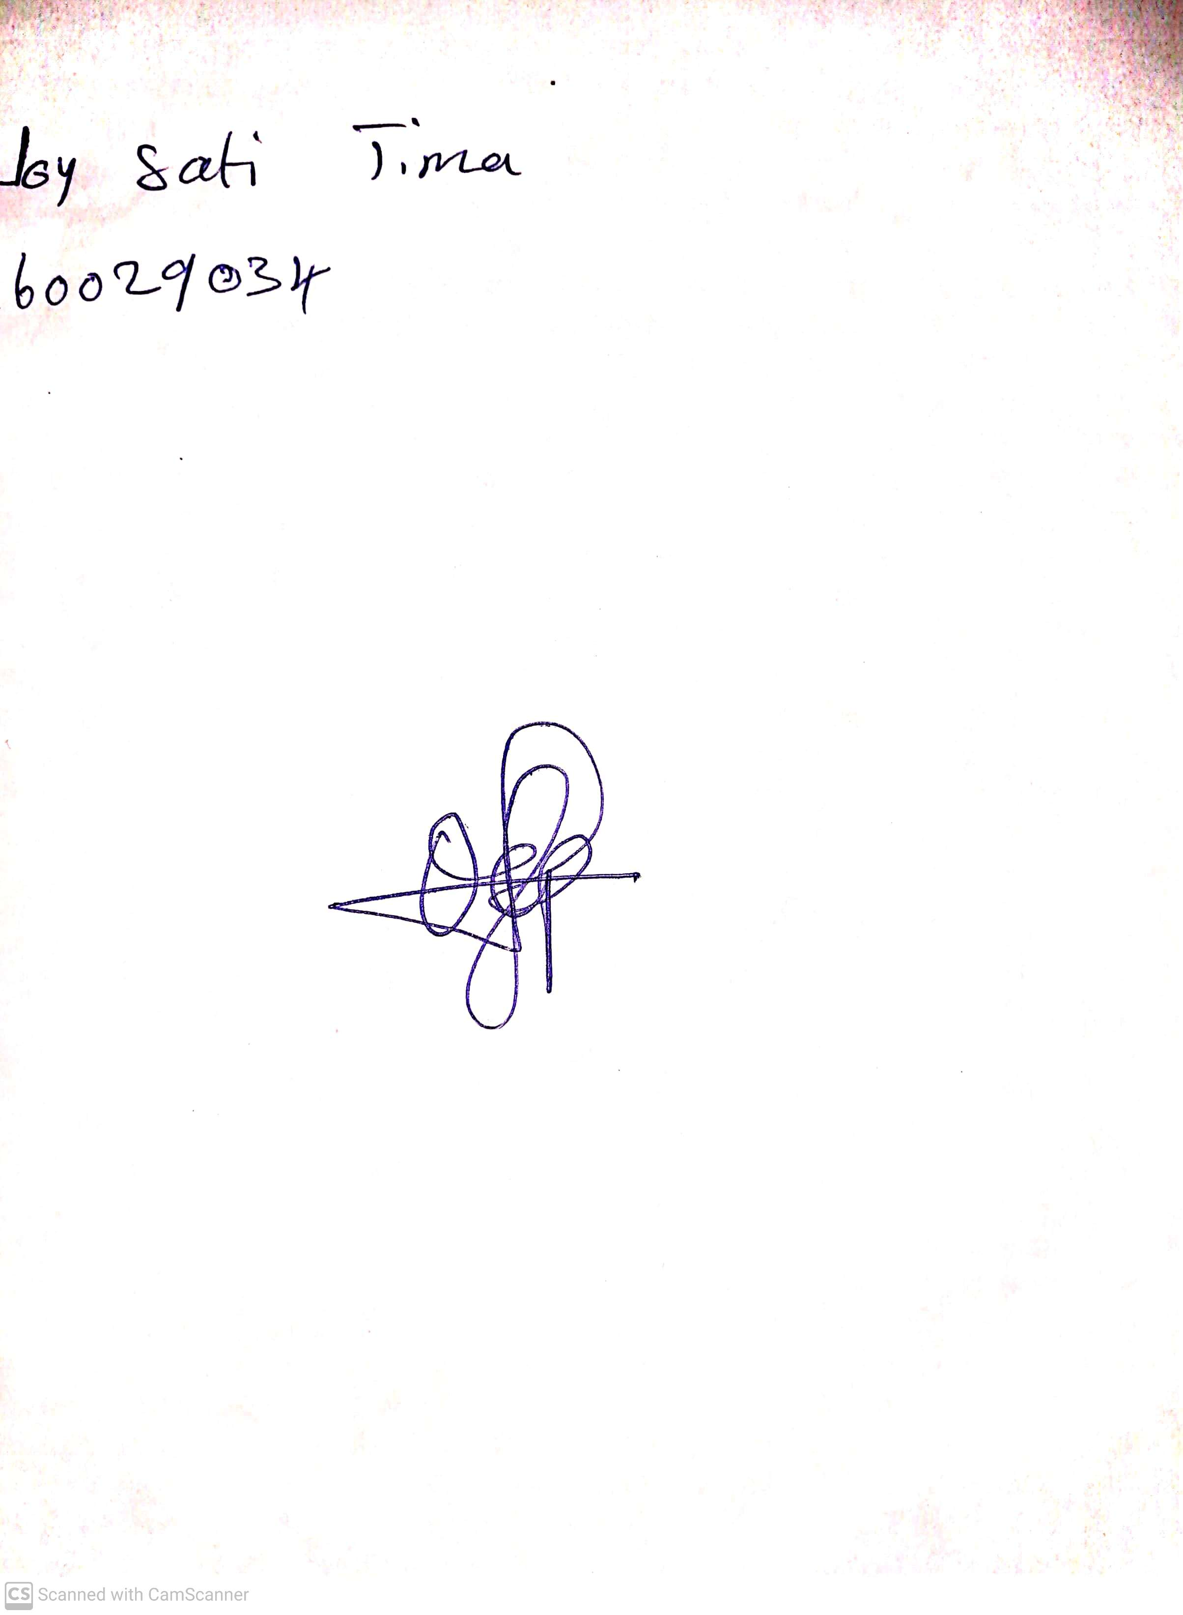

29th April, 2023

Perpetual Ojoma

Stream Head Nursery