EMERALD ROYAL INTERNATIONAL SCHOOL

MPAPE, ABUJA.

LESSON PLAN AND NOTE 1 FOR WEEK 6 ENDING 9TH JUNE, 2023.

SUBJECT: Letter work

TOPIC: Matching letters Uu -Zzt with picture word,colouring and tracing, copy letter Gg-Kk

SUB-TOPIC: identification of letters Uu-Zz

DATE: 6/6/2023.

DURATION: 40 minutes.

TIME: 08:50--09:30.

PERIOD: 2nd

CLASS: Pre-nursery

NUMBER OF PUPILS: 11

AVERAGE AGE: 2 YEARS

SEX: Mixed.

SPECIFIC OBJECTIVES: By the end of the lesson, the pupils should be able to:-

1. Identify letters Uu-Zz
2. Match the upper case with the lower case.

RATIONALE: For pupils to know letters and their sounds.

PREVIOUS KNOWLEDGE: Pupils have been learning the lower case.

INSTRUCTIONAL MATERIALS: Flash cards, board, and phonics song.

REFERENCE:Mastering English for nursery schools book 1 by J.M.Omogbai.

LESSON DEVELOPMENT

|  |  |  |  |
| --- | --- | --- | --- |
| STAGES/STEPS | TEACHER’S ACTIVITIES | PUPILS’ ACTIVITIES | LEARNING POINTS |
| INTRODUCTION | Teacher introduces the lesson by singing a jolly phonics song for the pupils. | Puils sing along with the teacher. | To arouse the interest of the pupilsfor the lesson. |
| PRESENTATION  STEP 1 | Teacher scattered the flash cards of upper and lower case on the table and asks the pupils the upper case and the lower case of each letters. | Pupils identify the upper and lower case ofeach letters on the table. | For betterr understanding of the lesson . |
| STEP2 | Teacher prepares the pupils books for them to match the upper case with lower case .  U x  V w  W v  X u  Y z  Z y | Pupils match the upper case with the lower-case.  U x .  V w  W v  X u    Y z  Z y | To improve pupils psychomotive skills. |
| SUMMARY | Teacher summarizes the lesson by going over the lesson again for more understanding | Pupils listen very attentively to the teacher | For more understanding of the lesson. |
| EVALUATION | Teacher calls out the pupils one after another to identify the upper and the lower case of letter Uu-Zz.. | Pupils answer the teacher’s questions. | To assess the level of pupils understanding of the lesson. |
| CONCLUSION | Teacher marks the pupils books and make corrections where necessary. | Pupils submit their books for marking and corrections . | For onwards study. |
| ASSIGNMENT | Teacher asks the pupils to read and match upper case and lower case of letter Uu-Zz | Pupils do their Home work at home. | To ensure learning takes place at home. |

LESSON PLAN AND NOTE 2 FOR WEEK 6 ENDING 9TH JUNE, 2023.

SUBJECT: Letter work

TOPIC: Matching letter Uu-Zz with picture word,colouring and tracing,copying letter Gg-Kk

SUB-TOPIC: Colouring and tracing letter Uu-Zz.

DATE: 30/5/2023.

DURATION: 40 minutes.

TIME: 08:50--09:30.

PERIOD: 2nd

CLASS: Pre-nursery

NUMBER OF PUPILS: 11

AVERAGE AGE: 2 YEARS

SEX: Mixed.

SPECIFIC OBJECTIVES: By the end of the lesson, the pupils should be able to:-

1. colour letter Uu-Zz.
2. Tracing letter Uu-Zz.

RATIONALE: For pupils to know letters and their sounds.

PREVIOUS KNOWLEDGE: Pupils have been learning the lower case.

INSTRUCTIONAL MATERIALS: Flash cards, board, and phonics song.

REFERENCE:Mastering English for nursery schools book 1 by J.M.Omogbai.

LESSON DEVELOPMENT

|  |  |  |  |  |
| --- | --- | --- | --- | --- |
| STAGES/STEPS | | TEACHER’S ACTIVITIES | PUPILS’ ACTIVITIES | LEARNING POINTS |
| INTRODUCTION | Teacher introduces the lesson by singing a jolly phonics song for the pupils. | | Pupils sing along with the teacher. | To arouse the interest of the pupils for the lesson. |
| PRESENTATION  STEP 1 | Teacher presents a coloured letter Uu-Zz on the table for the pupils to identify the lower case and the upper case of each letters.  Y U V W X  Z u w y x z v | | Pupils identify the upper and lower case of each letters on the table. | For better understanding of the lesson . |
| STEP2 | Teacher prepares the pupils books for them to trace letter Uu-Zz    ABC-Tracing-Worksheets-212x300 | | Pupils trace the letters Uu-Zz.    . | To improve pupils chomotive skills. |
| SUMMARY | Teacher summarizes the lesson by going over the lesson again for more understanding | | Pupils listen very attentively to the teacher | For more understanding of the lesson. |
| EVALUATION | Teacher calls out the pupils one after another to:- 1. identify the letters Uu-Zz and colour them.   1. Trace letters Uu-Zz | | Pupils answer the teacher’s questions. | To assess the level of pupils understanding of the lesson. |
| CONCLUSION | Teacher marks the pupils books and make corrections where necessary. | | Pupils submit their books for marking and corrections . | For onwards study. |
| ASSIGNMENT | Teacher asks the pupils to read and trace the upper and lower case of letter Uu-Zz in the text books. | | Pupils do their Home work at home. | To ensure learning takes place at home. |

LESSON PLAN AND NOTE 3 FOR WEEK 6 ENDING 2ND JUNE, 2023.

SUBJECT: Letter work

TOPIC: Matching letter Uu-Zz with picture word ,,colouring and tracing, copying letter Gg-Kk.

SUB-TOPIC: identification of letters Pp-Tt and writing letters.

DATE: 2/6/2023.

DURATION: 40 minutes.

TIME: 08:50--09:30.

PERIOD: 2nd

CLASS: Pre-nursery

NUMBER OF PUPILS: 11

AVERAGE AGE: 2 YEARS

SEX: Mixed.

SPECIFIC OBJECTIVES: By the end of the lesson, the pupils should be able to:-

1. Identify letter Gg-Kk
2. Copy letters Gg-Kk.

RATIONALE: For pupils to know letters and their sounds.

PREVIOUS KNOWLEDGE: Pupils have been learning the lower case.

INSTRUCTIONAL MATERIALS: Flash cards, board, and phonics song.

REFERENCE:Mastering English for nursery schools book 1 by J.M.Omogbai.

LESSON DEVELOPMENT

|  |  |  |  |
| --- | --- | --- | --- |
| STAGES/STEPS | TEACHER’S ACTIVITIES | PUPILS’ ACTIVITIES | LEARNING POINTS |
| INTRODUCTION | Teacher introduces the lesson by singing a nursery rhyme for the pupils. | Puils sing along with the teacher. | To arouse the interest of the pupils for the lesson. |
| PRESENTATION  STEP 1 | Teacher writes the upper case and lower case of letter Gg-Kk on the board for pupils to identify.  Gg Hh Ii Jj Kk. | Pupils points at the letters on the chalk board and identify them by reading them one after another. | For proper recognition of letters. |
| STEP2 | Teacher prepares the pupils books for them to re-write letter Pp-Tt  .  Gg Hh Ii Jj Kk | Pupils re-write Pp-Qq in the books.  Gg Hh Ii Jj Kk  .  Gg Hh Ii Jj Kk  Gg Hh Ii Jj Kk | To improve pupils psychomotive skills. |
| SUMMARY | Teacher summarizes the lesson by asking the pupils to sing the phonics song for letters Gg-Kk with the teacher. | Pupils sing the phonics song for letters Gg-Kk with the teacher. | For more understanding of the lesson. |
| EVALUATION | Teacher calls out the pupils one after another to:- 1. identify the upper and lower case on the flash card.  2.Re-write letter Gg-Kk. | Pupils answer the teacher’s questions. | To assess the level of pupils understanding of the lesson. |
| CONCLUSION | Teacher marks the pupils books and make corrections where necessary. | Pupils submit their books for marking and corrections . | For onwards study. |
| ASSIGNMENT | Teacher asks the pupils to read and match upper case with the lower case in the text books. | Pupils do their Home work at home. | To ensure learning takes place at home. |

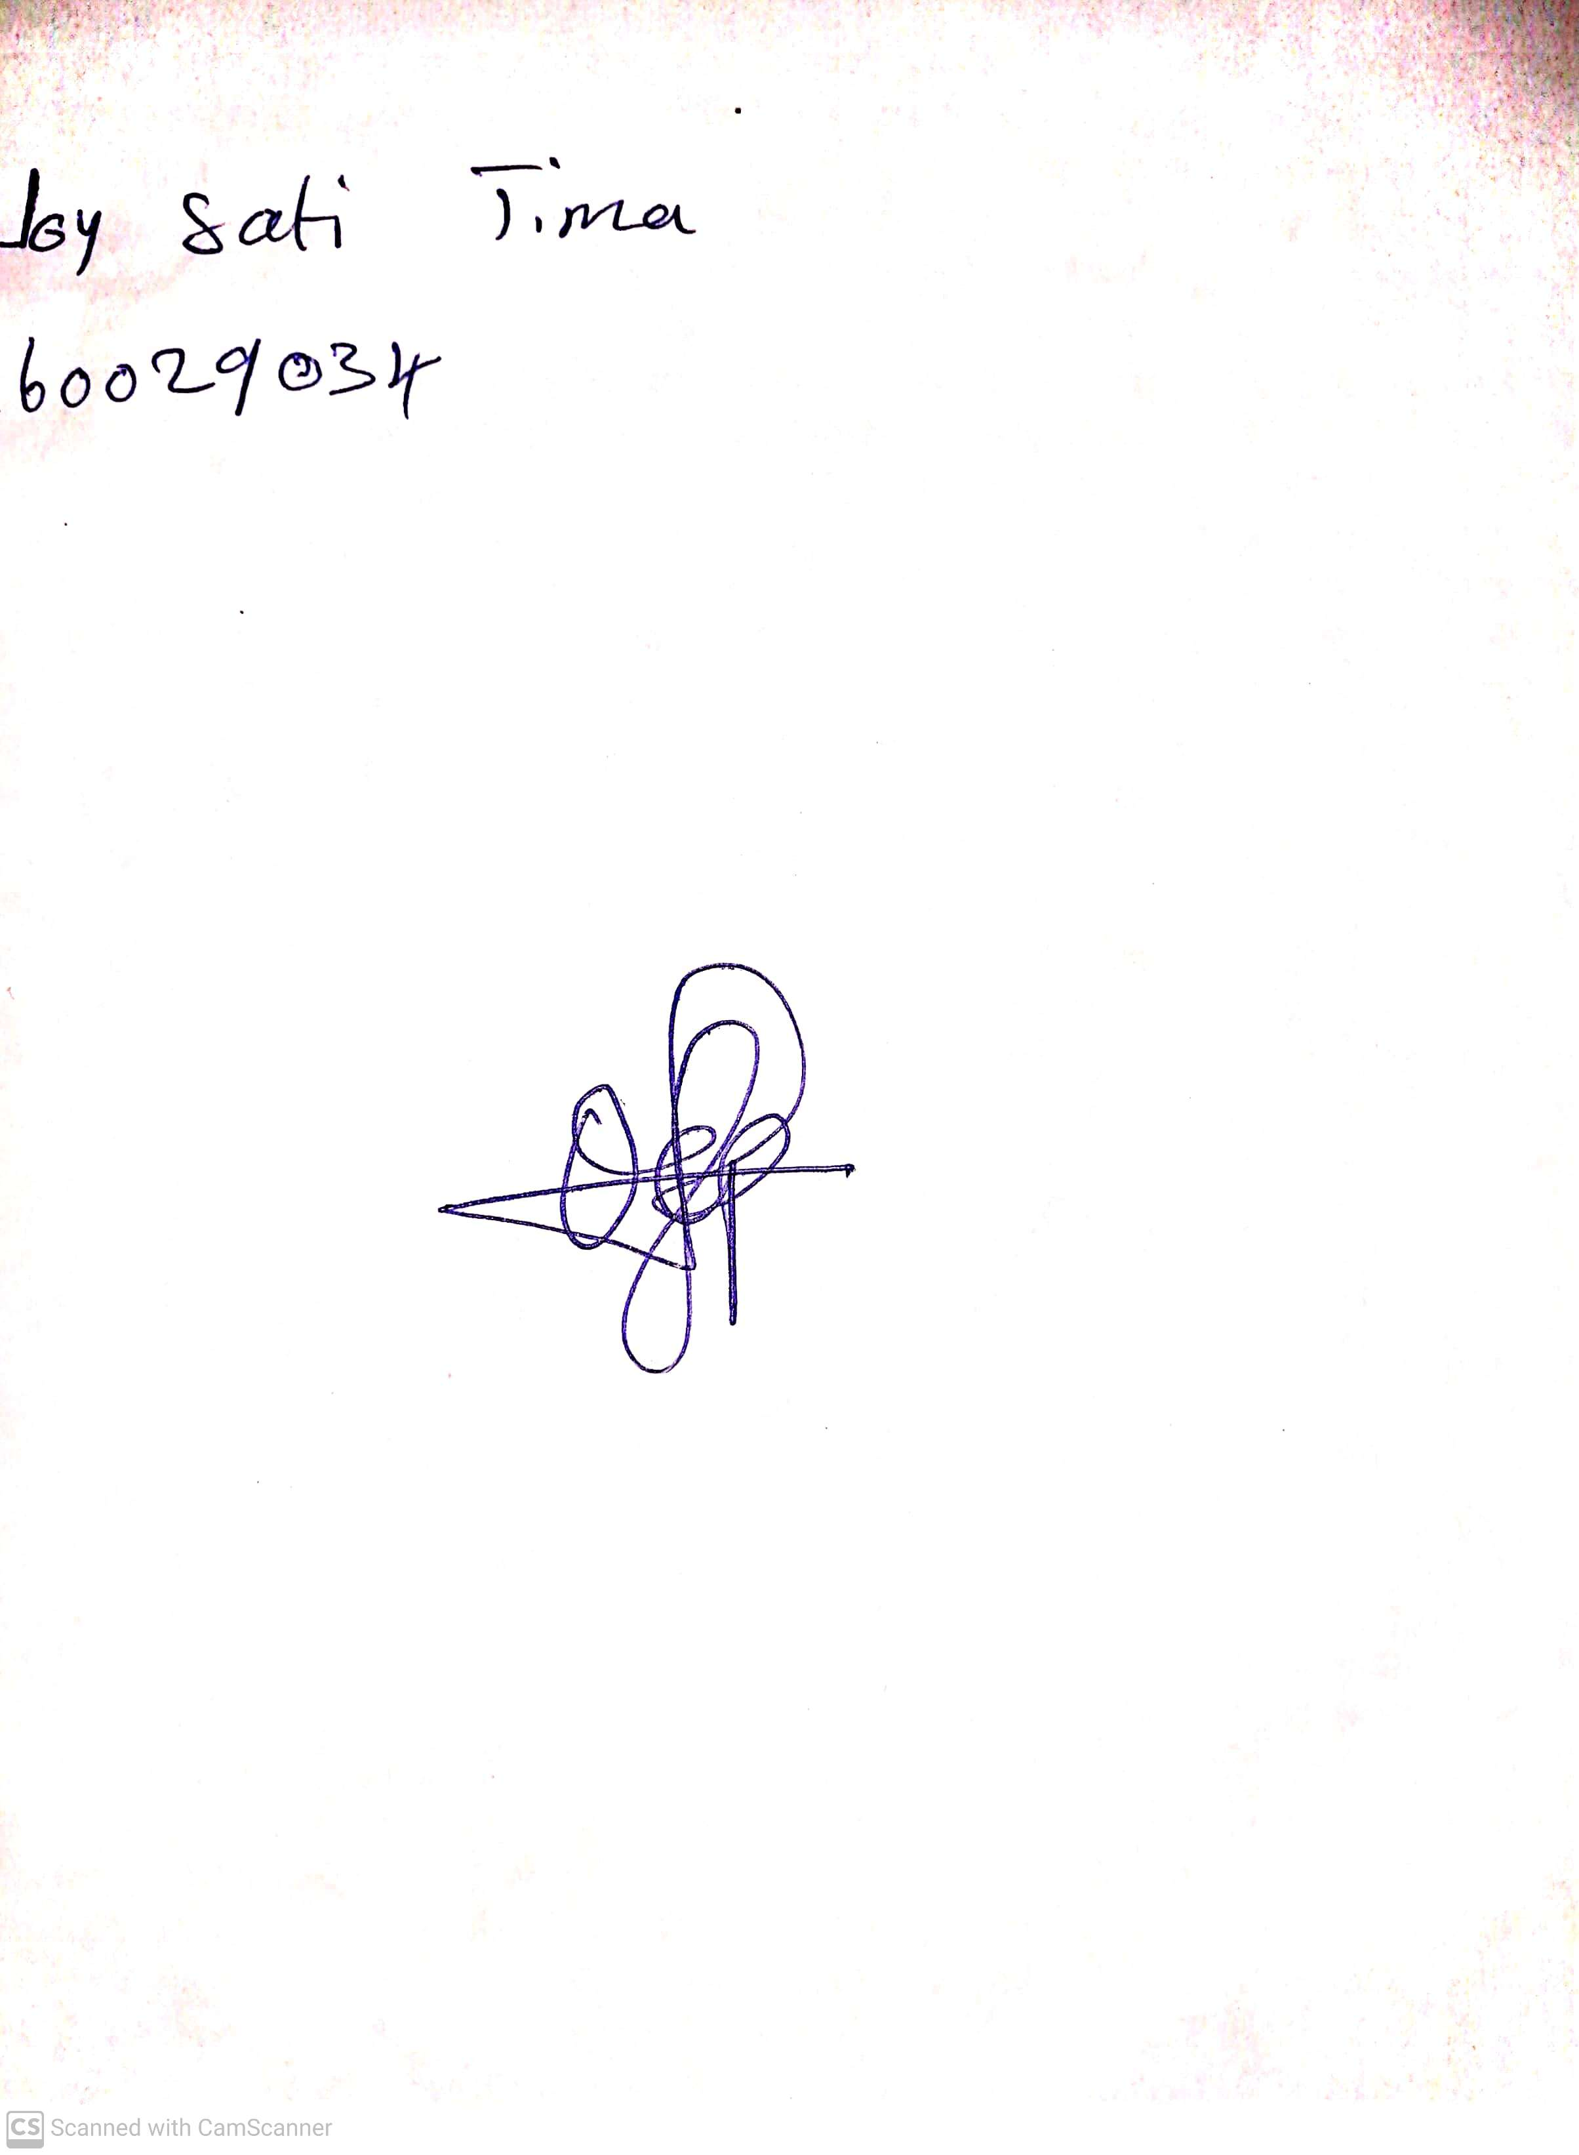

5th July, 2023

Perpetual Ojoma

Stream Head Nursery