**EMERALD ROYAL INTERNATIONAL SCHOOL, MPAPE ABUJA**

**LESSON PLAN AND NOTE FOR WEEK 7 ENDING FRIDAY, 27TH OCTOBER, 2023**

**TERM:** FIRST TERM

**WEEK:** WEEK 7

**SUBJECT:** BASIC SCIENCE

**TOPIC:** SOIL

**SUB-TOPIC:** MEANING OF SOIL

**DATE:** TUESDAY, 24TH AND WEDNESDAY, 25TH OCTOBER, 2023

**TIME:** 08:45 – 09:25AM AND 09:25 – 09:55AM

**DURATION:** 40 MINUTES

**PERIOD:** 2ND AND 3RD

**CLASS:** NURSERY 3

**NUMBER IN CLASS:** ELEVEN

**AVERAGE AGE:** FIVE

**SEX:** MIXED

**LEARNING OBJECTIVES:** By the end of the lesson, the pupils should be able to:

1. Define the meaning of soil.
2. List the types of soil.

**RATIONALE:** for pupils to learn the meaning of soil.

**PREVIOUS KNOWLEGDE:** pupils have learnt how to cross the road.

**INSTRUCTIONAL MATERIALS:**

1. Flash cards.
2. Road chart.

**REFERENCE MATERIALS:**

Smart Basic Science and Technology book 1 by D. I. Bika, Cambridge University Press

**LESSON DEVELOPMENT**

|  |  |  |  |
| --- | --- | --- | --- |
| **STAGES/STEPS** | **TEACHER’S ACTIVITIES** | **PUPILS’ ACTIVITIES** | **LEARNING POINTS** |
| **INTRODUCTION** | Review previous knowledge | Respond to the teacher | To arouse the pupils’ interest. |
| **PRESENTATION**  **STEP 1** | Teaches and explain the meaning of soil.  **Meaning of soil**  Soil is the top layer of the earth on which plant grow. It consist of broken rocks and humus. | State the meaning of soil. | Meaning of soil. |
| **STEP 2** | Teaches and explain the types of soil.  **Types of soil**  There are different types of soil.   1. Clay soil 2. Loamy soil 3. Sandy soil | List the types of soil. | Types of soil. |
| **SUMMARY** | Summarises the lesson by emphasising on the main concept and writes note on the board | Listen and copy their notes | For onward study |
| **EVALUATION** | Asks pupils to:   1. Define soil. 2. List the types of soil. | Respond to the teacher’s question. | To test the pupils understanding on the lesson. |
| **CONCLUSION** | Summarizes, corrects and mark pupils’ notebooks | Submit their notebooks for marking. | Clarifying the concept. |
| **HOME WORK** | 1. Define soil. 2. Write down the types of soil. | Cope and return with task. | Extending lesson home. |

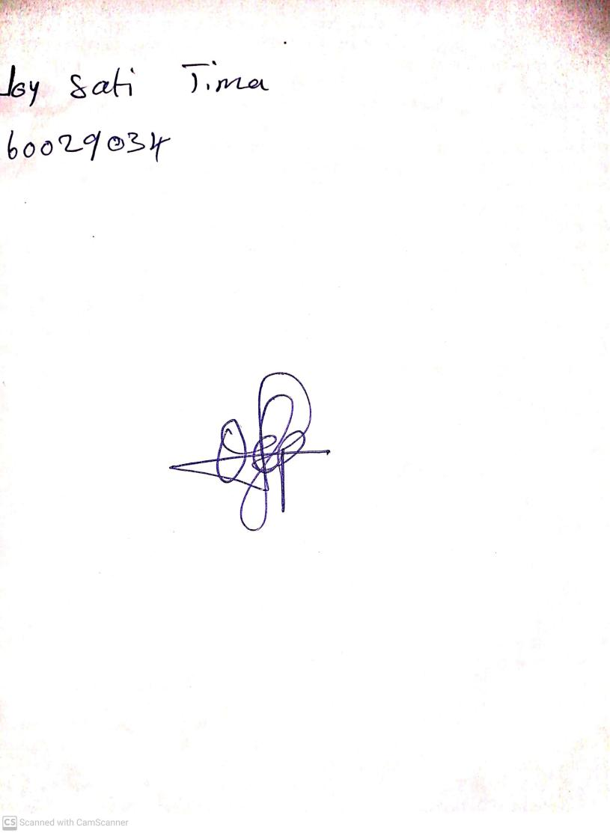

13th October, 2023

Perpetual Ojoma Ocheja

Stream Head Nursery