**LESSON PLAN AND NOTE 1 FOR WEEK 1 ENDING 26/4/2024**

**Term 3rd term**

**Week 1st week**

**Date 23/4/2024**

**Class Nursery one**

**Subject Number work**

**Topic counting numbers 1-100**

**Sub-topic Counting numbers 90-95**

**Period 2nd period**

**Time 9:05 am**

**Duration 35 minutes**

**No in class 14**

**Average Age 3 years**

**Sex Mixed**

**Specific Objectives: By the end of the lesson the pupils should be able to;**

1. **Count numbers 90-95**
2. **Identify numbers 90-95**
3. **Write numbers 90-95**

**Rationale: To make sure the pupils count, identify and write numbers 90-95**

**Previous knowledge: The pupils can colour numbers 85-90**

**Instructional Resources: Chart, board, marker, exercise books, pencils.**

**Reference Materials: Online Research,chart,board.**

**LESSON PRESENTATION**

|  |  |  |  |
| --- | --- | --- | --- |
| **Steps** | **Teacher’s Activities** | **Pupils’ Activities** | **Learning Points** |
| **Introduction** | **The teacher introduces the topic [counting numbers 1-100] by rhyming with them.** | **The pupils rhyme with the teacher numbers 1-100.** | **To arouse the pupils’ interest towards the lesson.** |
| **Step 1** | **The teacher assists the pupils to count numbers 90-95**  **90 91 92 93 94 95** | **The pupils individually counts numbers 90-95** | **For proper understanding.** |
| **Step 2** | **The teacher leads the pupils to identify numbers 90-95.** | **The pupils identify the numbers 90-95.** | **For better understanding.** |
| **Step 3** | **The teacher guides the pupils in writing numbers 90-95 inside their notebook** | **The pupils write numbers 90-95 inside their notebooks as the teacher guides them.** | **For further understanding.** |
| **Summary** | **The teacher summarizes the lesson by counting numbers 90-95 for their perfection.** | **The pupils can count numbers 90-95.** | **For onward study.** |
| **Conclusion** | **The teacher summarizes, reacts, and corrects the pupils.** | **The pupils gives answers to the teacher’s question.** | **To consolidate the lesson.** |
| **Evaluation** | **Question:**  **Count numbers 90-95.**  **Identify numbers 94 95 91 92 90**  **Write numbers 90-95**   |  |  | | --- | --- | | **90** | **91** | |  |  | | **92** | **93** | |  |  | | **94** | **95** | |  |  | | **The pupils answer the question accordingly** | **To ascertain the pupils’ understanding.** |
| **Assignment** | **Question:**  **Count numbers 90-95.**  **Identify numbers 94 95 91 92 90**  **Write the following numbers below**   |  |  | | --- | --- | | **90** | **91** | |  |  | | **92** | **93** | |  |  | | **94** | **95** | |  |  | | **The pupils copy and do their homework at home.** | **To encourage learning while at home.** |

**LESSON PLAN AND NOTE 2 FOR WEEK 1 ENDING 26/4/2024**

**Term 3rd term**

**Week 1st week**

**Date 25/4/2024**

**Class Nursery one**

**Subject Number work**

**Topic counting numbers 1-100**

**Sub-topic Counting numbers 95-100**

**Period 2nd period**

**Time 9:35 am**

**Duration 35 minutes**

**No in class 14**

**Average Age 3 years**

**Sex Mixed**

**Specific Objectives: By the end of the lesson the pupils should be able to;**

1. **Count numbers 95-100**
2. **Identify numbers 95-100**
3. **Write numbers 95-100**

**Rationale: To make sure the pupils count, identify and write numbers 95-100**

**Previous knowledge: The pupils can count, identify & write numbers 90-95**

**Instructional Resources: Chart, board, marker, exercise books, pencils.**

**Reference Materials: Online Research,chart,board.**

**LESSON PRESENTATION**

|  |  |  |  |
| --- | --- | --- | --- |
| **Steps** | **Teacher’s Activities** | **Pupils’ Activities** | **Learning Points** |
| **Introduction** | **The teacher introduces the topic [counting numbers 1-100] by rhyming with them.** | **The pupils rhyme with the teacher numbers 1-100.** | **To arouse the pupils’ interest towards the lesson.** |
| **Step 1** | **The teacher assists the pupils to count numbers 95-100**  **95 96 97 98 99 100** | **The pupils individually counts numbers 95-100** | **For proper understanding.** |
| **Step 2** | **The teacher leads the pupils to identify numbers 95-100.**  **95**  **96**  **97**  **98**  **100** | **The pupils identify the numbers 95-100.** | **For better understanding.** |
| **Step 3** | **The teacher guides the pupils in writing numbers 95-100 inside their notebook** | **The pupils write numbers 95-100 inside their notebooks as the teacher guides them.** | **For further understanding.** |
| **Summary** | **The teacher summarizes the lesson by counting numbers 95-100 for their perfection.** | **The pupils can count numbers 95-100.** | **For onward study.** |
| **Conclusion** | **The teacher summarizes, reacts, and corrects the pupils.** | **The pupils gives answers to the teacher’s question.** | **To consolidate the lesson.** |
| **Evaluation** | **Question:**  **Count numbers 95-100**  **Identify numbers 96 95 99 97 100**  **Write numbers 95-100**   |  |  | | --- | --- | | **95** | **96** | |  |  | | **97** | **98** | |  |  | | **99** | **100** | |  |  | | **The pupils answer the question accordingly** | **To ascertain the pupils’ understanding.** |
| **Assignment** | **Question:**  **Count numbers 95-100**  **Identify numbers 96 95 99 97 100**  **Write the following numbers below**   |  |  | | --- | --- | | **95** | **96** | |  |  | | **97** | **98** | |  |  | | **99** | **100** | |  |  | | **The pupils copy and do their homework at home.** | **To encourage learning while at home.** |

**LESSON PLAN AND NOTE 3 FOR WEEK 1 ENDING 26/4/2024**

**Term 3rd term**

**Week 1st week**

**Date 26/4/2024**

**Class Nursery one**

**Subject Number work**

**Topic counting numbers 1-100**

**Sub-topic Colouring numbers 90-95 &Matching numbers 95-100**

**Period 2nd period**

**Time 9:50 am**

**Duration 35 minutes**

**No in class 14**

**Average Age 3 years**

**Sex Mixed**

**Specific Objectives: By the end of the lesson the pupils should be able to;**

1. **Colour numbers 90-95**
2. **Match numbers 95-100**

**Rationale: To make sure the pupils colour and match numbers 90-100**

**Previous knowledge: The pupils can count, identify & write numbers 95-100**

**Instructional Resources: Crayons, exercise books, pencils.**

**Reference Materials: Online Research,chart,board.**

**LESSON PRESENTATION**

|  |  |  |  |
| --- | --- | --- | --- |
| **Steps** | **Teacher’s Activities** | **Pupils’ Activities** | **Learning Points** |
| **Introduction** | **The teacher introduces the topic [counting numbers 1-100] by rhyming with them.** | **The pupils rhyme with the teacher numbers 1-100.** | **To arouse the pupils’ interest towards the lesson.** |
| **Step 1** | **The teacher draws numbers 90-95 for the pupils to identify and colour.** | **The pupils participates in identifying and colouring of numbers 90-95.** | **For proper understanding.** |
| **Step 2** | **The teacher writes down numbers 105-110 for the pupils to match inside their notebooks.**  **95 99**  **96 100**  **97 95**  **98 96**  **99 97**  **100 98** | **The pupils match the numbers 105-110.**  **95 99**  **96 100**  **97 95**  **98 96**  **99 97**  **100 98** | **For better understanding.** |
| **Summary** | **The teacher summarizes the lesson by counting numbers 90-100 for their perfection.** | **The pupils can count numbers 90-100.** | **For onward study.** |
| **Conclusion** | **The teacher summarizes, reacts, and corrects the pupils.** | **The pupils gives answers to the teacher’s question.** | **To consolidate the lesson.** |
| **Evaluation** | **Question:**  **Count numbers 90-100**  **Colour numbers 94 and 98 inside your notebook.**  **Match the numbers below**  **95 99**  **96 100**  **97 95**  **98 96**  **99 97**  **100 98** | **The pupils answer the question accordingly** | **To ascertain the pupils’ understanding.** |
| **Assignment** | **Question:**  **Count numbers 90-100**  **Colour numbers 94 and 98 inside your notebook.**  **Match the following numbers below**  **100 96**  **95 99**  **99 100**  **90 91**  **96 95**  **93 90**  **91 97**  **97 93** | **The pupils copy and do their homework at home.** | **To encourage learning while at home.** |

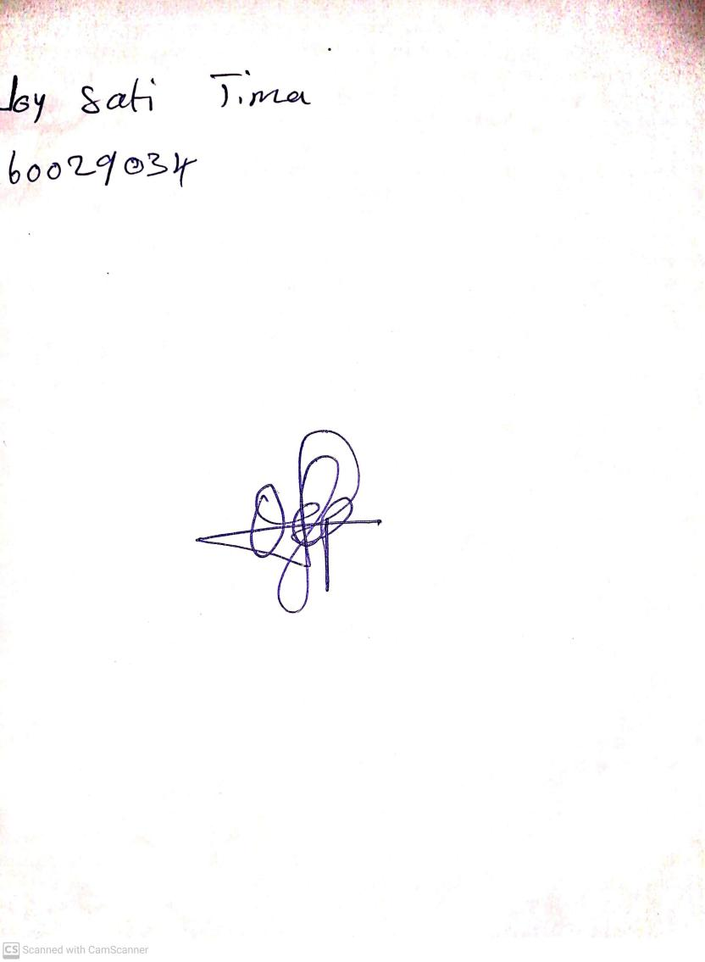

19th April, 2024

Perpetual Ojoma Ocheja

Stream Head Nursery