**LESSON PLAN FOR WEEK 6 ENDING 20/10/2023**

**Term 1st term**

**Week 6th  week**

**Date 17th October,2023**

**Class Nursery One**

**Subject Nature studies**

**Topic Things in the sky.**

**Sub-topic Meaning of things in the sky.**

**Period 2nd period**

**Time 8:50 am**

**Duration 35 minutes**

**No in class 15**

**Average Age 3 years**

**Sex Mixed**

**Specific Objectives: By the end of the lesson, the pupils should be able to:**

1. **Define things in the sky.**
2. **Name the things in the sky.**
3. **Identify the things in the sky.**

**Rationale: To ensure the pupils know and identify things in the sky.**

**Previous Knowledge: The pupils can identify the simple machines at school.**

**Instructional Resources: Things in the sky chart, online.**

**Reference Material: Elementary science by Showers kiddies nursery 1**

**LESSON PRESENTATION**

|  |  |  |  |
| --- | --- | --- | --- |
| **Steps** | **Teacher’s Activities** | **Pupils’ Activities** | **Learning Points** |
| **Introduction** | **The teacher introduces the lesson (Things in the sky) to the pupils.** | **The pupils pays attention to the teacher.** | **To arose the pupils’ interest.** |
| **Step 1** | **The teacher explains things in the sky “as those things that can be found up in the sky either during the day or during the night” for the pupils.** | **The pupils listen and repeats after the teacher the meaning of things in the sky.** | **For proper understanding.** |
| **Step 2** | **The teacher lists the things found in the sky either during the day or during the night which includes**  **SUN**  **MOON**  **STARS**  **CLOUDS**  **CRESENT**  **RAIN**  **RAINBOW ETC** | **The pupils name the things in the sky with their teacher.** | **For better understanding.** |
| **Step 3** | **The teacher leads the pupils to identify the things in the sky**  **A Star image of star**  **A Sun image of a sun**  **A Cresent image of a cresent**  **A Moon image of a moon**  **A Cloud image of a cloud**  **A Rain image of a rain**  **A Rainbow image of a rainbow** | **The pupils participates and identify thethings in the sky.** | **For further understanding.** |
| **Summary** | **The teacher summarizes the lesson by defining things in the sky for the pupils.** | **The pupils can define things in the sky.** | **For onward study.** |
| **Evaluation** | 1. **Define things in the sky ?** 2. **Name 3 things found in the sky?** 3. **Identify the following things in the sky?**   **image of a cloud ________** | **The pupils answer the question correctly.** | **To ascertain the pupils’ understanding.** |
| **Conclusion** | **The teacher summarizes, reacts, and corrects the pupils.** | **The pupils gives answer to the teacher’s questions** | **To consolidate the lesson.** |
| **Assignment** | 1. **Define things in the sky ?** 2. **Mention 4 things we can find in the sky?**   **Identify the following things in the sky?**  **image of a moon ________**  **image of a cloud ________**  **image of a rainbow ________** | **The pupils copy and do their homework at home.** | **To encourage learning while at home.** |

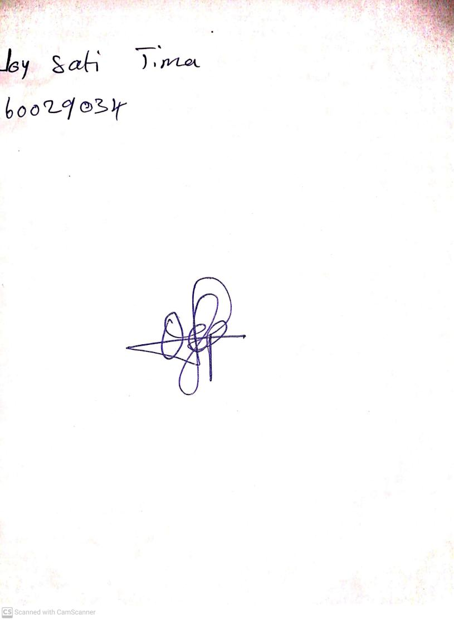

15th August, 2023

Perpetual Ojoma Ocheja

Stream Head Nursery