**EMERALD ROYAL INTERNATIONAL SCHOOL**

**MPAPE, ABUJA.**

**LESSON PLAN AND NOTE FOR WEEK 5 PERIOD 1 ENDING 13/10/2023**

TERM: FIRST

WEEK: 5TH

DATE: 09/10/2023

CLASS: NURSERY 2

SUBJECT: LETTER WORK

TOPIC: THREE LETTER WORDS CROSS CUTTING "a" "e" "i".

SUB-TOPIC: THREE LETTER WORDS CROSS CUTTING "a".

PERIOD: 1ST

TIME: O8:50-09:30.

DURATION: 40 MINUTES.

NUMBER IN CLASS: 17

AVERAGE AGE: 5 YEARS.

SEX: MIXED.

SPECIFIC OBJECTIVES: BY THE END OF THE LESSON,THE PUPILS SHOULD BE

ABLE TO:

1. IDENTIFY THREE LETTER WORDS CROSS CUTTING

"a".

2. SPELL AND PRONOUNCE THREE LETTER WORDS

CROSS CUTTING "a".

RATIONALE: FOR PUPILS TO BE ABLE TO SPELL AND PRONOUNCE

THERE LETTER WORDS CROSS CUTTING "a".

PREVIOU KNOWLEDGE: PUPILS HAVE LEARNT THREE LETTER WORDS ENDING WITH "IB" IN PREVIOUS LESSON.

INSTRUCTIONAL MATERIALS: A CHART OF THREE LETTER WORDS CROSS

CUTTING "a"

REFERENCE MATERIALS: MASTERING ENGLISH BOOK 2 BY J. M OMOGBAI

**LESSON DEVELOPMENT**

|  |  |  |  |
| --- | --- | --- | --- |
| STAGES/STEPS | TEACHER’S ACTIVITIES | PUPILS’ ACTIVITIES | LEARNING POINTS |
| INTRODUCTION | Teacher introduces the lesson by reviewing the previous lesson. | Pupil listen to the teacher attentively. | To arouse pupils interest for the lesson ahead. |
| PRESENTATION  STEP 1 | Teacher presents the lesson by writing three letter words cross cutting "a" on the board, identify and then asks pupils to repeat after her. | Pupils pay attention and repeat after the teacher. | For proper understanding of the lesson . |
| STEP 2 | Teacher spells and pronounce the three letter words cross cutting "a" on the board and also asks pupils to repeat after her. | Pupils spelled the three letter words on the board after the teacher. | For better understanding of the lesson. |
| BOARD SUMMARY | Teacher summarizes the lesson by writing the whole note of lesson on the board for pupils to copy into their books.that is,  THREE LETTER WORDS CROSS CUTTING "a" ARE:  "a" as in   1. Bat 2. Cat 3. Fat 4. Hat 5. Mat 6. Pat 7. Rat 8. Sat 9. Has 10. Gas 11. Man 12. Fan 13. Van 14. Ban 15. Can 16. Arm 17. Bag 18. Sag 19. Lag 20. Rag 21. Cab 22. Sad etc. | Pupils copy the note into their exercise books. | For onward study. |
| EVALUATION | Teacher asks pupils to go to the board one after the other and read the three Letter words cross cutting "a". | Pupils read the note on the board one after another. | To assess pupils level of understanding of the lesson so far. |
| CONCLUSION | Teacher marks pupils books. | Pupils submit their books for marking. | For endorsement. |
| ASSIGNMENT | Fill in the missing letters and pronounce.   1. V__ n 2. C __ n 3. S__ t 4. P__ t 5. G__ s 6. T __ p 7. H__s 8. B__n 9. F__t 10. L__ p | Pupils do their assignment at home. | To encourage learning at home. |

**LESSON PLAN AND NOTE FOR WEEK 5 PERIOD 2 ENDING 13/10/2023**

TERM: FIRST

WEEK: 5TH

DATE: 10/10/2023

CLASS: NURSERY 2

SUBJECT: LETTER WORK

TOPIC: THREE LETTER WORDS CROSS CUTTING "a" "e" "i"

SUB-TOPIC: THREE LETTER WORDS CROSS CUTTING "e"

PERIOD: 2ND

TIME: O8:50-09:30.

DURATION: 40 MINUTES.

NUMBER IN CLASS: 17

AVERAGE AGE: 5 YEARS.

SEX: MIXED.

SPECIFIC OBJECTIVES: BY THE END OF THE LESSON,THE PUPILS SHOULD BE

ABLE TO:

1. IDENTIFY THREE LETTER WORDS CROSS CUTTING

"e"

2. SPELL AND PRONOUNCE THREE LETTER WORDS

CROSS CUTTING "e"

RATIONALE: FOR PUPILS TO BE ABLE TO READ WORDS WITH

VOWEL "e"

PREVIOU KNOWLEDGE: PUPILS HAVE LEARNT THREE LETTER WORDS CROSS CUTTING "a" IN PREVIOUS LESS0N.

INSTRUCTIONAL MATERIALS: A CHART OF THREE LETTER WORDS CROSS

CUTTING "e"

REFERENCE MATERIALS: MASTERING ENGLISH 2 BY J. M OMOGBAI.

**LESSON DEVELOPMENT**

|  |  |  |  |
| --- | --- | --- | --- |
| STAGES/STEPS | TEACHER’S ACTIVITIES | PUPILS’ ACTIVITIES | LEARNING POINTS |
| INTRODUCTION | Teacher introduces the lesson by reviewing the previous lesson. | Pupil listen attentively to the teacher. | To arouse pupils interest for the lesson ahead. |
| PRESENTATION  STEP 1 | Teacher presents the lesson by writing three Letter words cross cutting "e" on the board, identify and then asks pupils to repeat after. | Pupils listen and repeat after the teacher. | For proper understanding of the lesson . |
| STEP 2 | Teacher spells and pronounce the three letter words cross cutting "e" on the board and also asks pupils to repeat after her. | Pupils pay attention and repeat after the teacher. | For better understanding of the lesson. |
| BOARD SUMMARY | Teacher summarizes the lesson by writing the whole note of lesson on the board for pupils to copy into their books.That is;  THREE LETTER WORDS CROSS CUTTING "E" ARE:  "e" as in;   1. Bed 2. Leg 3. Set 4. Bet 5. Ben 6. Peg 7. Men 8. End 9. Pet 10. Pen 11. Ten 12. Net 13. Den 14. Hen 15. Bet 16. Fed 17. Get 18. Beg 19. Wet 20. Egg etc. | Pupils copy the note into their exercise books. | For onward study. |
| EVALUATION | Teacher asks Pupils to read the three Letter words cross cutting "e" on the board one after the other. | Pupils read the note on the board one after another. | To assess pupils understanding of the lesson. |
| CONCLUSION | Teacher marks pupils books. | Pupils submit their books for marking. | For endorsement. |
| ASSIGNMENT | Spell, pronounce and write 10 three Letter words cross cutting vowel "i" . | Pupils do their assignment at home. | To encourage learning at home. |

**LESSON PLAN AND NOTE FOR WEEK 5 PERIOD 3 ENDING 13/10/2023**

TERM: FIRST

WEEK: 5TH

DATE: 13/10/2023

CLASS: NURSERY 2

SUBJECT: LETTER WORK

TOPIC: THREE LETTER WORDS CROSS CUTTING "a", "e" "i"

SUB-TOPIC: THREE LETTER WORDS CROSS CUTTING "i"

PERIOD: 3RD

TIME: 08:10- 08:50am

DURATION: 40 MINUTES.

NUMBER IN CLASS: 17

AVERAGE AGE: 5 YEARS.

SEX: MIXED.

SPECIFIC OBJECTIVES: BY THE END OF THE LESSON,THE PUPILS SHOULD

BE ABLE TO:

1. IDENTIFY THREE LETTER WORDS CROSS CUTTING

"i".

2. SPELL AND PRONOUNCE THREE LETTER WORDS

CROSS CUTTING "i".

RATIONALE: FOR PUPILS TO KNOW HOW TO PRONOUNCE WORDS

WITH VOWEL "i".

PREVIOU KNOWLEDGE: PUPILS HAVE LEARNT ABOUT THREE LETTER WORDS CROSS CUTTING "e" IN PREVIOUS LESS0N.

INSTRUCTIONAL MATERIALS: A CHART OF WORDS CROSS CUTTING "i".

REFERENCE MATERIALS: MASTERING ENGLISH BOOK 2 BY J.M OMOGBAI.

**LESSON DEVELOPMENT**

|  |  |  |  |
| --- | --- | --- | --- |
| STAGES/STEPS | TEACHER’S ACTIVITIES | PUPILS’ ACTIVITIES | LEARNING POINTS |
| INTRODUCTION | Teacher introduces the lesson by reviewing the previous lesson. | Pupils pay attention to the teacher. | To arouse pupils interest for the lesson ahead. |
| PRESENTATION  STEP 1 | Teacher presents the lesson by writing three letter words cross cutting "i" on the board, identify and then asks pupils to repeat after her. | Pupils listen to the teacher and repeat after her. | For proper understanding of the lesson . |
| STEP 2 | Teacher guides pupils to spell and pronounce the words cross cutting "i" on the board. | Pupils spell and pronounced the words on the board. | For better understanding of the lesson. |
| BOARD SUMMARY | Teacher summarizes the lesson by preparing pupils books for them to copy the note on the board.ie,  Three Letter words cross cutting vowel " i" are:  "i" as in;   1. Pin 2. Bit 3. Fit 4. Pit 5. Sit 6. Kit 7. Lit 8. Wit 9. Dig 10. Wig 11. Big 12. Pig 13. Kid 14. Did 15. Sin 16. Fin 17. Win 18. Zip 19. Lip 20. Oil etc. | Pupils copy the note into their exercise books. | For onward study. |
| EVALUATION | Teacher evaluates the lesson by asking pupils to all stand and spell and pronounce the three Letter words cross cutting vowel "i" on the board all together. | Pupils all stand and spelled and pronounced the words on the board. | To create platform for slow learners. |
| CONCLUSION | Teacher concludes the lesson by marking pupils books. | Pupils submit their books for marking. | For endorsement. |
| ASSIGNMENT | Answer the following questions:   1. Write 5 three Letter words cross cutting vowel "o". 2. State 5 three Letter words cross cutting vowel "u".   (Submit on Monday) | Pupils do their assignment at home. | To encourage learning at home. |

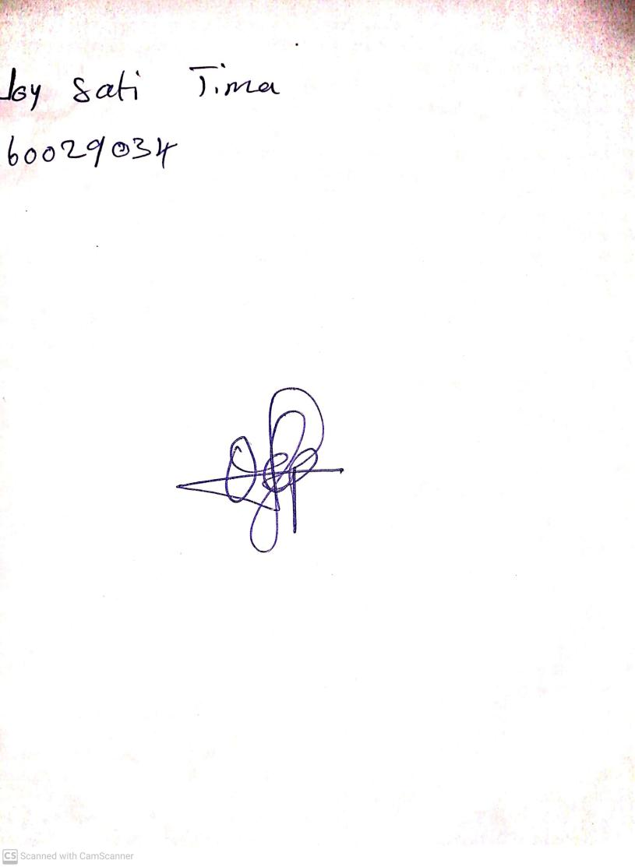

18th September, 2023

Perpetual Ojoma Ocheja

Stream Head Nursery