**EMERALD ROYAL INTERNATIONAL SCHOOL**

**MPAPE, ABUJA.**

**LESSON PLAN AND NOTE FOR WEEK 7 ENDING 25/10/2024**

**TERM: 1st**

**WEEK: 7th**

**DATE: 21/10/2024**

**CLASS: Nursery 2**

**SUBJECT: Nature studies**

**TOPIC: Non living things**

**SUB—TOPIC: Meaning and examples of non living things.**

**PERIOD: 4th**

**TIME: 10:40—11:20am**

**DURATION: 40 minutes**

**NUMBER IN CLASS: 14**

**AVERAGE AGE: 5 years**

**SEX: Mixed**

**LEARNING OBJECTIVES: By the end of the lesson, the pupils should be able to:**

**1. Define non living things.**

**2. Mention the examples of non living things in school.**

**3. States the non living things at home.**

**RATIONALE: For pupils to know what non living things means.**

**PREVIOUS KNOWLEDGE: Pupils have learnt about living things in previous lesson.**

**INSTRUCTIONAL MATERIALS: stone, books, pencils, chairs, and desk.**

**REFERENCE MATERIALS: Basic science and technology for Nursery schools book 3 by OPEMIPO DADA.**

**LESSON DEVELOPMENT**

|  |  |  |  |
| --- | --- | --- | --- |
| **Steps** | **Teacher's activities** | **Pupils' activities** | **Learning point** |
| **Introduction** | **Teacher introduces the lesson by reviewing the previous lesson.** | **Pupils pay attention to the teacher.** | **To prepare pupils minds for the lesson ahead.** |
| **Presentation step 1** | **Teacher defines non living things to pupils and then asks them to repeat after her.** | **Pupils listen to the teacher and repeat after her.** | **To improve pupils listening and speaking ability.** |
| **Step 2** | **Teacher mentions the examples of non living things in school to pupils and also asks them to repeat after her.** | **Pupils pay attention to the teacher and repeat her.** | **To enhance pupils participation in the class.** |
| **Step 3** | **Teacher states the examples of non living things at home to pupils and also asks pupils to repeat after her.** | **Pupils listen attentively to the teacher and repeat after her.** | **To improve pupils speaking ability.** |
| **Board summary** | **Teacher writes the whole note of lesson on the board for pupils to copy into their books. That is;**  **Non living things:**  **Non living things are the objects that do not have life in them. They cannot eat, grow or produce young ones like living things.**  **Examples of non living things in school:**   1. **Pencil** 2. **School bags** 3. **Eraser** 4. **Ruler** 5. **Duster** 6. **Food flask** 7. **Marker** 8. **Sharpener** 9. **Books** 10. **Desk** 11. **Water bottle etc.**   **Examples of non living things at home:**   1. **Fan** 2. **Shoes** 3. **Bags** 4. **Gas cylinder** 5. **Electric iron** 6. **Plate** 7. **Spoon** 8. **Knife** 9. **Cream** 10. **Bed etc.** | **Pupils copy the note into their exercise books.** | **For onward study.** |
| **Evaluation** | **Teacher evaluates the lesson by asking pupils the following questions;**   1. **Define non living things.** 2. **Mention the examples of non living things in school.** 3. **States the examples of non living things at home.** | **Pupils answer the questions asked by the teacher.** | **To assess pupils level of understanding.** |
| **Conclusion** | **Teacher concludes the lesson by marking pupils books.** | **Pupils submit their books for marking.** | **For endorsement.** |
| **Assignment** | 1. **What are living things?** 2. **Define non living things.** 3. **List 5 living things and 5 non living things.** | **Pupils do their assignment at home.** | **To encourage learning at home.** |

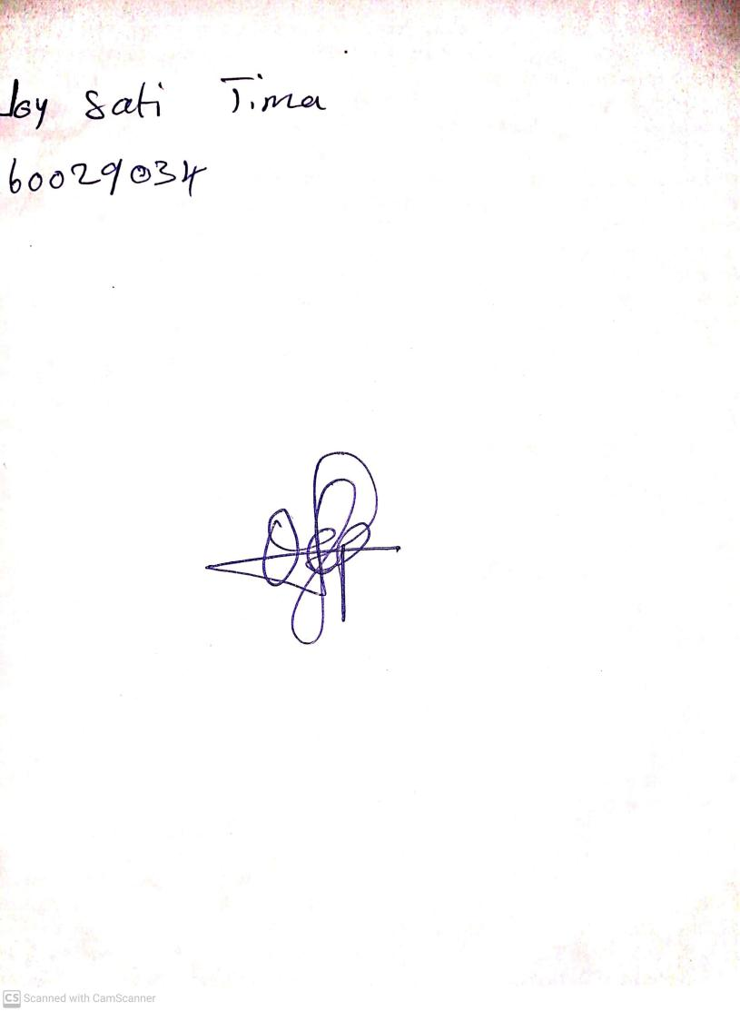

**18th October, 2024**

**Perpetual Ojoma Ocheja**

**Stream Head Nursery**