EMERALD ROYAL INTERNATIONAL SCHOOL

MPAPE, ABUJA.

LESSON PLAN AND NOTE FOR WEEK 4 ENDING 26TH MAY,2023

TERM: Third term.

WEEK: 4

SUBJECT: Nature studies.

TOPIC: Sinking objects.

SUB-TOPIC: Meaning of sinking objects and examples of sinking objects.

DATE: 25/5/2023

DURATION: 40 minutes

TIME: 08:50-09:30

PERIOD: 3rd

CLASS: Pre-nursery

NUMBER OF PUPILS: 11

AVERAGE AGE: 2 years

SEX: Mixed

SPECIFIC OBJECTIVES: By the end of the lesson, the pupils should be able to:-

I Define sinking objects

2. State the examples of sinking objects.

RATIONALE: For Pupils to know the objects that stays inside the water.

PREVIOUS KNOWLEDGE: Pupils have been taught the floating objects.

INSTRUCTIONAL MATERIALS: iron sharpeners, glass cup .

REFERENCE: Showers kiddies books Elementary science book nursery 1 by Showers kiddies books.

LESSON DEVELOPMENT

|  |  |  |  |
| --- | --- | --- | --- |
| Stages/steps | Teacher's activities | Pupils' activities | Learning points |
| Introduction | Teacher introduces the lesson by going over the previous lesson which was on floating objects. After that, the teacher introduces the lesson as "sinking objects". | Pupils listen to the teacher | To arouse the interest of the pupils. |
| Presentation  Step 1 | Teacher defines sinking objects to the pupils as:-  "Sinking objects are those objects that goes down the water". Teacher asks the pupils to repeat after the teacher. | Pupils listen to the teacher and repeat after the teacher. | For better understanding of the lesson. |
| Step 2 | Teacher leads the pupils to mention the examples of sinking objects they know. | Pupils list the examples of sinking objects.   1. Iron spoons. 2. Glass cups 3. Iron sharpner 4. Stone | To ensure active participation |
| Summary | Teacher summarizes the lesson by going over the lesson again for more understanding. | Pupils listen attentively to the teacher as she is going over the lesson. | To ensure better understanding. |
| Evaluation | Teacher asks the Pupils to :-   1. Define sinking objects. 2. State three examples of sinking objects. | Pupils answer the teacher's questions correctly. | To ascertain the level of pupils understanding of the lesson. |
| Conclusion | Teacher concludes the lesson by demonstrating on how objects sinks inside the water by pouring water inside the bucket and putting Stone inside the water to show the pupils that Stone goes down the water | Pupils watch and also participate in the activities. | For better understanding of the lesson. |
| Assignment | Teacher encourages the pupils to practice the demonstration at home. | Pupils do the assignment at home. | To encourage Learning at home. |

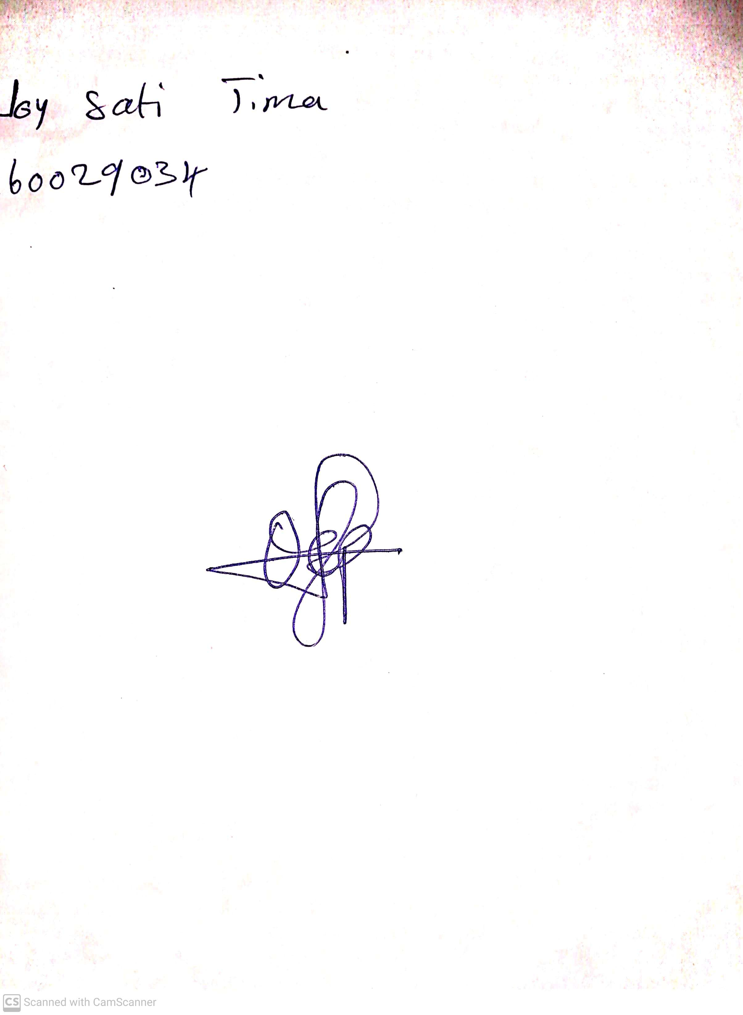

29th April, 2023

Perpetual Ojoma

Stream Head Nursery