**LESSON PLAN AND NOTE 1 FOR WEEK 1 ENDING 12/01/2024**

**Term 2nd term**

**Week 1st week**

**Date 8th January,2024**

**Class Nursery One**

**Subject Number Work**

**Topic Counting numbers 1-60.**

**Sub-topic Count numbers 50-55**

**Period 4th period**

**Time 9:05 am**

**Duration 35 minutes**

**No in class 15**

**Average Age 3 years**

**Sex Mixed**

**Specific Objectives: By the end of the lesson ,the pupils should be able to:**

1. **Count numbers 50-55.**
2. **Identify numbers 50-55.**
3. **Write numbers 50-55**

**Rationale: To make sure the pupils count numbers 1-60.**

**Previous Knowledge: The pupils can match & fill in missing numbers 1-50.**

**Instructional Resources: Chart, board, marker, etc.**

**Reference Material: The new mastering mathematics.**

**LESSON PRESENTATION**

|  |  |  |  |  |
| --- | --- | --- | --- | --- |
| **Steps** | **Teacher’s Activities** | **Pupils’ Activities** | **Learning Points** | |
| **Introduction** | **The teacher introduces the topic (counting numbers 1-60) to the pupils by rhyming it.** | **The pupils with the teacher rhyme the numbers 1-60.** | **To arouse the pupils’ interest.** | |
| **Step 1** | **The teacher assists the pupils to count numbers 50-55**  **50 51 52**  **53 54 55** | **The pupils counts numbers 50-55 with their teacher.** | | **For proper understanding.** |
| **Step 2** | **The teacher leads the pupils to identify numbers 50-55**  **50 51 52**  **53** | **The pupils participate with the teacher in identifying numbers 50-55.**  **50 51 52**  **53** | | **For better understanding.** |
| **Step 3** | **The teacher guides the pupils to write numbers 50-55 inside their notebooks.**   |  |  | | --- | --- | | **50** | **51** | |  |  | | **52** | **53** | |  |  | | **54** | **55** | |  |  | | **The pupils write numbers 50-55 as the teacher guides them.**   |  |  | | --- | --- | | **50** | **51** | |  |  | | **52** | **53** | |  |  | | **54** | **55** | |  |  | | | **For further understanding** |
| **Summary** | **The teacher summarizes the lesson by counting numbers 50-55.** | **The pupils have master and count numbers 50-55**  **.** | | **For onward study.** |
| **Evaluation** | **Question:**  **Identify numbers 50-55.**  **50 51 52**  **53** | **The pupils answers the question correctly.** | | **To ascertain the pupils’ understanding.** |
| **Conclusion** | **The teacher summarizes, reacts and corrects the lesson.** | **The pupils gives answers to the teacher’s questions** | | **To consolidate the lesson** |
| **Assignment** | **Question:**  **Write the following numbers below**   |  |  | | --- | --- | | **50** | **51** | |  |  | | **52** | **53** | |  |  | | **54** | **55** | |  |  | | **The pupils copy and do their homework at home.** | | **To encourage learning while at home.** |

**LESSON PLAN AND NOTE 2 FOR WEEK 1 ENDING 12/01/2024**

**Term 2nd term**

**Week 1st week**

**Date 10th January,2024**

**Class Nursery One**

**Subject Number Work**

**Topic Counting numbers 1-60.**

**Sub-topic Count numbers 55-60**

**Period 4th period**

**Time 9:05 am**

**Duration 35 minutes**

**No in class 15**

**Average Age 3 years**

**Sex Mixed**

**Specific Objectives: By the end of the lesson ,the pupils should be able to:**

1. **Count numbers 55-60.**
2. **Identify numbers 55-60.**
3. **Write numbers 55-60.**

**Rationale: To make sure the pupils count numbers 1-60.**

**Previous Knowledge: The pupils knows how to count numbers 50-55.**

**Instructional Resources: Chart, board, marker, etc.**

**Reference Material: The new mastering mathematics.**

**LESSON PRESENTATION**

|  |  |  |  |
| --- | --- | --- | --- |
| **Steps** | **Teacher’s Activities** | **Pupils’ Activities** | **Learning Points** |
| **Introduction** | **The teacher introduces the topic (counting numbers 1-60) to the pupils by rhyming it.** | **The pupils with the teacher rhyme the numbers 1-60.** | **To arouse the pupils’ interest.** |
| **Step 1** | **The teacher assists the pupils to count numbers 55-60**  **55 56 57**  **58 59 60** | **The pupils counts numbers 55-60 with their teacher.** | **For proper understanding.** |
| **Step 2** | **The teacher leads the pupils to identify numbers 55-60**  **55 56 57**  **58** | **The pupils participate with the teacher in identifying numbers 55-60.**  **55 56 57**  **58** | **For better understanding.** |
| **Step 3** | **The teacher guides the pupils to write numbers 55-60 inside their notebooks.**   |  |  | | --- | --- | | **55** | **56** | |  |  | | **57** | **58** | |  |  | | **59** | **60** | |  |  | | **The pupils write numbers 55-60 as the teacher guides them.** | **For further understanding** |
| **Summary** | **The teacher summarizes the lesson by counting numbers 55-60** | **The pupils have master and count numbers 55-60.** | **For onward study.** |
| **Evaluation** | **Question:**  **Identify numbers 55-60.**  **55 56 57**  **58** | **The pupils answers the question correctly.** | **To ascertain the pupils’ understanding.** |
| **Conclusion** | **The teacher summarizes, reacts and corrects the lesson.** | **The pupils gives answers to the teacher’s questions** | **To consolidate the lesson** |
| **Assignment** | **Question:**  **Identify the following numbers**  **55 56 57**  **58**  **Write the following numbers below**   |  |  | | --- | --- | | **55** | **56** | |  |  | | **57** | **58** | |  |  | | **59** | **60** | |  |  | | **The pupils copy and do their homework at home.** | **To encourage learning while at home.** |

**LESSON PLAN AND NOTE 3 FOR WEEK 1 ENDING 12/01/2024**

**Term 1st term**

**Week 1st week**

**Date 12th January,2024**

**Class Nursery One**

**Subject Number Work**

**Topic Counting numbers 1-60.**

**Sub-topic Matching numbers 50-60**

**Period 4th period**

**Time 9:05 am**

**Duration 35 minutes**

**No in class 15**

**Average Age 3 years**

**Sex Mixed**

**Specific Objectives: By the end of the lesson ,the pupils should be able to:**

1. **Match numbers 50-55.**
2. **Fill in the numbers 55-60.**

**Rationale: To make sure the pupils match numbers 1-60.**

**Previous Knowledge: The pupils knows how to count numbers 55-60.**

**Instructional Resources: Chart, board, marker, etc.**

**Reference Material: The new mastering mathematics.**

**LESSON PRESENTATION**

|  |  |  |  |
| --- | --- | --- | --- |
| **Steps** | **Teacher’s Activities** | **Pupils’ Activities** | **Learning Points** |
| **Introduction** | **The teacher introduces the topic (counting numbers 1-60) to the pupils by rhyming it.** | **The pupils with the teacher rhyme the numbers 1-60.** | **To arouse the pupils’ interest.** |
| **Step 1** | **The teacher assists the pupils to match numbers 50-55**  **50 55**  **51 54**    **52 53**  **53 52**  **54 51**  **55 50** | **The pupils match numbers 50-55 with their teacher.**  **50 55**  **51 54**    **52 53**  **53 52**  **54 51**  **55 50** | **For proper understanding.** |
| **Step 2** | **The teacher leads the pupils to fill in the numbers 55-60**  **55____ 57 ______ 59**  **____** | **The pupils participate with the teacher in filling in the missing numbers 55-60.**  **55 56 57**  **58 59 60** | **For better understanding.** |
| **Summary** | **The teacher summarizes the lesson by counting numbers**  **50-60** | **The pupils have master and count numbers 50-60.** | **For onward study.** |
| **Evaluation** | **Question:**  **Count numbers 50-60.** | **The pupils answers the question correctly.** | **To ascertain the pupils’ understanding.** |
| **Conclusion** | **The teacher summarizes, reacts and corrects the lesson.** | **The pupils gives answers to the teacher’s questions** | **To consolidate the lesson** |
| **Assignment** | **Question:**  **Fill in the missing numbers below**  **50____52____54____56**  **____ 58____ 60** | **The pupils copy and do their homework at home.** | **To encourage learning while at home.** |

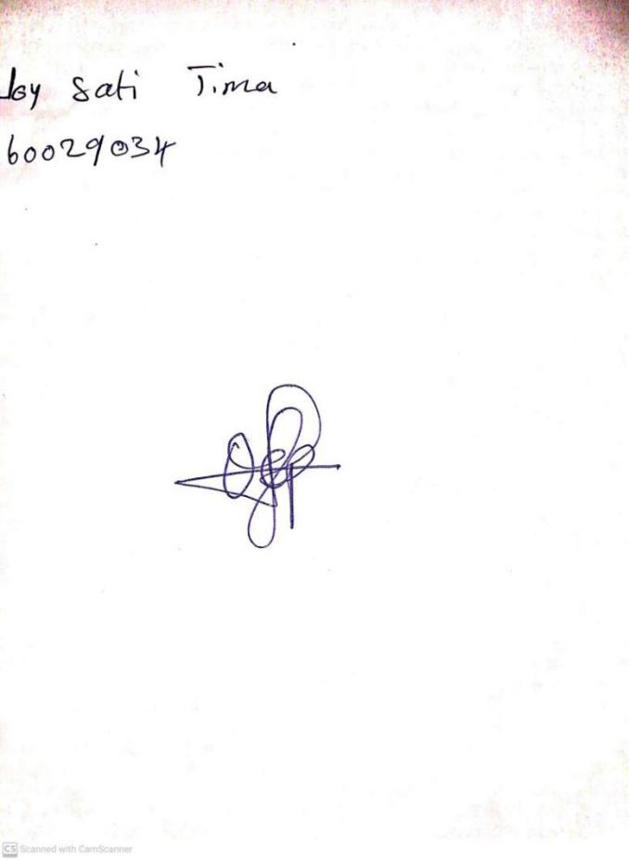

5TH January, 2024

Perpetual Ojoma Ocheja

Stream Head Nursery

**N.B THE EVALUATION SHOULD TALLY WITH THE LEARNING OBJECTIVES**

|  |  |
| --- | --- |
| **Evaluation** | **Question:**  **Count numbers 50-60.** |

**Specific Objectives: By the end of the lesson ,the pupils should be able to:**

1. **Match numbers 50-55.**
2. **Fill in the numbers 55-60.**

KINDLY DO SAME FOR THE OTHER NOTES