EMERALD ROYAL INTERNATIONAL SCHOOL MPAPE, ABUJA. LESSON NOTE 1 FOR WEEK 7 ENDING 23RD FEBRUARY, 2024.

SUBJECT: Letter work

TOPIC: Identification of letter j and it's sound.

SUB-TOPIC: Recognition of letter j .

DATE: 20/2/2024.

DURATION: 40 minutes.

TIME: 08:50---- 09:30.

PERIOD: 2nd

CLASS: Pre-nursery

NUMBER OF PUPILS: 17

AVERAGE AGE: 2 years

SEX: Mixed.

SPECIFIC OBJECTIVES: By the end of the lesson, the pupils should be able to:-

I. Sing the jolly phonics song for letter j

2. Identify letter j on the flash card.

RATIONALE: For Pupils to know letters and their sounds.

PREVIOUS KNOWLEDGE: Pupils have been learning how to identify and say the sounds for letter a -i.

INSTRUCTIONAL MATERIAL: flash cards and phonics song.

REFERENCE: Mastering English for Nursery schools book 1 by J.M.Omogbai.

LESSON DEVELOPMENT

|  |  |  |  |
| --- | --- | --- | --- |
| Stages/steps | Teacher's activities | Pupils' activities | Learning points. |
| Introduction | Teacher introduces the lesson by singing A,B,C, D'S song for the Pupils. | Pupils sing the song along with the teacher. | To arouse the Pupils interest for the lesson. |
| Presentation | Teacher sing the jolly phonics song for letter j and does the action for the Pupils. | Pupils attempt singing and imitates the teacher to do the action of the song that is:-  Jelly and Jam  Jelly and Jam  Juggling on the plates............. | For better understanding of the lesson. |
| Step 2 | Teacher shows the Pupils letter /j/ on the flash card and asks them to point at it and say /j/ /j/ /j/ /j/. | Pupils point at the flash and make the sound for letter j | For proper understanding of the lesson. |
| Summary | Teacher summarizes the lesson by calling out the Pupils one after another to point at letter j on the flash card again and make it's sound. | Pupils come out one after another and touch the letter j on the flash card and makes it's sound. | To enhance Pupils knowledge of the letter and it sound. |
| Evaluation | Teacher asks the Pupils to:-   1. Point at letter j on the white board. 2. Say the sound for letter j. | Pupils answer the questions asked by the teacher. | To ascertain pupils level of understanding of the lesson. |
| Conclusion | Teacher sing the A, B, C, D'S song again for the Pupils. | Pupils sing the rhyme along with the teacher. | To consolidate the lesson. |

EMERALD ROYAL INTERNATIONAL SCHOOL MPAPE, ABUJA. LESSON NOTE 2 FOR WEEK 7 ENDING 23RD FEBRUARY, 2024.

SUBJECT: Letter work

TOPIC: Identification of letter j and it's sound.

SUB-TOPIC: Recognition and sounding letter j .

DATE: 21/2/2024.

DURATION: 40 minutes.

TIME: 11:20---12:00

PERIOD: 5th

CLASS: Pre-nursery

NUMBER OF PUPILS: 17

AVERAGE AGE: 2 years

SEX: Mixed.

SPECIFIC OBJECTIVES: By the end of the lesson, the pupils should be able to:-

I. Point and Identify letter j amongst other letters.

2. Sing a phonics song for letter j

RATIONALE: For Pupils to know letters and their sounds.

PREVIOUS KNOWLEDGE: Pupils have been learning how to identify and say the sounds for letter a -i.

INSTRUCTIONAL MATERIAL: flash cards, board and phonics song.

REFERENCE: Mastering English for Nursery schools book 1 by J.M.Omogbai

LESSON DEVELOPMENT

|  |  |  |  |
| --- | --- | --- | --- |
| Stages/steps | Teacher's activities | Pupils' activities | Learning points. |
| Introduction | Teacher introduces the lesson by singing the A,B,C, D'S song for the pupils. | Pupils sing the rhyme along with the teacher. | To get pupils interested in the lesson. |
| Presentation  Step 1 | Teacher prepares the pupils exercise books for them to circle letter j amongst other letters. | Pupils circle letter j  Example.  a (j) b c  (j) h (j) i  e (j) f d | To improve pupils psycomotive skills. |
| Step 2 | Teacher sings a phonics song of letter j for the pupils. | Pupils sing the song along with the teacher . That's:-  The j says /j/  The j says /j/  Every letter makes a sound  The j says /j/. | For better understanding of the lesson. |
| Summary | Teacher summarizes the lesson by asking the pupils to point at letter j on the flash card and say it's sound. | Pupils point at letter j on the and say it's sound. | To improve pupils understanding of the lesson. |
| Evaluation | Teacher puts flash cards of different letters on the table including letter j and asks the pupils to:-  1. Identify letter j amongst other letters.  2.Say the sound for letter j. | Pupils answer the questions asked by the teacher. | To assess the level of pupils understanding of the lesson. |
| Conclusion | Teacher marks the pupils books and makes necessary corrections. | Pupils submit their books for marking and corrections. | For onwards learning. |
| Assignment | Teacher asks the pupils to trace letter j. | Pupils trace letter j | To encourage Learning at home. |

EMERALD ROYAL INTERNATIONAL SCHOOL MPAPE, ABUJA. LESSON NOTE 3 FOR WEEK 7 ENDING 23RD FEBRUARY, 2024.

SUBJECT: Letter work

TOPIC: Identification of letter j and it's sound.

SUB-TOPIC: Recognition and sounding letter j .

DATE: 23/2/2024.

DURATION: 40 minutes.

TIME: 8:50---9:30

PERIOD: 2nd

CLASS: Pre-nursery

NUMBER OF PUPILS: 17

AVERAGE AGE: 2 years

SEX: Mixed.

SPECIFIC OBJECTIVES: By the end of the lesson, the pupils should be able to:-

I. Identify letter j .

2. Trace letter j.

RATIONALE: For Pupils to know letters and their sounds.

PREVIOUS KNOWLEDGE: Pupils have been learning how to identify and say the sounds for letter a -i.

INSTRUCTIONAL MATERIAL: flash cards, board and phonics song.

REFERENCE: Mastering English for Nursery schools book 1 by J.M.Omogbai

LESSON DEVELOPMENT

|  |  |  |  |
| --- | --- | --- | --- |
| Stages/steps | Teacher's activities | Pupils' activities | Learning points. |
| Introduction | Teacher introduces the lesson by singing the jolly phonics song for letter j. | Pupils sing along with the teacher. | To arouse the pupils interest for the lesson. |
| Presentation  Step 1 | Teacher writes letter j boldly on the board and asks the pupils to point at it and say "letter j". | Pupils point at letter j on the board . That is:-  **j** | To improve the pupils understanding. |
| Step 2 | Teacher prepares the pupils books for them to trace letter j. | Pupils trace letter j in their exercise books. That's :- | To improve pupils psycomotive skills. |
| Summary | Teacher summarizes the lesson by asking the pupils to point at letter j again on the board. | Pupils point at letter j on the board. | For better understanding of the lesson. |
| Evaluation | Teacher asks the pupils to:-   1. Point at letter j on the board. 2. Say the sound for letter j. | Pupils answer the teacher's questions. | To assess the level of pupils understanding. |
| Conclusion | Teacher asks the pupils to submit their books for corrections and marking. | Pupils submit their books for marking and corrections. | For onwards study. |
| Assignment | Teacher asks the pupils to colour letter j  j | Pupils colour the letter j | To encourage Learning at home. |

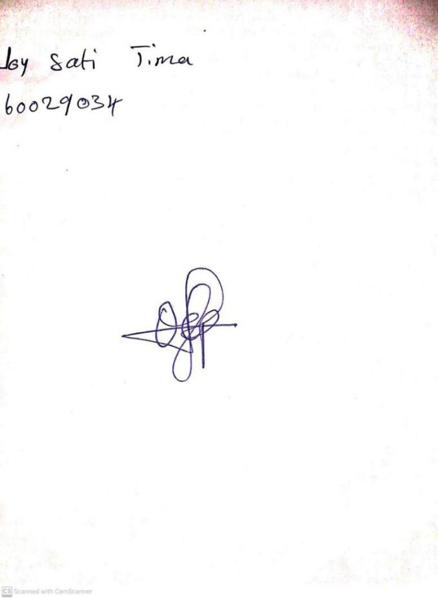

**16TH FEBRUARY, 2024**

**Perpetual Ojoma Ocheja**

**Stream Head Nursery**