**EMERALD ROYAL INTERNATIONAL SCHOOL MPAPE, ABUJA**

**LESSON PLAN AND NOTE FOR WEEK 9 ENDING 08/03/2024**

**TERM: 2nd**

**WEEK: 9th**

**DATE: 04/03/2024**

**CLASS: Nursery 2**

**SUBJECT: Letter work**

**TOPIC: Consonant digraphs 2**

**SUB—TOPIC: ` Words with consonant digraphs‘ th’ and ‘wh’**

**PERIOD: 3rd**

**TIME: 09:30–10:10am**

**DURATION: 40 minutes**

**NUMBER IN CLASS: 13**

**AVERAGE AGE: 5 years**

**SEX: Mixed**

**LEARNING OBJECTIVES: By the end of the lesson, the Pupils should be able to:**

**1. Generate words with consonant digraphs ‘th’**

**2. Make words with consonant digraphs ‘wh’**

**RATIONALE: For Pupils to know words with consonant digraphs th and wh.**

**PREVIOUS KNOWLEDGE: Pupils have learnt consonant digraphs ck,ph, sh and ch in previous lesson.**

**INSTRUCTIONAL MATERIALS: A chart of words with initial ‘th’ and ‘wh’**

**REFERENCE MATERIALS: My choice of English language stage 3 by JF OMOTAYO**

**LESSON DEVELOPMENT**

|  |  |  |  |
| --- | --- | --- | --- |
| **Steps** | **Teacher's activities** | **Pupils' activities** | **Learning point** |
| **Introduction** | **Teacher introduces the lesson by reviewing the previous lesson.** | **Pupils pay attention to the teacher.** | **To arouse pupils interest for the lesson ahead.** |
| **Presentation Step 2** | **Teacher generates words with consonant digraphs ‘th’ and then asks Pupils to repeat after her.** | **Pupils listen to the teacher and repeat after her.** | **For proper understanding.** |
| **Step 2** | **Teacher makes words with consonant digraphs ‘wh’ and also asks Pupils to repeat after her.** | **Pupils pay attention to the teacher and also repeat after her.** | **For better understanding.** |
| **Board summary** | **Teacher writes the whole note of lesson on the board for pupils to copy into their books. That is;**  **CONSONANT DIGRAPHS ‘TH’ ARE:**  **1. Then**  **2. Think**  **3. Thank**  **4. Thumb**  **5. Thursday**  **6. Thunder**  **7. Month etc**  **CONSONANT DIGRAPHS ‘WH’ ARE:**  **1. Wheel**  **2. What**  **3. When**  **4. Which**  **5. Where**  **6. Whiter**  **7. Whisper etc.** | **Pupils copy the note into their exercise books.** | **For onward study** |
| **Evaluation** | **Teacher evaluates the lesson by asking pupils to read the words on the board one after another.** | **Pupils go to the board one after another and read.** | **To assess Pupils reading ability.** |
| **Conclusion** | **Teacher concludes the lesson by marking pupils books.** | **Pupils submit their books for marking.** | **For endorsement.** |
| **Assignment** | **Generate 10 words with consonant digraphs‘wr’** | **Pupils do their assignment at home.** | **To encourage learning at home.** |

**LESSON PLAN AND NOTE FOR WEEK 9 ENDING 08/03/2024**

**TERM: 2nd**

**WEEK: 9th**

**DATE: 07/03/2024**

**CLASS: Nursery 2**

**SUBJECT: Letter work**

**TOPIC: Consonant Digraphs 2**

**SUB—TOPIC: Words with consonant digraphs ‘wr’**

**PERIOD: 2nd**

**TIME: 08:50–09:30am**

**DURATION: 40 minutes**

**NUMBER IN CLASS: 13**

**AVERAGE AGE: 5 years**

**SEX: Mixed**

**LEARNING OBJECTIVES: By the end of the lesson, the Pupils should be able to:**

**1. Generate Words with consonant digraphs ‘wr’**

**2. Spell and pronounce words with consonant digraphs ‘wr’**

**RATIONALE: For Pupils to know how to pronounce words has ‘wr’ as their first two letters.**

**PREVIOUS KNOWLEDGE: Pupils have learnt consonant digraphs ' th' and 'wh' in previous lesson.**

**INSTRUCTIONAL MATERIALS: Chart of words with consonant digraphs 'wr'**

**REFERENCE MATERIALS: My choice of english language stage 3 by J.F. OMOTAYO**

**LESSON DEVELOPMENT**

|  |  |  |  |
| --- | --- | --- | --- |
| **Steps** | **Teacher's activities** | **Pupils' activities** | **Learning point** |
| **Introduction** | **Teacher reviews the previous lesson on consonant digraphs 'th' and 'wh' with the Pupils.** | **Pupils pay attention to the teacher.** | **To arouse pupils interest for the lesson ahead.** |
| **Presentation step 1** | **Teacher generates words with consonant digraphs 'wr' to pupils on the board and asks them to repeat after her.** | **Pupils listen attentively to the teacher and repeat after her.** | **For proper understanding.** |
| **Step 2** | **Teacher guides pupils to spell and pronounce the words with consonant digraphs 'wr' on the board all together.** | **Pupils spell and pronounce the words on the board all together.** | **For better understanding.** |
| **Board summary** | **Teacher summarizes the lesson by writing the words with consonant digraphs 'wr' on the board for pupils to copy. As;**  **Consonant digraphs 'wr' are:**  **'wr' as in write**  **'wr' as in wrap**  **'wr' as in worst**  **'wr' as in wrist**  **'wr' as in wrestle**  **'wr' as in wring**  **'wr' as in wrong etc.** | **Pupils copy the note into their exercise books.** | **For onward study.** |
| **Evaluation** | **Teacher asks pupils to spell and pronounce the words on the board one after another.** | **Pupils go to the board one after another and read the words on the board.** | **To build Pupils reading ability.** |
| **Conclusion** | **Teacher concludes the lesson by marking pupils books.** | **Pupils submit their books for marking.** | **For endorsement** |
| **Assignment** | **Spell, pronounce and write at least 10 words with consonant digraphs 'mb'.** | **Pupils do their assignment at home.** | **To encourage learning at home.** |

**LESSON PLAN AND NOTE FOR WEEK 9 ENDING 08/03/2024**

**TERM: 2nd**

**WEEK: 9th**

**DATE: 08/03/2024**

**CLASS: Nursery 2**

**SUBJECT: Letter work**

**TOPIC: Consonant Digraphs 2**

**SUB—TOPIC: Words with consonant digraphs 'mb'**

**PERIOD: 3rd**

**TIME: 09:30–10:10am**

**DURATION: 40 minutes**

**NUMBER IN CLASS: 13**

**AVERAGE AGE: 5 years**

**SEX: Mixed**

**LEARNING OBJECTIVES: By the end of the lesson, the Pupils should be able to:**

**1. Make words with consonant digraphs 'mb'.**

**2. Spell and pronounce words with consonant digraphs 'mb'**

**RATIONALE: For Pupils to know how to pronounce words with consonant digraphs 'mb'**

**PREVIOUS KNOWLEDGE: Pupils have learnt consonant digraphs 'wr' in previous lesson.**

**INSTRUCTIONAL MATERIALS: A chart of words with consonant digraphs "mb"**

**REFERENCE MATERIALS: My choice of english language stage 3 by J.F. OMOTAYO**

**LESSON DEVELOPMENT**

|  |  |  |  |
| --- | --- | --- | --- |
| **Steps** | **Teacher's activities** | **Pupils' activities** | **Learning point** |
| **Introduction** | **Teacher introduces the lesson by singing nursery rhymes.** | **Pupils sing the rhymes along with the teacher.** | **To prepare pupils minds for the lesson ahead.** |
| **Presentation step 1** | **Teacher makes words with consonant digraphs 'mb' on the board and then asks Pupils to repeat after her.** | **Pupils pay attention to the teacher and repeat after her.** | **For proper understanding.** |
| **Step 2** | **Teacher guides pupils to all stand and then spell and pronounce the words on the board .** | **Pupils all stand and then spell and pronounce the words on the board.** | **For better understanding.** |
| **Board summary** | **Teacher writes the whole note of lesson on the board for pupils to copy. That is;**  **Consonant digraphs 'mb' are:**  **‘mb’ as in comb**  **‘mb’ as in thumb**  **‘mb’ as in lamb**  **‘mb’ as in climb**  **‘mb’ as in limb**  **‘mb’ as in number etc.** | **Pupils copy the note into their books.** | **For onward study.** |
| **Evaluation** | **Teacher evaluates the lesson by asking pupils individually to go to the board and read.** | **Pupils go to the board one after another and read.** | **To create platform for slow learners.** |
| **Conclusion** | **Teacher concludes the lesson by marking pupils books and letting them ready for their examination.** | **Pupils submit their books on the teacher desk for marking.** | **For endorsement.** |
| **Assignment** | **Read all your notes for examination.** | **Pupils read their books at home.** | **To get pupils prepare for their examination.** |

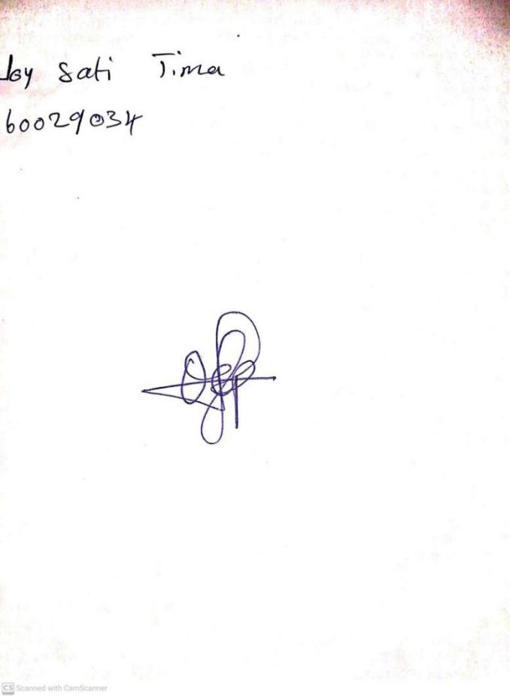

**1ST MARCH, 2024**

**Perpetual Ojoma Ocheja**

**Stream Head Nursery**