EMERALD ROYAL INTERNATIONAL SCHOOL

MPAPE, ABUJA.

LESSON NOTE 1 FOR WEEK 6 ENDING 16TH FEBRUARY, 2024.

SUBJECT: Letter work

TOPIC: Reviewing letter g---I and their sounds.

SUB-TOPIC: Letter i and it’s sound.

DATE: 13/2/2024.

DURATION: 40 minutes.

TIME: 11:20--12:00.

PERIOD: 2nd

CLASS: Pre-nursery

NUMBER OF PUPILS: 17

AVERAGE AGE: 2 YEARS

SEX: Mixed.

SPECIFIC OBJECTIVES: By the end of the lesson, the pupils should be able to:-

1. Identify letter i and it’s sound.
2. Circle letter I amongst other letters

RATIONALE: For pupils to know letters and their sounds.

PREVIOUS KNOWLEDGE: Pupils have been practising sounds of the alphabets.

REFERENCE:Mastering English for nursery schools book 1 by J.M.Omogbai.

LESSON DEVELOPMENT

|  |  |  |  |
| --- | --- | --- | --- |
| STAGES/STEPS | TEACHER’S ACTIVITIES | PUPILS’ ACTIVITIES | LEARNING POINTS |
| INTRODUCTION | Teacher introduces the lesson by singing and practising the letter sound /a/----/h/. | Pupils practice the sounds for letter a--h along with the teacher . | To prepare the pupils for the main topic. |
| PRESENTATION  STEP 1 | Teacher writes letter I boldly on a flash card  Asks the pupils one after another to point at it and say letter I says  **I.** | Pupils point at letter I on the flash card and practice it’s sound. | For better understanding of the lesson . |
| STEP2 | Teacher prepares the pupils book for them to identify and circle letter I. | Pupils identify and circle letter I in their books e.g  a (I) e b  C d (I) f i) g b h | To improve pupils writing skills. |
| SUMMARY | Teacher summarizes the lesson by singing a jolly phonics song for letter i. | Pupils sing the rhyme along with the teacher.  That is  I ----- as in ink ink ink | For more understanding of the lesson. |
| EVALUATION | Teacher asks the pupils to:-   1. Say the sound for letter i 2. Point at letter i amongst other letters on the chart. | Pupils answer the teacher’s questions. | To assess the level of pupils understanding of the lesson. |
| CONCLUSION | Teacher marks the pupils books and make corrections where necessary. | Pupils submit their books for marking and corrections . | For onwards study. |
| ASSIGNMENT | Circle letter i and practice it’s sound.  a e I o u  I s h I I  g m I o e | Pupils do their Home work at home. | To ensure learning takes place at home. |

LESSON NOTE 2 FOR WEEK 6 ENDING 16TH FEBRUARY, 2024.

SUBJECT: Letter work

TOPIC: Reviewing letter g---I and their sounds.

SUB-TOPIC: Letter h and it’s sound.

DATE: 14/2/2024.

DURATION: 40 minutes.

TIME: 11:20--12:00.

PERIOD: 5th

CLASS: Pre-nursery

NUMBER OF PUPILS: 17

AVERAGE AGE: 2 YEARS

SEX: Mixed.

SPECIFIC OBJECTIVES: By the end of the lesson, the pupils should be able to:-

1. Identify letter h and it’s sound.
2. trace letter h

RATIONALE: For pupils to know letters and their sounds.

PREVIOUS KNOWLEDGE: Pupils have been practising sounds of the alphabets.

REFERENCE:Mastering English for nursery schools book 1 by J.M.Omogbai.

LESSON DEVELOPMENT

|  |  |  |  |
| --- | --- | --- | --- |
| STAGES/STEPS | TEACHER’S ACTIVITIES | PUPILS’ ACTIVITIES | LEARNING POINTS |
| INTRODUCTION | Teacher introduces the lesson by going over the previous lesson. | Pupils listen to the teacher and participate in the activities. | To arouse the interest of the pupils for the lesson. |
| PRESENTATION  STEP 1 | Teacher sing a phonics song for letter h for the pupils. | Pupils sing along with the teacher,that is  The h says /h/  The h says /h/  Every letter makes a sound  The h says /h/. | For better understanding of the lesson . |
| STEP2 | Teacher prepares the pupils book for them to trace letter h. | Pupils trace letter h and practice it's sound. | To improve pupils writing skills. |
| SUMMARY | Teacher summarizes the lesson by singing a jolly phonics song for letter h. | Pupils sing the rhyme along with the teacher. | For more understanding of the lesson. |
| EVALUATION | Teacher asks the pupils to:-   1. Say the sound for letter h 2. Point at letter h amongst other letters on the chart. | Pupils answer the teacher’s questions. | To assess the level of pupils understanding of the lesson. |
| CONCLUSION | Teacher marks the pupils books and make corrections where necessary. | Pupils submit their books for marking and corrections . | For onwards study. |
| ASSIGNMENT | Colour letter h and practice it’s sound.  **h** | Pupils do their Home work at home. | To ensure learning takes place at home. |

LESSON NOTE 3 FOR WEEK 6 ENDING 16TH FEBRUARY, 2024.

SUBJECT: Letter work

TOPIC: Reviewing letter g---I and their sounds.

SUB-TOPIC: Letter g and it’s sound.

DATE: 16/2/2024.

DURATION: 40 minutes.

TIME: 08:50--09:30.

PERIOD: 2nd

CLASS: Pre-nursery

NUMBER OF PUPILS: 17

AVERAGE AGE: 2 YEARS

SEX: Mixed.

SPECIFIC OBJECTIVES: By the end of the lesson, the pupils should be able to:-

1. Identify letter g and it’s sound.
2. Colour letter g

RATIONALE: For pupils to know letters and their sounds.

PREVIOUS KNOWLEDGE: Pupils have been practising sounds of the alphabets.

REFERENCE:Mastering English for nursery schools book 1 by J.M.Omogbai.

LESSON DEVELOPMENT

|  |  |  |  |
| --- | --- | --- | --- |
| STAGES/STEPS | TEACHER’S ACTIVITIES | PUPILS’ ACTIVITIES | LEARNING POINTS |
| INTRODUCTION | Teacher introduces the lesson by singing a jolly phonics song for letter f. | Puils sing song along with the teacher as:-”My friends and I went to the bitch with a floating fish.  It get to a point and the air came out  /f/-/f/-/f/-/f/”. | To remind the pupils of the previ0us lesson. |
| PRESENTATION  STEP 1 | Teacher shows the pupils letter g on a flash card and asks them to say:-  Letter g and it’ says /g/ /g/ /g/. | Puils point at letter g on a flash card and also say it’s sound .Pupils also practice with the teacher the phonics song as:  The water gurgles down the drain,  The water gurgles down the drain  With the /g/ /g/ /g/ /g/ /g/. | For better understanding of the lesson . |
| STEP2 | Teacher prepares the pupils book for them to colour letter g. | Pupils colour letter g and practice it's sound.  **g** | To improve pupils pschomotive skills. |
| SUMMARY | Teacher summarizes the lesson by going over the lesson again for more understanding | Pupils listen veery attentively to the teacher | For more understanding of the lesson. |
| EVALUATION | Teacher asks the pupils to:-   1. Say the sound for letter g. 2. Point at letter g amongst other letters. | Pupils answer the teacher’s questions. | To assess the level of pupils understanding of the lesson. |
| CONCLUSION | Teacher marks the pupils books and make corrections where necessary. | Pupils submit their books for marking and corrections . | For onwards study. |
| ASSIGNMENT | Colour letter g and practice it’s sound.  **g** | Pupils do their Home work at home. | To ensure learning takes place at home. |

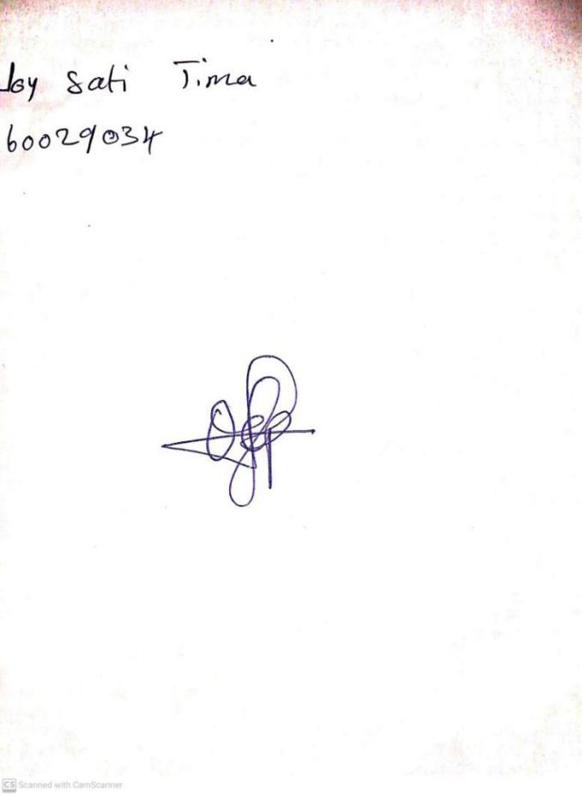

**9TH FEBRUARY, 2024**

**Perpetual Ojoma Ocheja**

**Stream Head Nursery**